Lesson 1 – Predicting Future Wildfire in Nevada
How Will Climate Change Affect Wildfire?

What impacts wildfire behavior?
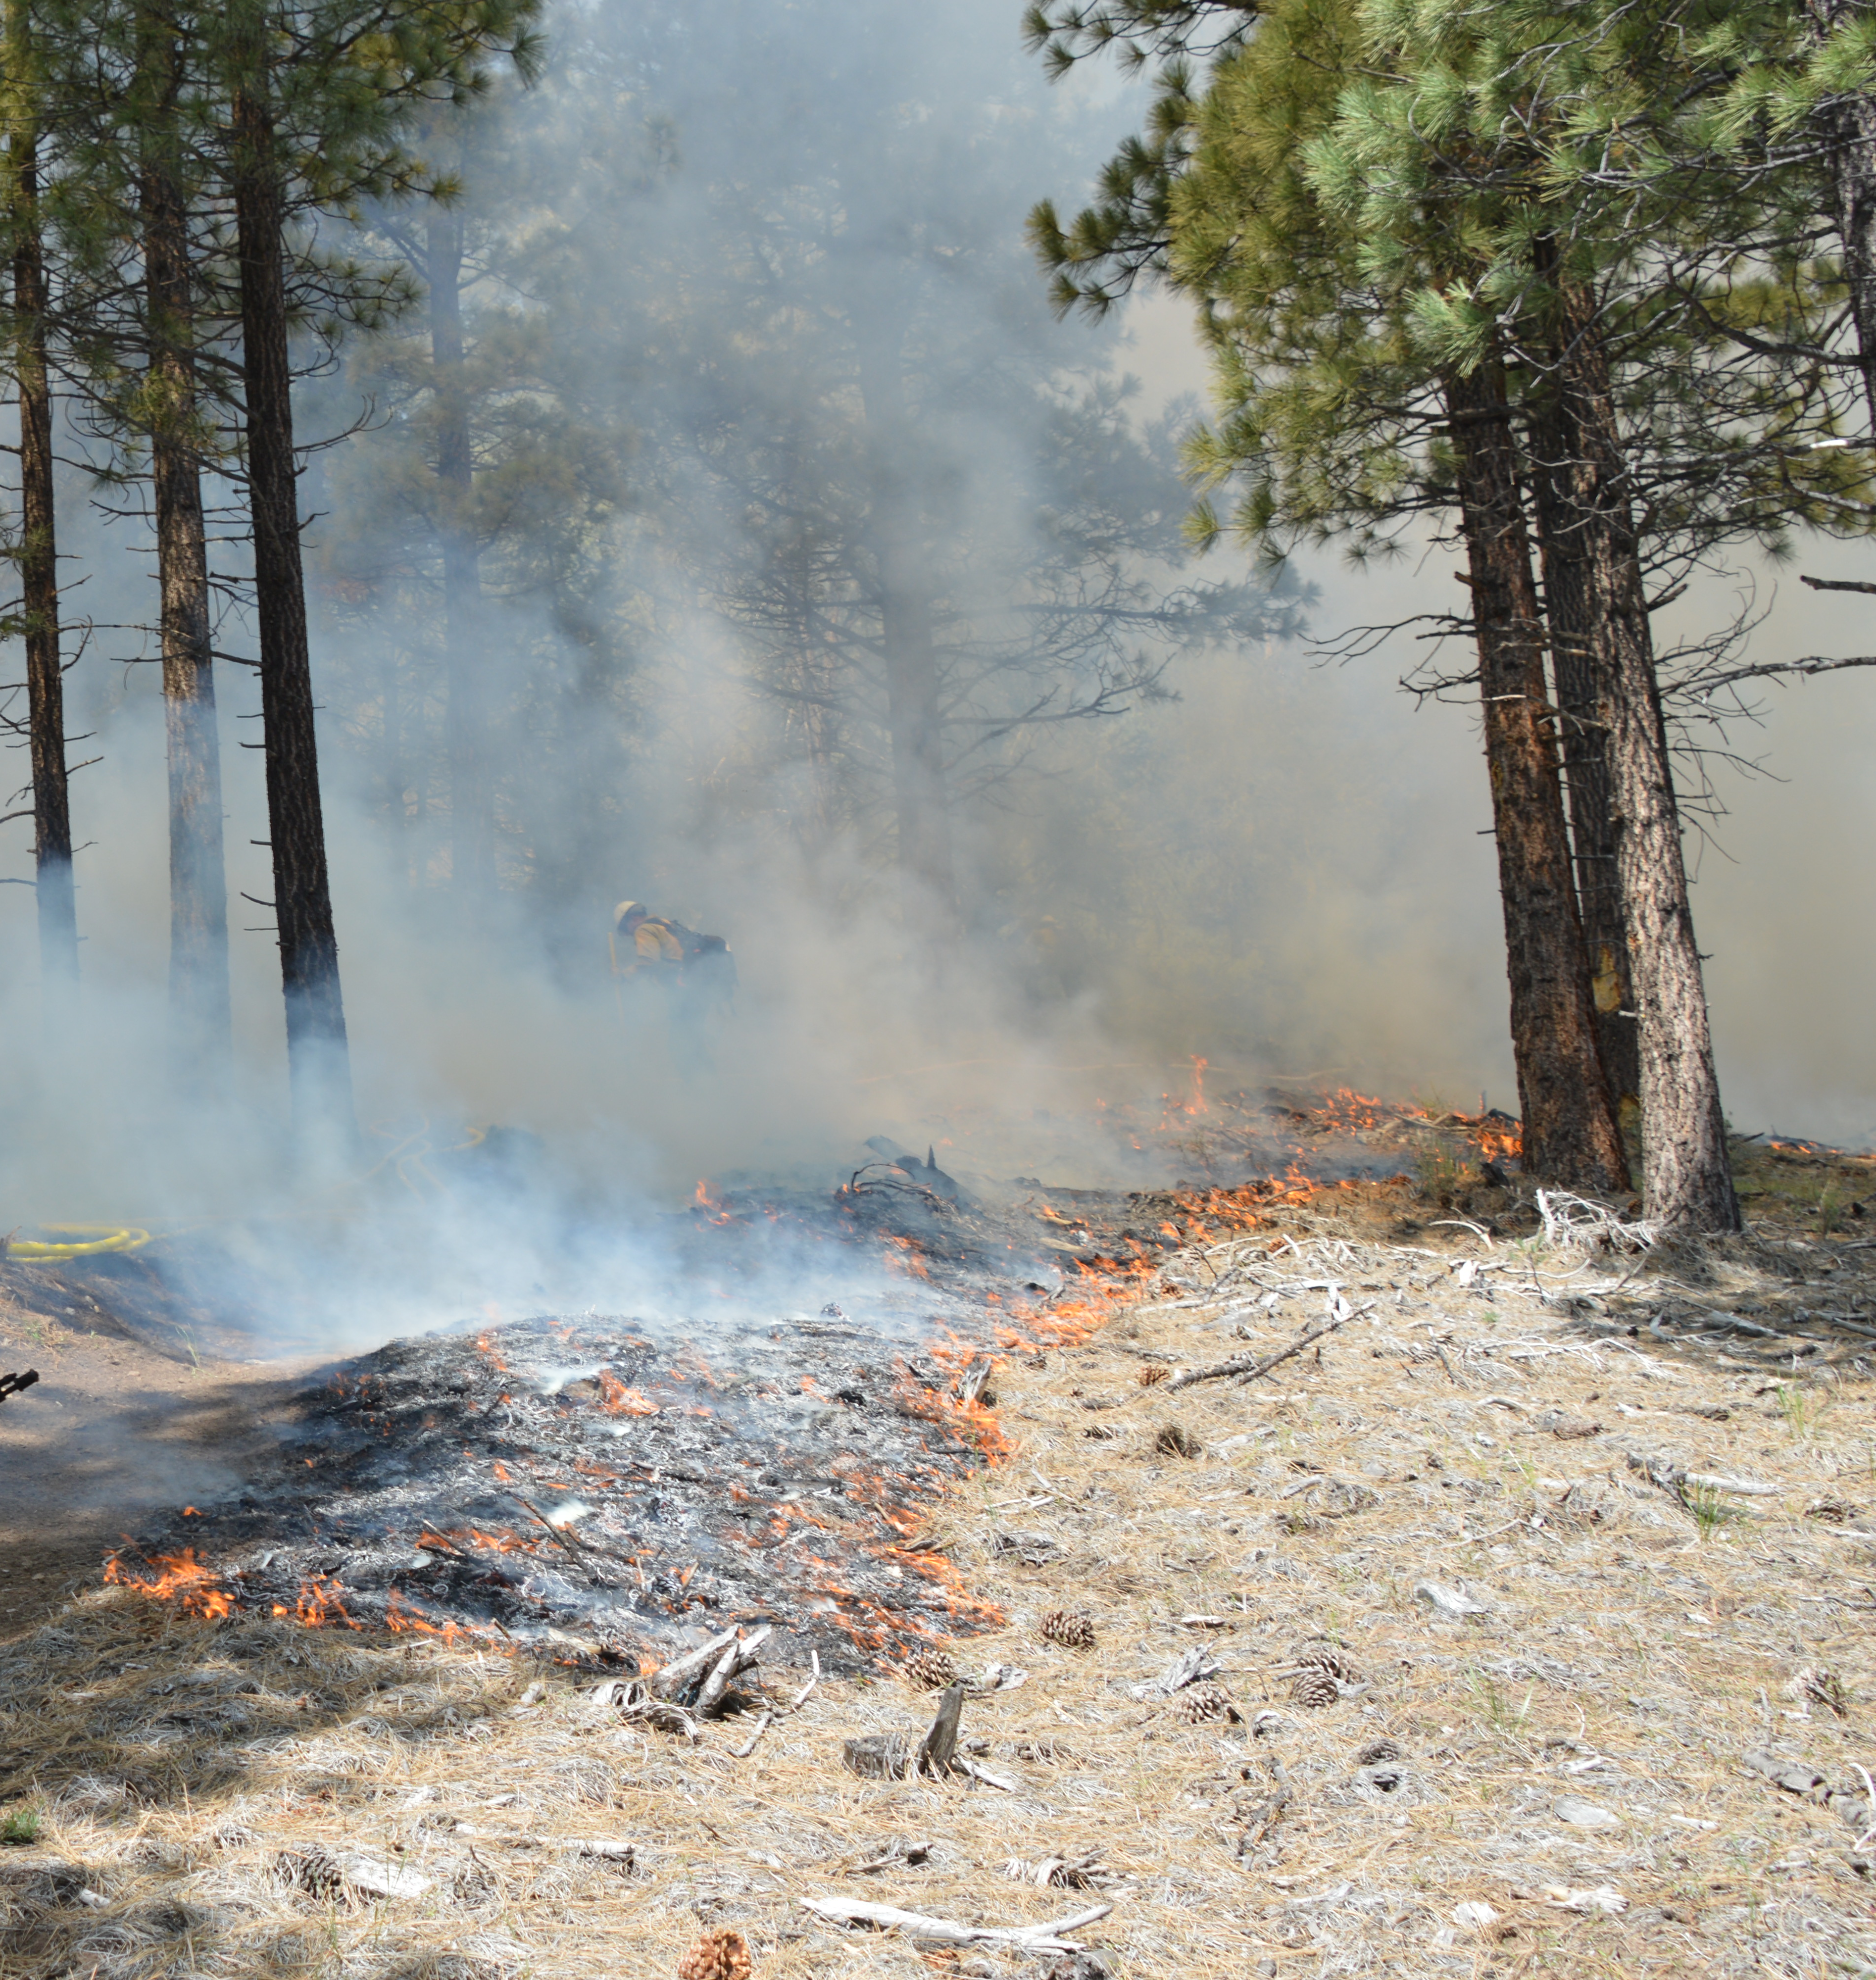
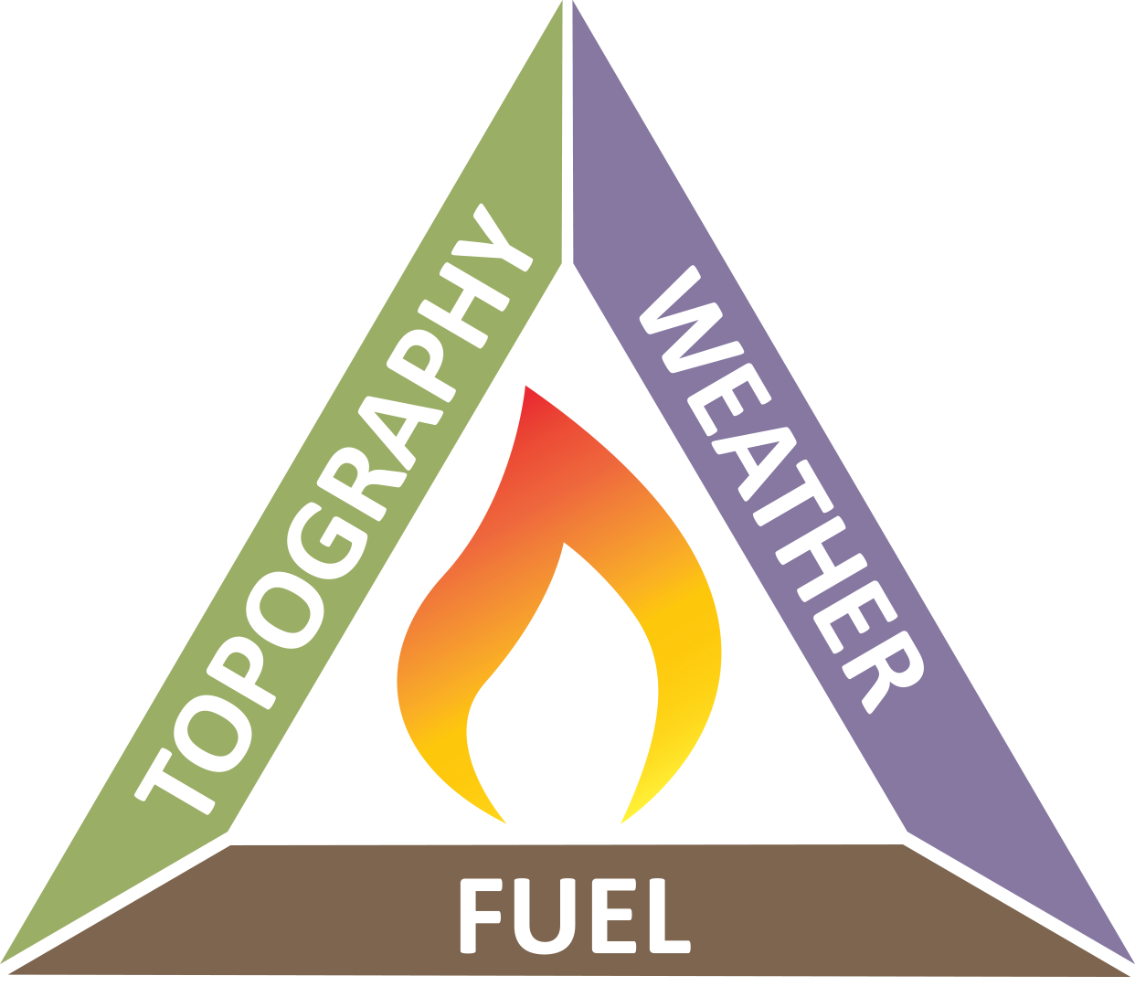
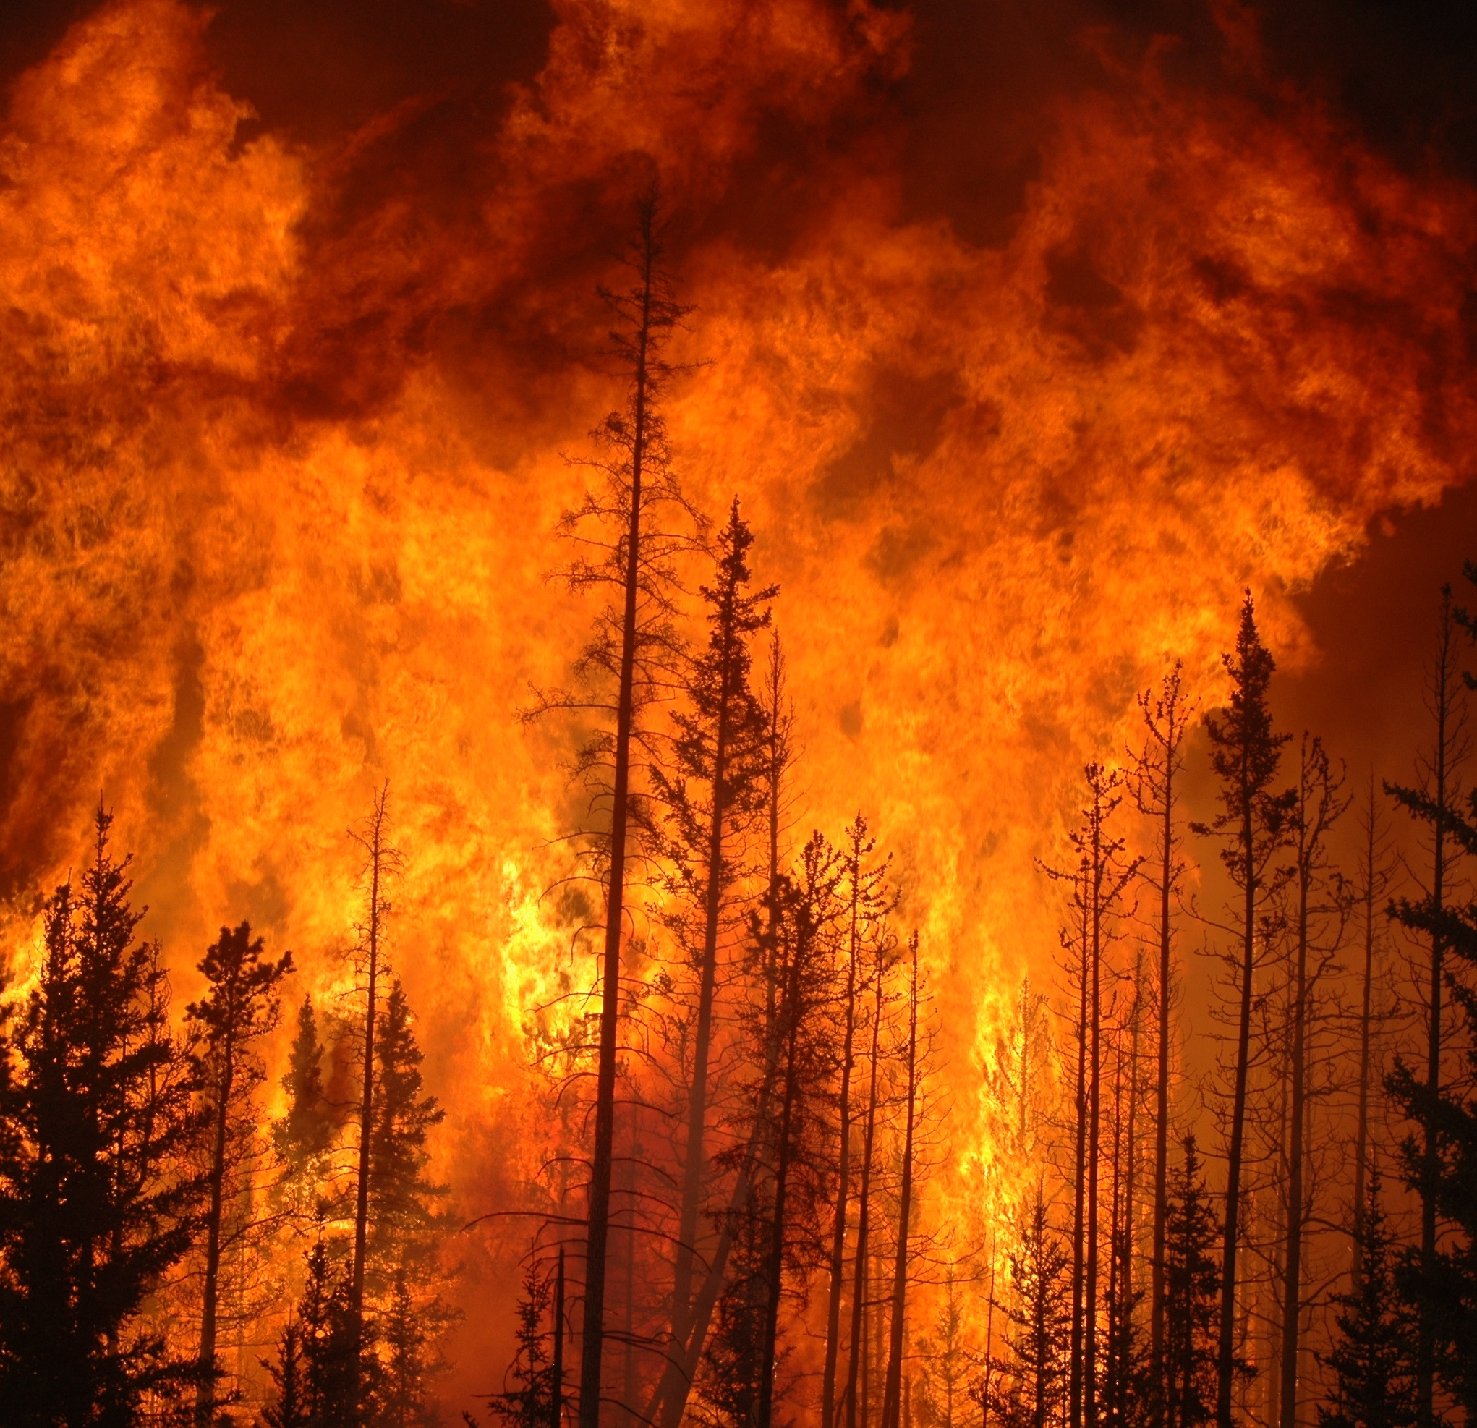
Why do some fires burn very large and destructively whiles others are small and less severe?
Figure 1. (Left) A low-severity wildfire burning only the small fuels on the ground but not the trees. Bureau of Land Management photo. (Right) A high severity fire burning entire trees.
The photos above show two different types of fire behavior. On the left we have a less severe fire that is only burning small fuels on the ground but not the larger trees. This type of fire is usually very healthy. The trees here will survive and benefit from nutrients cycled by the fire. On the right is a very severe wildfire. Most of these trees will be fully burned and die. Nutrients in the soil will be burned away by very hot temperatures. We can understand why a fire might behave like the one pictured on the left or right by looking at the fire behavior triangle (Figure 2).
In the fire behavior triangle, topography includes the three-dimensional shape of an area. Is it hilly or flat? Hilly areas have more severe wildfire than flat areas. The fuel side of the triangle includes how many fuels, such as plants or trees, are present, how flammable that fuel is, and how easy it is for fire to spread from one plant to the next. Weather includes the temperature, wind, and humidity or dryness of an area. Having many dry fuels and hot windy conditions causes more severe wildfires.
Figure 2. The fire behavior triangle.
On the next pages are predictions of how Nevada’s climate and day-to-day weather will change in the future. Your job is to use these predictions and the fire behavior triangle to build a future forecast of wildfire in Nevada.

Remember, weather refers to short term conditions, such as today or tomorrow, and climate is the average weather over a long period of time, such as a month or season.

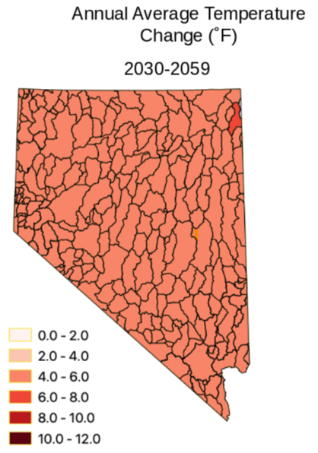
Climate Predictions

These maps are taken from the Nevada Climate Initiative Climate Strategy report and show a prediction of likely conditions in 2030-2059. Each map shows a change compared to past conditions from 1970-2000.
Look through these five figures, pick three, and describe how you think these changes will affect wildfire in the worksheet provided.
Figure 3 shows the likely increase in temperature between 1970-2000 and 2030-2059. Most places in Nevada will be an average of 4.0 F to 6.0 F warmer. Warmer temperatures will likely mean a longer growing season for plants, but those plants will need more water to grow. Plants and fuels are also more likely to be dry and easier to ignite.

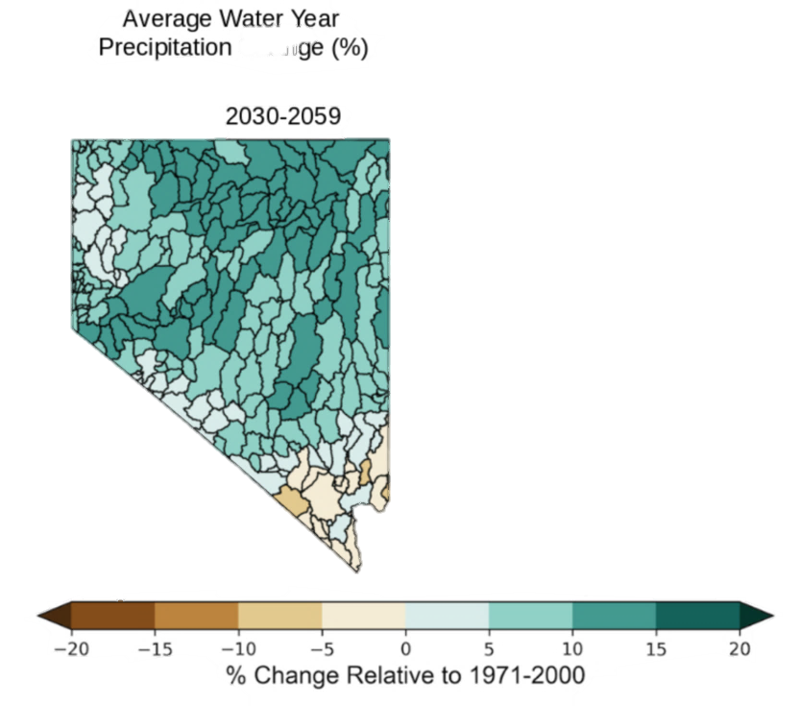
Figure 3. The predicted increase in temperature in Nevada from 1970-2000 to 2030-2059.

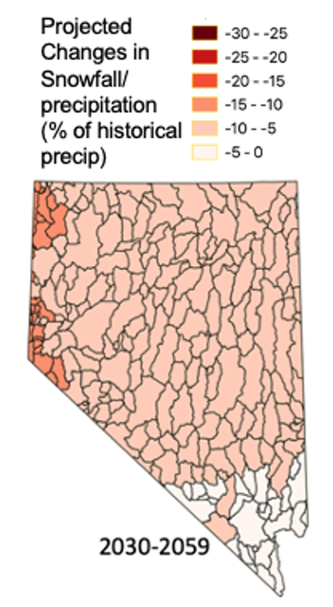
Figure 4 shows the likely change in annual precipitation in Nevada. Annual precipitation is all the rain and snow that falls in a year. Blue colors show an increase in annual precipitation, and brown colors show a decrease. One of the main reasons for such an increase in precipitation is the expected increase in temperature. Warmer air holds more moisture than cold air, which is why we get summer thunderstorms in Nevada. In warmer conditions, air moving across the Pacific Ocean will hold more water and have more moisture to rain or snow in Nevada. Much of this precipitation falls each year as snow, which melts to water later in the year.
Preciptiation either falls as rain or snow. Figure 5 (right) shows the predicted change in the amount of snow falling compared to the total amount of precipitation in Nevada in 2030-2059 compared to what was recorded in 1970-2000. Most of the state is likely to have 5 to 10% more of the preciptaiton falling as rain than snow. The western edge of the state will likely see 10-15% of their snow fall as rain. The darker areas are also some of the places that receive the most snow. A decrease in snow means that a higher percentage of annual precipitation will fall as rain. Most of the precipitation Nevada receives happens between October and May each year.
Vocabulary: Annual Precipitation
The total amount of water or precipitation an area receives in a year either as rain or snow. Nevada is the driest state in the United States, receiving an average of 9.5 inches of annual precipitation per year.
Figure 4. Percent change in annual precipitation in Nevada from 1970-2000 to 2030-2059.

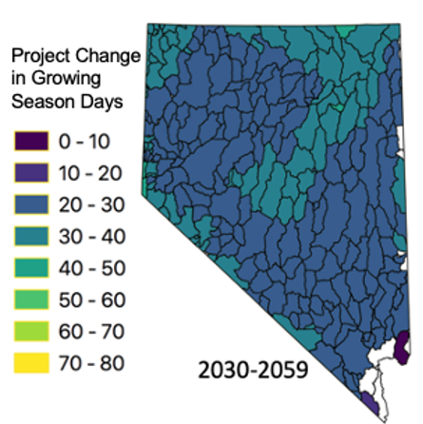

Figure 5. Change in amount of snowfall in Nevada from 1970-2000.

Figure 6. Change in growing season days in Nevada from 1970-2000 to 2030-2059.

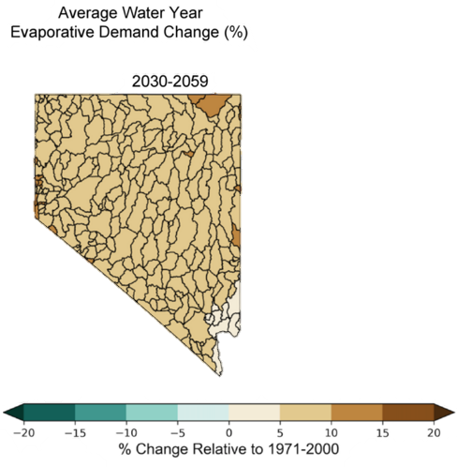
Figure 6 (left) shows the change in days of the growing season in 2030-2059 compared to in 1970-2000. The growing season is defined as the number of days between when days become consistently warmer than 50 F in the spring and when high temperatures during the day become consistently lower than 50 F in the fall. Most of Nevada will see an increase in the growing season of 20-40 days.
Figure 7 shows the change in evaporative demand. Evaporative demand means how quickly air can dry out soils, living and dead vegetation, and evaporate open water. Evaporative demand goes up during hot and windy conditions. It is important to consider both annual precipitation and evaporative demand when thinking about the water available for plants to grow in Nevada. More precipitation can be erased by higher evaporative demand. Alternatively, a year with less precipitation could still provide more water for plants if the evaporative demand is very low. When plants do not have enough water to meet the evaporative demand of their environment, they can be damaged, stop growing, or dry up and die.
Scientist Spotlight:

Stephanie McAfee Ph.D. — Nevada State Climatologist
How do you make a or prediction of what future climates for Nevada?
It is complicated. We start with estimates of what greenhouse emissions will be in the future. Will they be high, low or somewhere in between? Then, one of those estimates is used in a really, really (really!) complicated computer model that scientists have been working on for decades. These models are so complicated that they can't be run on the kind of computer you might use for work or school. Instead, they are run on supercomputers that are up to 150,000 times faster than a normal laptop.

Scientist Spotlight: - Continued.
Stephanie McAfee Ph.D.
How did you become interested in studying climate change?
In college and then for my master’s degree, I studied soil science. A lot of my work focused on how things like nitrogen and heavy metals were stored in the soil and could be used by trees. Climate is a really important aspect of that. Winds and storms move pollution around in the atmosphere. When it rains a lot, chemicals like nitrogen can get rinsed out of the soil. After working for a while, I decided that I wanted to get a Ph.D. to understand how changes in the storm track influence ecosystems in the western U.S. To do that, I had to learn a lot more about the physics of the atmosphere and how to write computer code.
Figure 7. Average change in water year evaporative demand from 1970-2000 to 2030-2059.
What are some of the main challenges of making climate projections in Nevada?
The biggest challenge in Nevada is that we have lots of little mountain ranges, and they're really important. That's where snow falls and gets stored in the winter, and the higher parts of mountains have different kinds of ecosystems. Because climate models are so complicated, they have to zoom out and make a single projection for a square of land that is roughly 60 by 60 miles large. This means that Nevada is covered by only about 16 of those squares, and the mountain ranges don't show up. So, if we have questions about what might happen to those mountain ecosystems, we need to come up with a way to combine the climate projections with the information we already have about what climate is like in the mountains. There are ways to do that, but it's another step of writing computer programs to handle lots of data.
What is one of the hardest parts of your job?
The hardest part of my job right now is that it's so many different jobs. I might spend part of my day teaching college students about climate (some of you might be in one my classes in just a few years) and then have to switch to doing research on how high temperatures make drought worse. Then the next day, I might need to talk to a state agency about how to use climate projection data to study wildlife or how dangerous a heat wave might be in Las Vegas, and then prepare a briefing for farmers about the current drought.
What is your favorite part of your job?
My favorite part of the job is helping people. We know that climate is changing. Even if we do reduce greenhouse gas emissions, we know that the climate will be different than it is now. If we start planning now, the future can be better, even if there are some new challenges.

