Life Cycle

Shrubs - Sagebrush

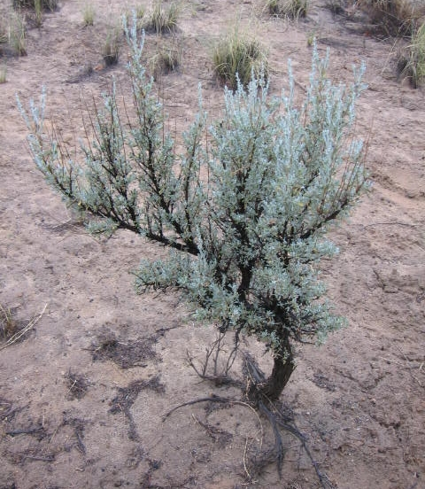
Sagebrush is a type of shrub found in most of Nevada and can live for over 100 years. Every fall from October to December, sagebrush produce seeds that normally spread up to 10 feet from the plant. If there is enough rain the following spring, those seeds will start to grow and form a new sagebrush plant. In some parts of Nevada, there is only enough springtime rain for sagebrush seeds to sprout once every five or more years. Like bunchgrasses, sagebrush grows very deep roots that allow them to get to water and nutrients. It takes two to three years for a sagebrush plant to be able to first produce seeds. Sagebrush grow slowly. It can take 25 to 75+ years for sagebrush to fully regrow after a wildfire.

Herbivory – Being Eaten

Sagebrush do not taste as good as perennial grasses to most animals. Sheep and pronghorn antelope will eat sagebrush, especially during the winter when other plants are not available. Cows have trouble digesting sagebrush.
Figure 1. A sagebrush plant.

Fire
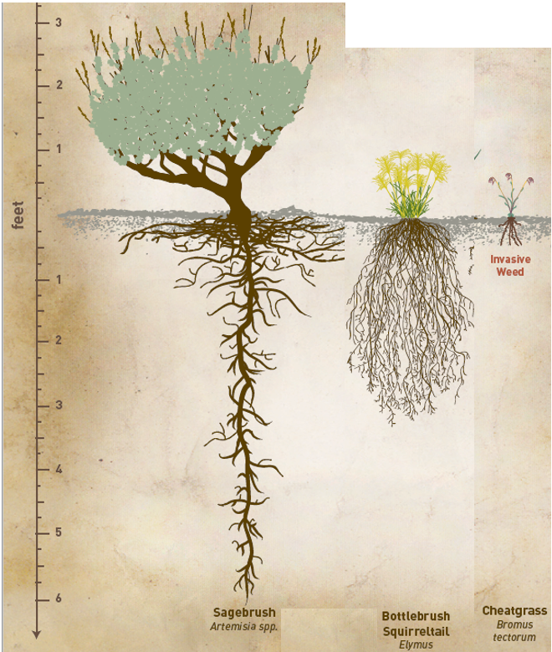
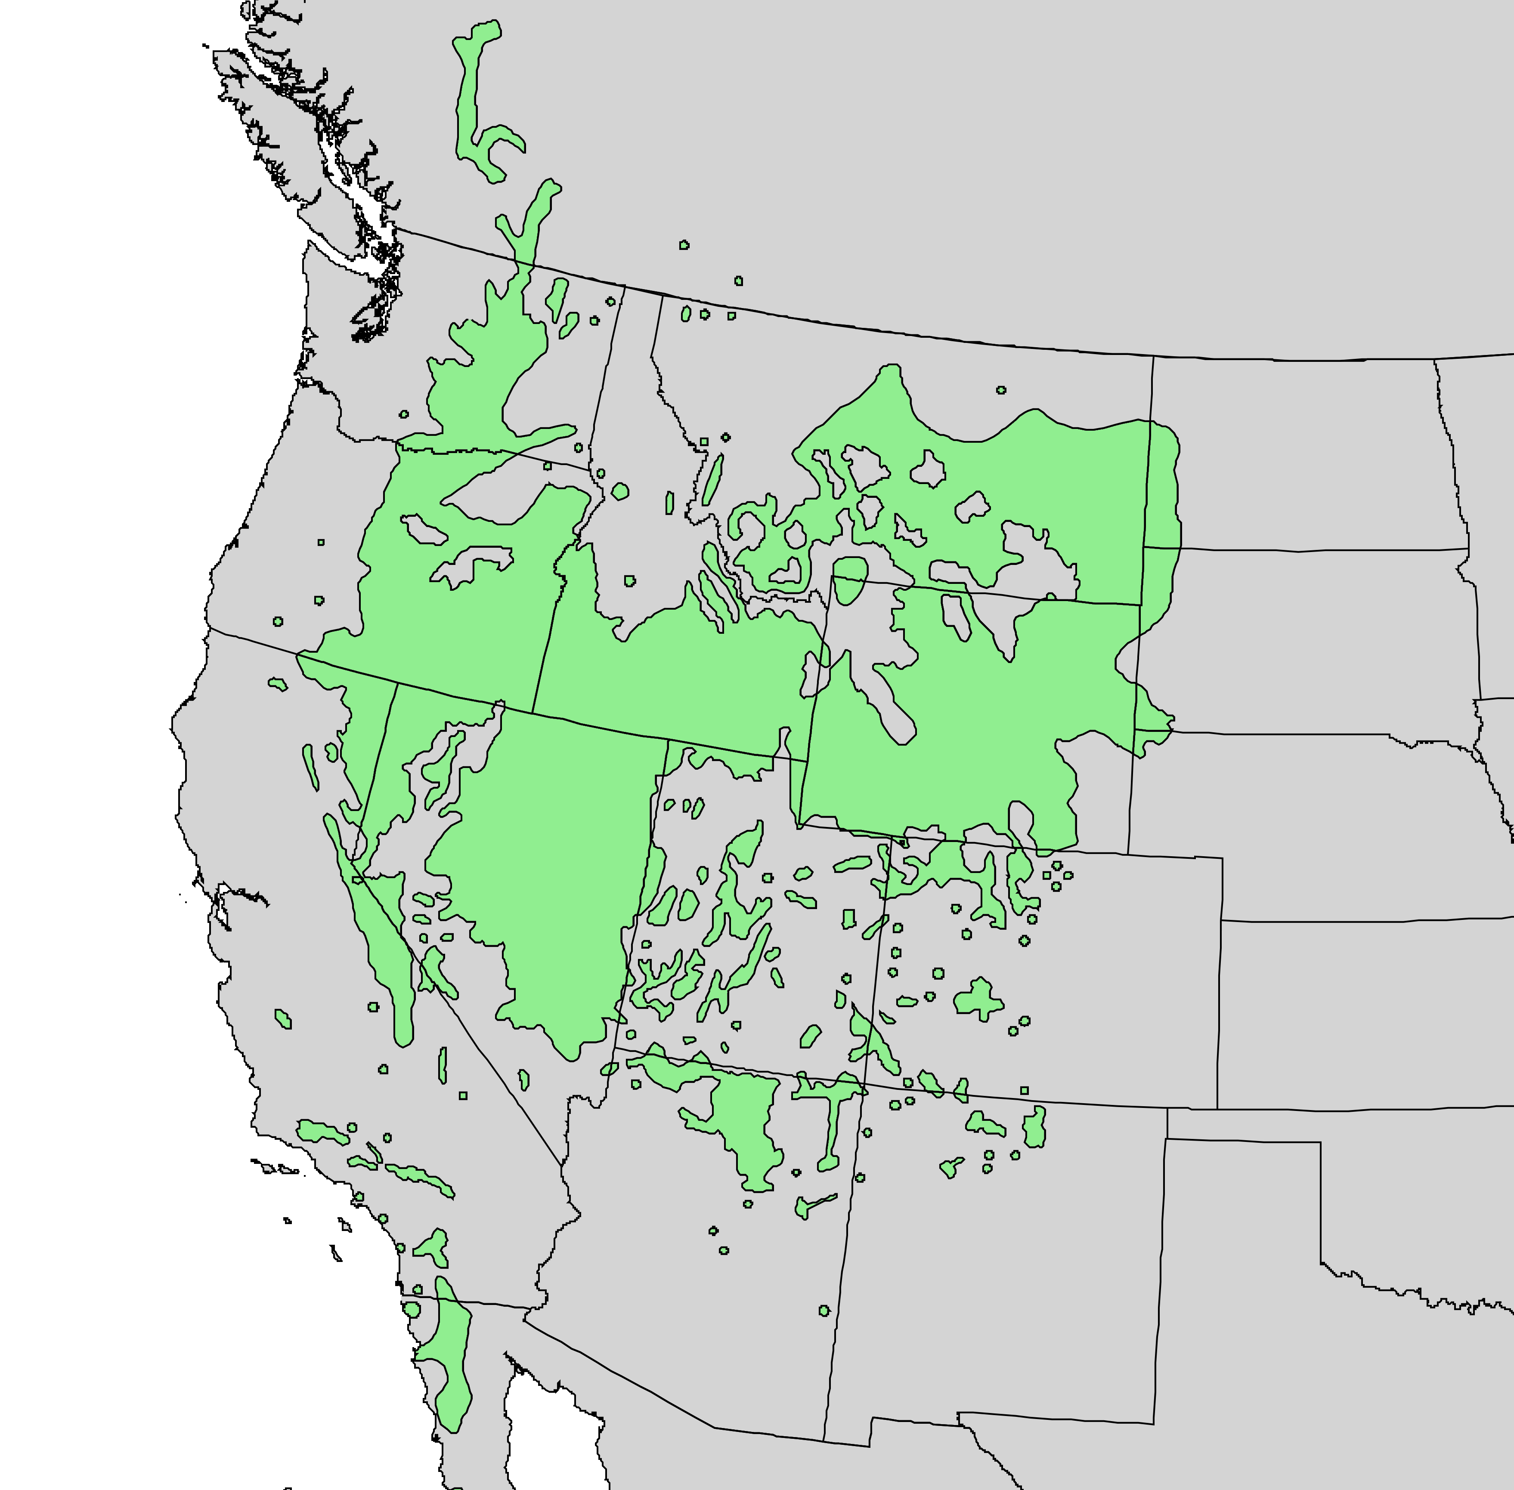
Many of the oils and natural chemicals that give sagebrush its unique smell also make it very flammable. While it does not catch on fire as easily as cheatgrass, when sagebrush does catch on fire it burns very hot, usually killing the plant. Since wildfire typically happens before sagebrush seeds are released, sagebrush must regrow from the seeds already in the soil from the year before and only if those seeds are not killed by a very hot wildfire.
Figure 3. Root size of Nevada plants.
Figure 2. Map of sagebrush ecosystems.

