Lesson 2: Biodiversity
What Does Wildfire Resilience Look Like?

What Is Percent Cover?
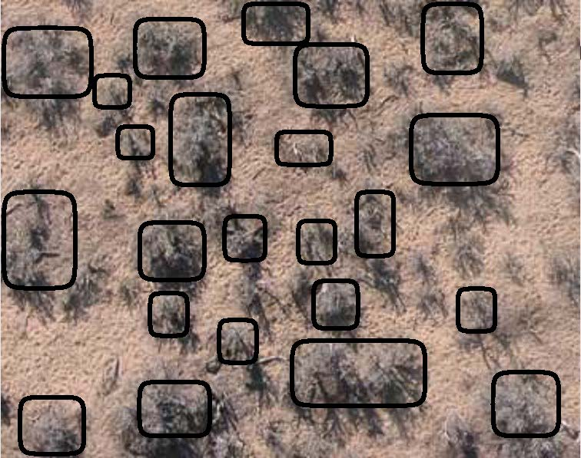
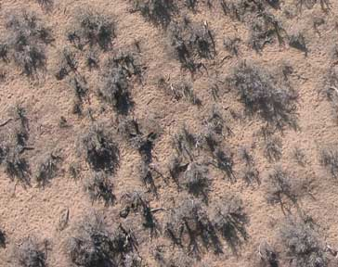
Many of today’s graphs have a Y axis of percent cover. This means the percent of the ground is covered in a type of plant if you were looking down on an area from a tall building or outer space. This data is collected from a set of satellites orbiting earth. The example on the below shows the shrubs outlined in black with 33% cover of shrubs.
Figure 1. A satellite image showing shrubs (left) with the area of shrubs outlined in black (right).

Using the Graph Decoder
During today’s lesson you will look at several different graphs. You can use the graph decoder handout to help you understand what each graph means and the patterns it shows.
1. What clues do the title, legend or caption give us about this graph?
2. What are the units for each axis? Use the space for horizontal if your graph has one axis or type of unit.
Horizontal X axis units: |  | Vertical Y axis units:
3. What type of graph is this? Circle your answer below.
Line graph or scatter plot (Answer these questions ↓) |  | Bar graph or pie chart (Answer these questions ↓)
4. Find a part of the graph where a line or group of points is either mostly increasing or decreasing. Then draw a straight line that follows the main pattern there. |  | 4. Circle the bars or categories that have the highest values. Then circle the lowest values.
5. Describe the relationship between the values of the horizontal and vertical axis in your line from step 4.  As the horizontal axis increases, does the vertical axis increase, decrease or stay the same? Ignore any small ups and downs. | (Answer # 5 here) |  | 5. Describe any similarities among categories or bars have higher values.  Are there any differences among those and the ones that have lower values?
6. Brainstorm one way the results of this graph could impact something else in the real world.

Time Series 1
Year | Trees
1985 | 6.2
1986 | 8.8
1987 | 9.8
1988 | 9.5
1989 | 9.5
1990 | 9.3
1991 | 8.6
1992 | 7.9
1993 | 8.0
1994 | 8.7
1995 | 9.7
1996 | 10.8
1997 | 11.3
1998 | 10.6
1999 | 9.6
2000 | 9.7
2001 | 10.0
2002 | 10.3
2003 | 10.9
2004 | 11.0
2005 | 10.5
2006 | 9.9
2007 | 10.5
2008 | 11.6
2009 | 11.6
2010 | 11.2
2011 | 11.0
2012 | 12.3
2013 | 13.9
2014 | 15.7
2015 | 17.2
2016 | 16.8
2017 | 16.3
2018 | 15.7
2019 | 15.7
Figure 6. (time series 1).
This graph shows the change in the cover of trees in an area near Battle Mountain, Nevada from 1985 to 2020. The values from this graph are show in the table to the right. Data from the Rangland Analysis Platform (https://rangelands.app/).

Time Series 2

Figure 7. (time series 2).
Here is a time series from an area just south of Battle Mountain. This area has not had a wildfire since measurements started in 1985. Cheatgrass populations are shown with the annual grass category (in green). The shrub category (red) is mostly sagebrush. Data from the Rangland Analysis Platform https://rangelands.app/.

Time Series 3

Figure 8. (time series 3).
This time series is from a very similar slope a mile away from the first time series near Battle Mountain. However, this area burned during a wildfire in 2000. Data from the Rangland Analysis Platform https://rangelands.app/.

Time Series 4

Figure 9. (time series 4).
This time series is from one of the areas that has burned the most in Nevada over the past 35 years, located north of Interstate 80 between Winnemucca and Elko. Data from the Rangland Analysis Platform https://rangelands.app/.

Biodiversity
What kind of wildfire would increase biodiversity? Wildfire can come in many different types, from high and low severity, to frequent or not frequent, in different sizes, and at different times of the year. Use what you know about wildfire to write a description of how wildfire might be able to increase biodiversity. Areas with high plant biodiversity have:
- Many different types of plants
- Plants of the same type but of many different ages
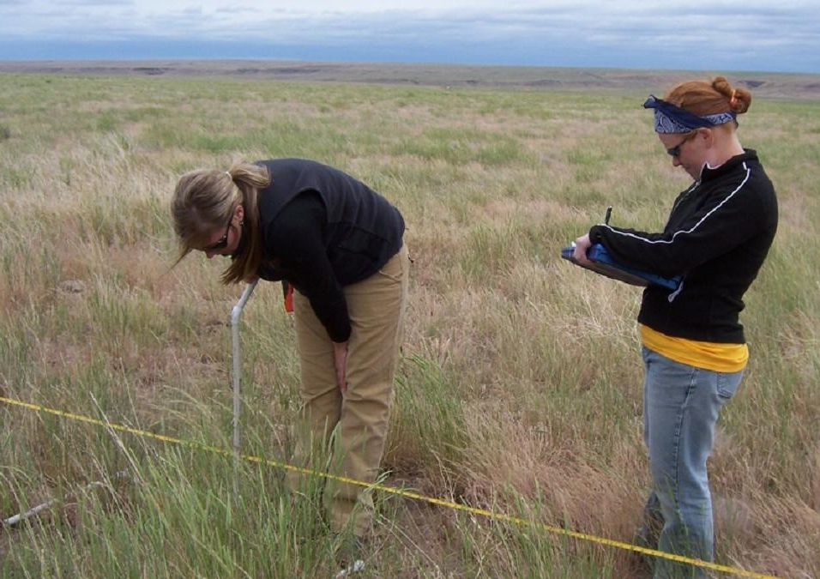
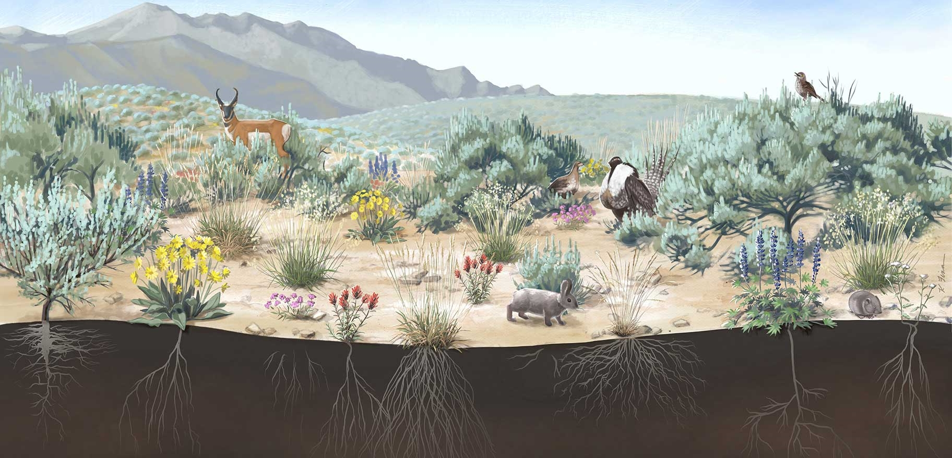
- Patchy or “heterogenous” distribution of plants
Figure 2. A diagram of a highly biodiverse sagebrush shrubland in Nevada.

Career Spotlight – Rangeland Scientist

Overview
Scientists studying Nevada rangelands are often trying to understand what plant populations exist in an area, how an area could be made more healthy or resilient, and how different human actions in an area might impact the populations living there.

Job duties
A rangeland scientist might try to do many different things, from increasing biodiversity and wildfire resilience to restoring a degraded ecosystem or making an area more suitable for grazing by livestock. How to get rid of the invasive species cheatgrass is a large problem many rangeland scientists are actively trying to solve. These scientists regularly use data such as the graphs shown above to analyze the ecosystems they are working in. This data can come from satellites or field data.

Getting started and career opportunities
To become a rangeland scientist, you need a bachelor's degree in the sciences and some work experience in rangeland management or a graduate degree related to that field. Rangeland scientists earn an average salary of $76,000 and can work at many different places, such as the United States Forest Service, Bureau of Land Management, Nevada state government agencies, private or nonprofit organizations, or universities such as the University of Nevada, Reno.

Common Types of Plants in Nevada
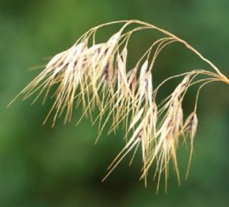  Figure 2.Cheatgrass. | 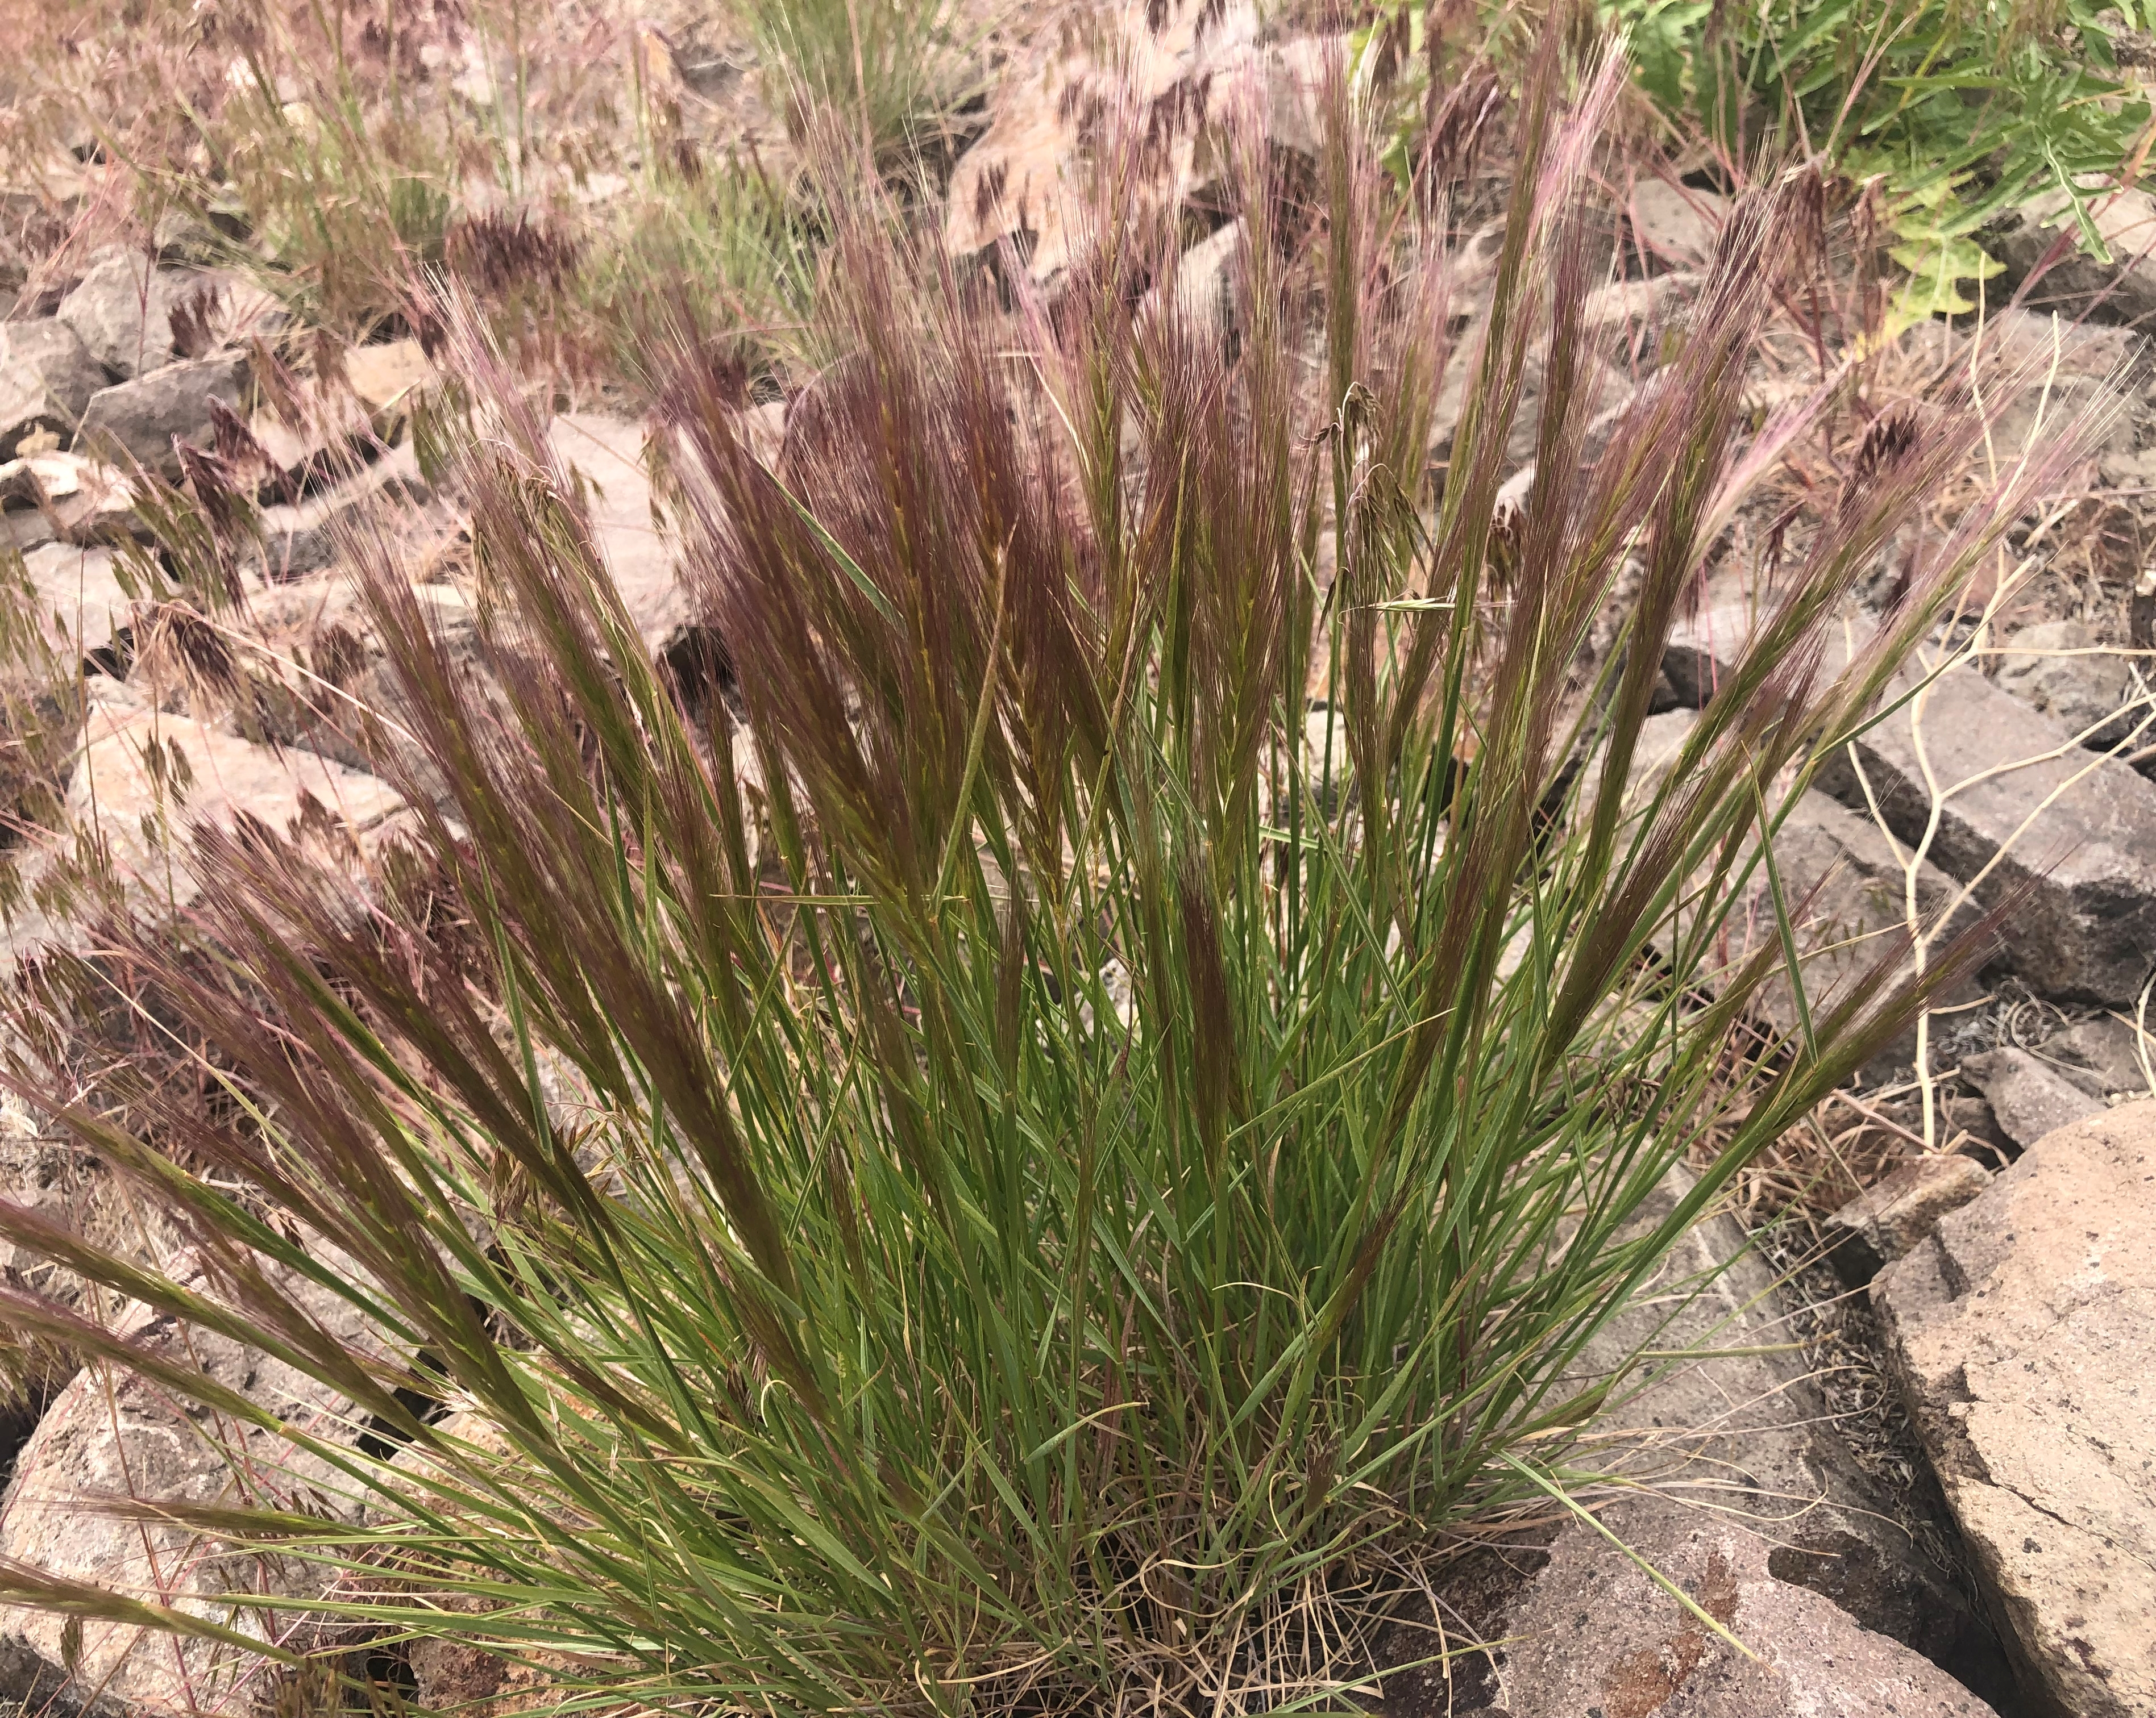  Figure 3. Bottlebrush squirreltail grass.
Annual grass: Much of this is cheatgrass but also includes some other invasive annual grasses. Annual grasses grow entirely from seed each year. They often grow during the early spring before drying out and dying in the beginning of the summer. Once dry, they are not suitable for animals to eat. Cheatgrass can decrease biodiversity by growing back quickly after a disturbance such as wildfire before other plants are able to regrow. | Perennial grass: Most of Nevada’s native grasses are perennial grasses. These tend to grow in bunches and grow from the same roots from one year to the next. Consequently, perennial grasses have much larger root systems than annual grasses. These grasses stay greener longer and provide better food for grazing animals. Bottlebrush squirreltail is a perennial grass. The stalks are purple during the spring and light brown after they dry later in the summer.
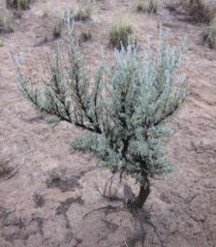  Figure 4. A smaller sagebrush shrub. | 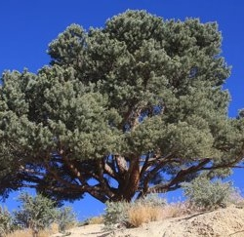  Figure 5. A pinyon pine tree.
Shrubs: This group is mostly composed of different types of sagebrush. Sagebrush is one of the most recognizable and common plants in Nevada, and it grows very slowly. Shrublands mixed with sagebrush and perennial grasses are one of the more biodiverse ecosystems in Nevada. While sagebrush tends to be too bitter for many animals to eat, several other types of native shrubs are commonly eaten. | Trees: Some of the most common trees in Nevada are pinyon pines and junipers. These trees grow even more slowly than sagebrush. Pine nuts from pinyon pines are an important ecological food source for some animals such as squirrels and birds as well a native tribes including the Washoe, Paiute and Shoshone peoples. Pinyon pines have needles that come off the branch in pairs or as a single needle.

