Common Nevada Plants Field Guide
Is a plant an annual, perennial, or shrub? Use this key to find out.
1. How many stalks or stems does the plant have?
1.a. One or two stalks or stems = Annual
1.b. Many stalks or stems = Go to 3
1.c. Unsure = Go to 2
2. Can you pull the plant out of the ground?
2.a. Can easily be pulled out of the ground with one small main root = Annual
2.c. Can’t be pulled out of the ground or has many roots = Go to 3
3. Are the stems woody?
3.a. Has woody stems near the base of the plant = Shrub
3.b. Stems near the base of the plant are not woody = Perennial

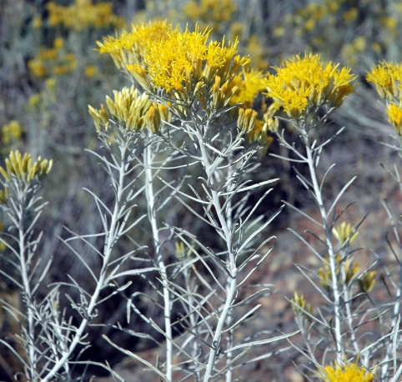
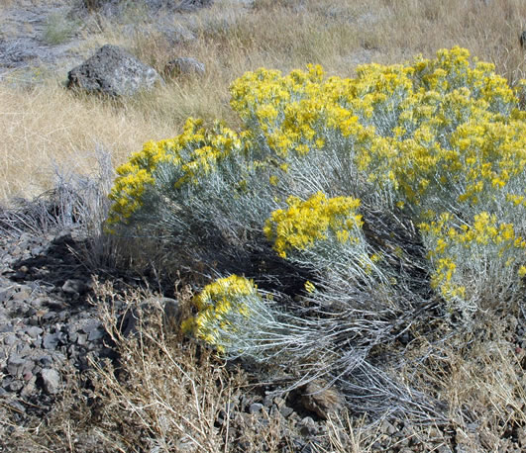
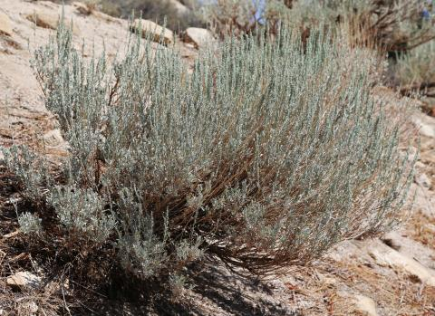
Shrubs

Rabbit brush: Shrubs are rounded and generally 2 to 5 feet tall. Yellow flower heads bloom from August to October.

Sagebrush: A coarse, many-branched, pale-grey shrub with yellow flowers and silvery-grey foliage, which is generally 1 to 3 feet tall. Leaves smell strongly of sage when you rub them together.

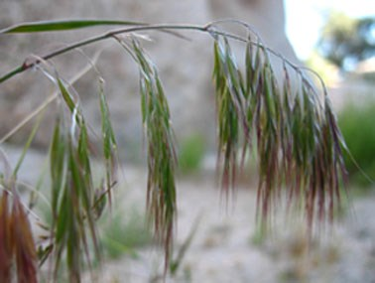
Annuals
Cheatgrass: Also called Downy brome. The stems are smooth and slender. The leaves are hairy. It typically reaches 16 to 35 inches tall. Flowers that hold seeds are arranged on a drooping bunches with approximately 30 spikelets.
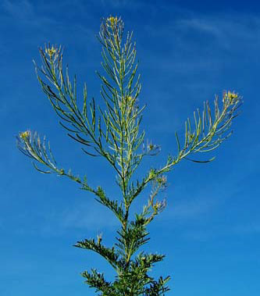
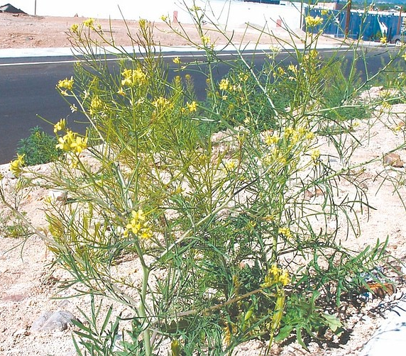
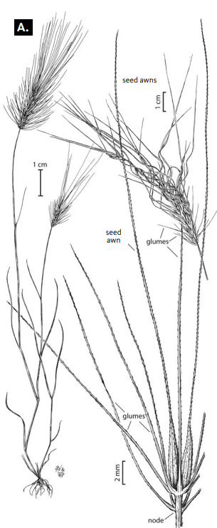
Flixweed (left) and tumble mustard (right): These two plants have small yellow flowers and grow up to 2 or more feet tall. Both will bloom early in the spring. Their leaves are lower on the plant with taller stems up to the flowers. Stems are upright and branched. Flowers tend to be small.

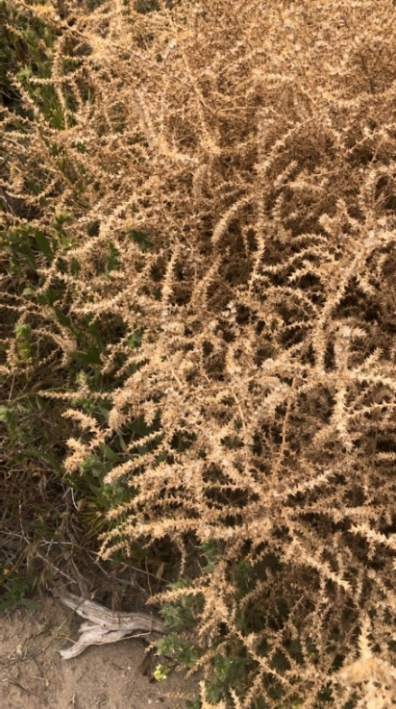
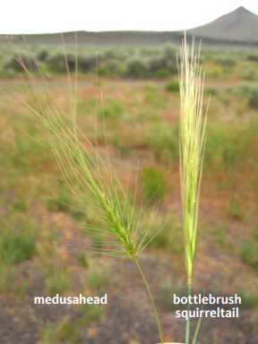
Medusahead: An annual grass with a single stalk and bushy tip. It is easy to pull Medusahead’s roots out of the ground. The tip of this grass looks similar to bottlebrush squirreltail. Bottlebrush squirreltail has deep roots that would be difficult to pull up. Medusahead is 6 to 24 inches tall.

Russian thistle - tumbleweed: Bushy plant reaching heights of 3 feet. Lateral branches curve upward, giving the plant a spherical shape. Leaves are alternate and needle-like. Leaves on upper part of stems are stiff and prickly.
Perennials
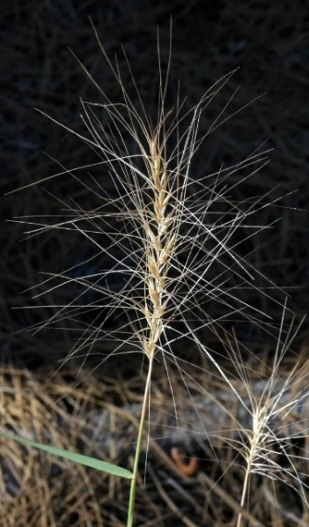
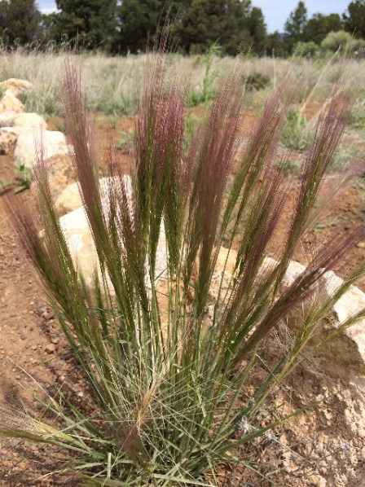
Many of the perennials grow in bunches with many stems coming out of one clump. They have much larger roots than annuals.

Bottlebrush squirreltail: The dark green/red young seed heads look like a squirrel’s tail, and the lighter color ripe seed heads spread out like a bottlebrush. Bottlebrush squirreltail is 1 to 2 feet tall.

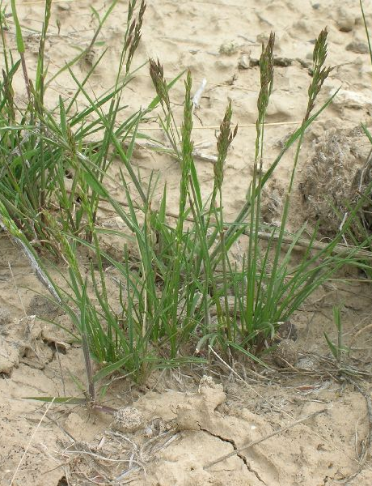

Sandberg bluegrass: This is a short bunch grass with leaves only a few inches tall. The stalk is up to 20 inches tall and this plant is one of the first perennial grasses to dry up and brown in early summer.

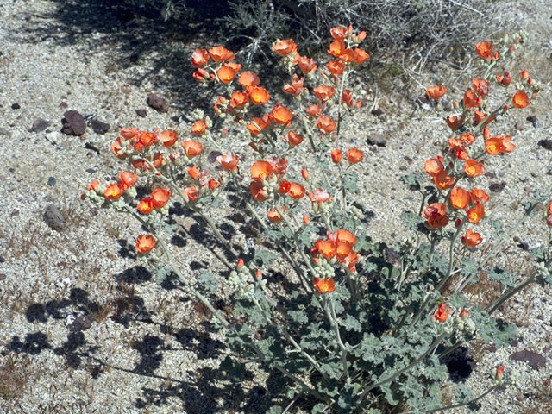
Globe mallow: 1 to 3 feet tall with distinctive orange globe-like flowers. An annual herb that often regrows quickly after a disturbance. The stems of globe mallow are somewhat flexible and not woody all the way to the ground.

