Lesson 5: Design a Land Management Plan

How Can We Prepare Emberville for Wildfire?

Background
You are a project manager for a local fire department who has been asked to improve the wildfire resilience of Emberville and the surrounding areas. Your job is to come up with a plan that improves the fire resilience of the surrounding ecosystems and reduces the threat of wildfire to homes in Emberville. You have a total budget of $30,000 to pay for the services you describe in your land management plan. While the budget may seem large, you will not have enough funds to pay for every service on every area of land. Use your knowledge of ecosystems and wildfire to purchase the services that will have the greatest impact without going over budget.

Map of Emberville
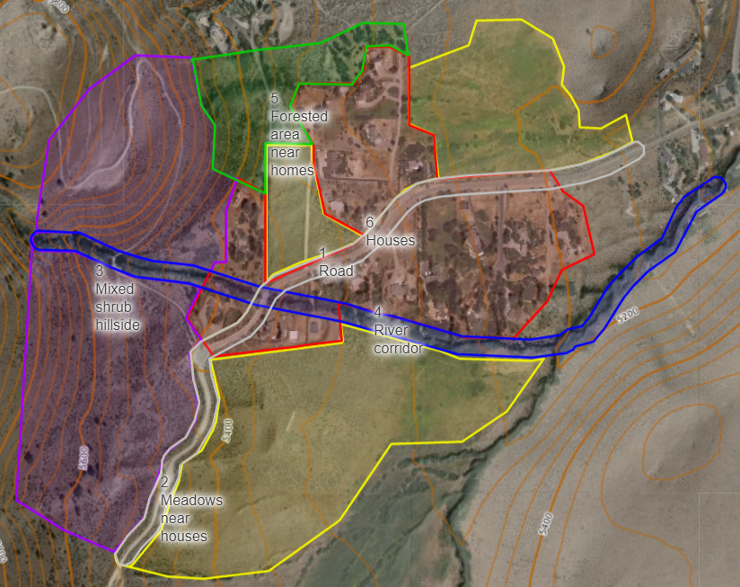
This map shows different management areas around Emberville. Houses are in red, the forested area with dead trees in green, a small stream in blue, road in grey, grassy meadow in yellow and shrub filled area in purple.
Figure 1. A digital version of this map can be found here: caltopo.com/m/1V52S.

Description of Each Area

Road - acres: 9
Description: There is a paved road running through Emberville. The sides of the road have a lot of shrubs and annual grasses. Firefighters often use roads as fire breaks to stop or slow the spread of a fire in an area. A common strategy is to remove burnable material alongside roadways to widen these existing firebreaks. Having roads clear of flammable material also allows firefighters to safely get in and out of an area.

Meadow - acres: 24
Description: There are three sections of meadow, highlighted in yellow, around Emberville. These areas are mostly flat and have large populations of both annual and perennial grasses.

Mixed shrub hillside - acres: 48
Description: The hillside above Emberville is filled with shrubs and annual grasses. Like much of Nevada, the wind in Emberville often comes from the West, which would blow fires on this hillside or the forested area toward the homes.

River - acres: 10
Description: A small river runs near Emberville and has a healthy mix of perennial grasses, shrubs, and trees. The water in the river helps the plants living here stay greener longer in the dry summers. The banks around the river are steep. A common practice among native tribes such as the Washoe, Paiute, or Shoshone in Nevada is to burn areas near waterways that have willows. After a wildfire, willows grow back quickly and with straighter branches that are useful for basket making and other uses.

Forested area - acres: 10
Description: The forested area has many trees just to the Northwest of Emberville next to a few homes. This area has not had a wildfire in many years and has some hilly areas.

Houses - acres: 6
Description: The areas around homes in Emberville have fewer plants than other areas. There are some places where there are shrubs or trees near homes that could help fire spread to buildings.

What Plant Populations Are in Each Area?
Type of plant | Road | Meadow | Mixed shrub | River | Forested area | Houses | Type of plant
Annuals | 26% | 33% | 24% | 6% | 9% | 7% | Annuals
Perennials | 14% | 31% | 12% | 19% | 11% | 6% | Perennials
Shrubs | 22% | 12% | 22% | 9% | 12% | 10% | Shrubs
Trees | 5% | 4% | 5% | 11% | 34% | 7% | Trees
Bare ground | 11% | 4% | 12% | 5% | 3% | 19% | Bare ground
# of Acres | 9 | 24 | 48 | 10 | 10 | 6 | # of Acres

Services
There are five types of services you can pay for to improve the fire resilience of Emberville. Each service has a different cost and impacts. Use the descriptions below and your knowledge of wildfire to make your decisions.

Chainsaw crew - cost per acre: $100
Description: A crew of people will cut down some of the trees and shrubs in an area. These crews can remove trees and shrubs on steeper hills or near buildings where larger machines cannot go.

Mowing and mastication - cost per acre: $275
Description: Mowing is like a large lawnmower behind a tractor. Masticators are an attachment on the front of heavy machinery that can grind trees and shrubs into small chips. Mastication is usually only done in areas with many trees or shrubs. Mowing is best for shrubs and grasses and cannot remove trees. These large machines are faster on flat ground but cannot go on steeper slopes. Mowing and mastication usually cut everything in the machine’s path, leaving an empty path behind that can easily be invaded by cheatgrass if nothing else is done.

Herbicide and grazing for cheatgrass - cost per acre: $35
Description: We can remove the invasive species with herbicide, a chemical that poisons a specific type of plant, or have animals eat that type of plant. Both of these need to be done at specific times of the year to be effective. Grazing to reduce cheatgrass only works during the winter/early spring when the cheatgrass is green and edible to animals. The herbicides for cheatgrass need to be applied to an area in the fall before the cheatgrass seeds sprout. Part of the cost of grazing includes setting up fences to keep animals in the correct area. Herbicide and grazing cannot be used in the river, as they could pollute the stream.

Planting competing plants - cost per acre: $250
Description: Another option is to plant plants, mostly perennial grasses, that can compete with cheatgrass. This can be done by hand or by plane. It often takes 20% or more cover of perennial grasses to compete with cheatgrass. If there are very few sagebrush or trees in an area where those populations should be hire sometimes seedlings of those plants are planted by hand.

Prescribed fire - cost per acre: $175
Description: Prescribed fire is the oldest service here. For thousands of years, Native tribes in Nevada, including the Washoe, Paiute, and Shoshone have been intentionally starting small fires in specific areas that can help remove dead or overcrowded plants and encourage the growth of plants that are helpful or culturally significant. Prescribed fire is very effective at reducing the amount of fuel in an area making it better prepared for a future wildfire. In order to conduct prescribed fire safely, the fire needs to be done in the right weather conditions (e.g. cool and not windy days). Sometimes it is also necessary to do some chainsaw thinning or mastication before doing a prescribed fire, so that the prescribe fire burns the intended plants, not too many or too few.

Cost of Services in Each Area
This table takes the cost per acre of each treatment and size of each area and calculates how much it would cost to do each treatment in each area.
Treatment | Road | Meadow | Mixed shrub | River | Forested area | Houses
Chainsaw crew | $ 900 | $ 2,400 | $ 4,800 | $ 1,000 | $ 1,000 | $ 4,200
Mowing and mastication | $ 2,475 | $ 6,600 | $ 13,200 | $ 2,750 | $ 2,750 | $ 11,550
Herbicide and grazing | $ 315 | $ 840 | $ 1,680 | $ 350 | $ 350 | $ 1,470
Planting plants | $ 2,250 | $ 6,000 | $ 12,000 | $ 2,500 | $ 2,500 | $ 10,500
Prescribed fire | $ 1,575 | $ 4,200 | $ 8,400 | $ 1,750 | $ 1,750 | $ 7,350

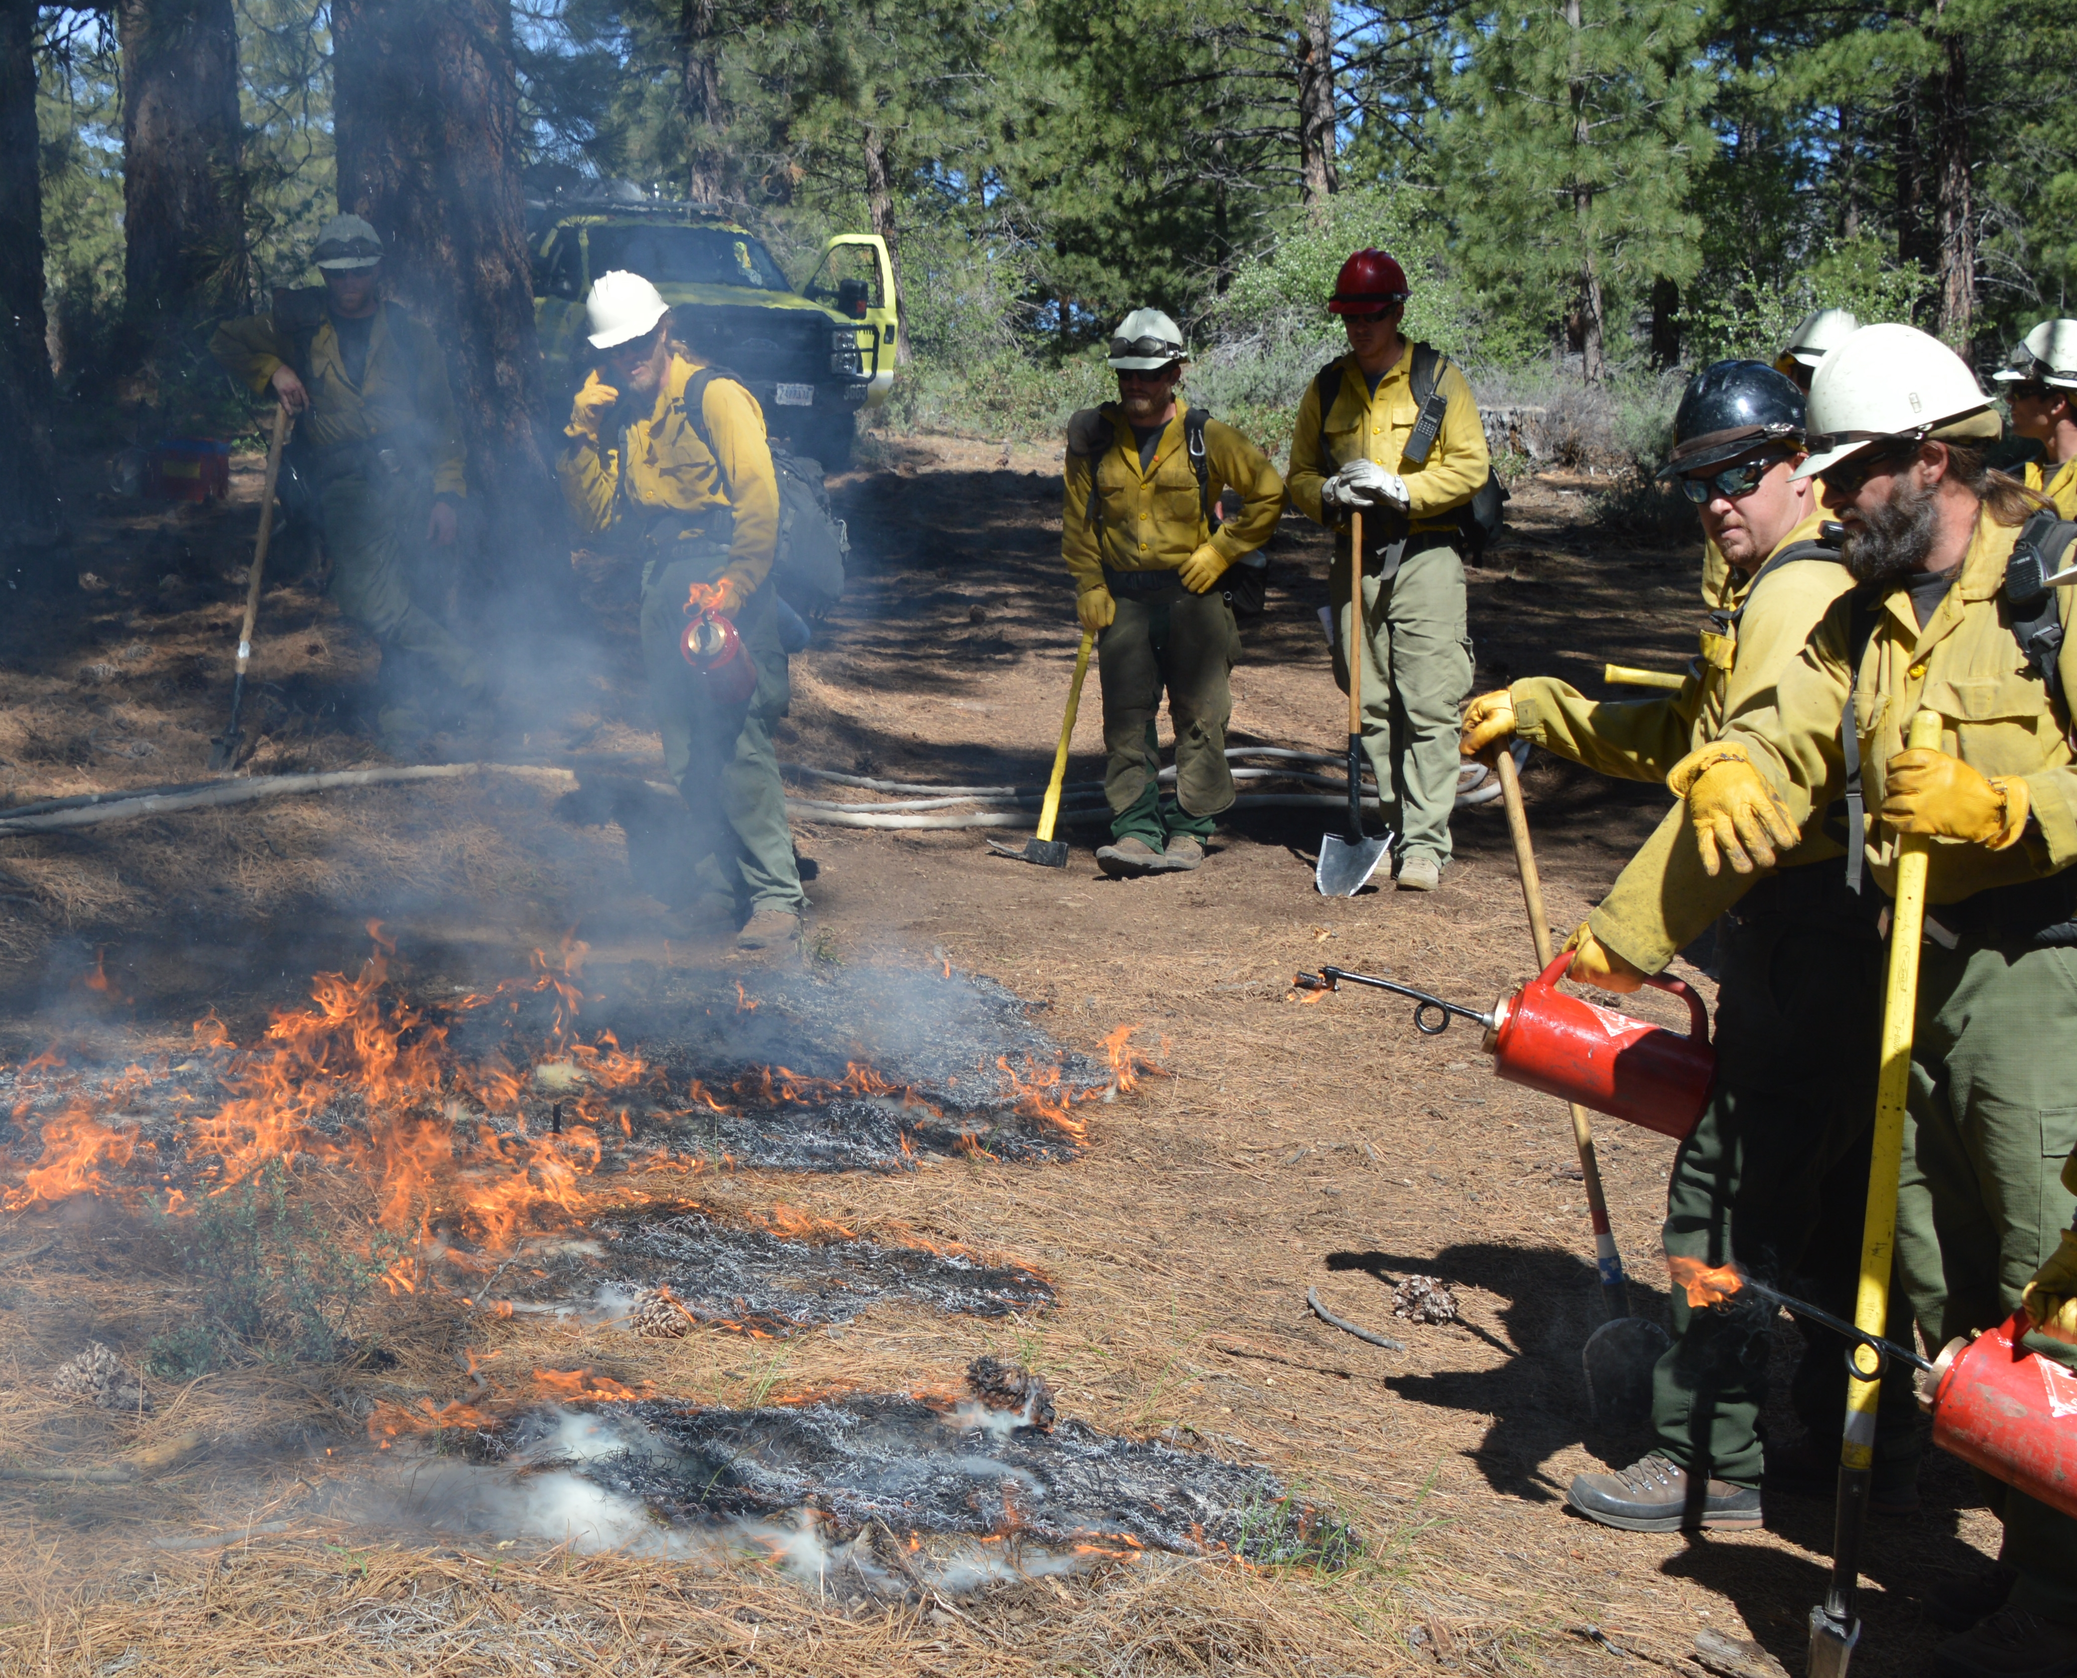
Career Spotlight - Land Manager/Fuels Specialist

Overview
There are many people whose job it is to plan for and organize the completion of land management plans, like this project, that increase the wildfire resilience of an area. While an individual household can do things to increase the wildfire resilience around their home, the most effective way to prepare homes for wildfire is to combine actions around homes with land management projects around communities such as this project around Emberville.

Job duties
Land managers and fuels specialists jobs are to lead a project such as this one from start to finish. This includes identifying areas where action needs to be taken, planning what types of services to use to meet the goal of this project, completing any required reports and assessments about potential environmental impacts, hiring contractors to complete the services, and tracking their budget and the actions taken. Many projects take multiple years to complete from the initial planning to the final tracking of what was accomplished.
Figure 2. Bureau of Land Management Firefighters Start a Prescribed Fire (B.L.M. Photo)

Getting started and career opportunities
There are several different ways to become a fuels specialist or land manager that completes these types of helpful projects. Many people start as some type of firefighter and then move to this job after several years of experience. Other people get a bachelor’s degree in natural resource management, ecology, or wildfire related field. A fuels specialist can work for a federal, state, or local fire department as well as many non-profit or consulting organizations. The pay range for these positions often ranges from $45,000 to $83,000 depending on a person’s experience and time in position.

Calculating Your Resilience Score
Once you have completed the questions on the worksheet, use the handout provided by your teacher or the spreadsheet to calculate your resilience score. The spreadsheet can also calculate your budget. For each area you want to do a treatment, put the number “1” in the corresponding yellow cell. Leave the cells for the areas and treatments you aren’t doing blank. The next table below will calculate the cost of each treatment, your total cost and resilience score. The resilience score is based on answers from several professional land managers.
Budget |  | Treatment | Road | Meadow | Mixed shrub | River | Forested area | Houses
Plot | Acres | Chainsaw crew
Road | 9 | Mowing and mastication | Enter “1” in the cells for the actions you plan to do. Your budget and resilience score will be calculated below.
Meadow | 24 | Herbicide and grazing
Mixed shrub | 48 | Planting plants
River | 10 | Prescribed fire
Forested area | 10
Houses | 42 | Treatment | Road | Meadow | Mixed shrub | River | Forested area | Houses
Treatment | Cost / Acre | Chainsaw crew | $ - | $ - | $ - | $ - | $ - | $ -
Chainsaw crew | $ 100 | Mowing and mastication | $ - | $ - | $ - | $ - | $ - | $ -
Mowing and mastication | $ 275 | Herbicide and grazing | $ - | $ - | $ - | $ - | $ - | $ -
Herbicide and grazing | $ 35 | Planting plants | $ - | $ - | $ - | $ - | $ - | $ -
Planting plants | $ 250 | Prescribed fire | $ - | $ - | $ - | $ - | $ - | $ -
Prescribed fire | $ 175 |  |  |  |  | Total cost |  | $ -
 |  |  | Resilience score |  | 0 | Total budget |  | $ 30,000

