Overview

Instructor Guide: Matchstick Model Forest
Full Class Activity
In this lesson students will investigate factors that affect fire behavior using a pegboard and matchstick model. Through iterative rounds of experiments, groups of students will develop and test hypotheses.

Safety
This lesson involves lighting matches on fire. While this is great for student engagement, there are a few safety considerations to consider. When these basic rules are followed, this activity is quite safe. However, these activities can be dangerous if rules are not followed. Please consider the maturity of your students and adjust the safety protocols as needed.
- Only have adults light the pegboards on fire. Do not give students the whole box of matches or a way to independently ignite their matches.
- Have students tie back long hair or loose clothing.
- These activities can produce a short-lived flame up to 12 inches long. Either burn the pegboards in a lab hood or outside in a place far from other flammable materials.
- For teachers or adults lighting the pegboards, a lighter with a long neck will help keep fingers away from the heat. Grill lighters work well, but a basic butane torch is the most effective.
Materials (One set per group of four)
- Wood or Masonite pegboard 1 for every 3-4 students (instructions for how to make one)
- 75 Medium/kitchen sized matches
- Aluminum baking sheet
- Plastic container ~1 quart half full of water
-Teacher materials-
- 1-2 butane torches (best) or long grill lighters (good)
- A small fan that can simulate wind

Introduction

Welcome
Today we are going to be conducting experiments about wildfire with fire. Before we get started, let’s take a moment to recognize that wildfire can be a very scary thing and many people have had their homes burned or threatened by wildfire. Please be respectful of each other’s feelings. If at any point during these activities you need a break please feel free to step outside of the classroom or go see our school counselor who is happy to support you if any challenging feelings come up.
Please take 2 minutes to discuss the following question with a partner or in your table group. “What can cause some wildfires to be small but others to be large?”
Since wildfires are dangerous, and it would not be ethical for these scientists to go around starting wildfires to study them, many of their experiments are done in more controlled lab settings. Just like these scientists, today we are going to burn things in controlled experiments to help us model what affects wildfire behavior.

Introducing the model system
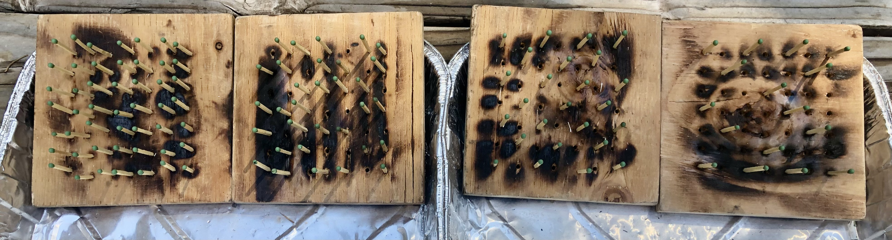
Figure 1. A series of pegboards, left to right, with 49, 32, 35 and 16 matches evenly distributed across the board. It is recommended to burn these left to right, starting with the board that has the fewest matches.
Each group will have a pegboard they can place matches on and then burn to see how fire behaves in that model. Your job is to use this model to test hypotheses about what factors affect fire behavior. Your group is in charge of positioning the pegboard with matches to test your hypothesis.
Before we get going, let’s cover a couple of safety items. My goal today is that no students are burned and we don’t set off the fire alarm. Does anyone have any suggestions of things we could do to make sure neither of those happen? Solicit student responses making sure to cover the following topics.
- Tie back long hair or loose clothing
- Don’t lean over the fire while it is burning
- Place burnt matches in the small tub of water you have
- Only adults will be lighting fires
- If you do catch on fire, use a jacket or blanket to smother the fire (point out the fire blanket if you have one)

Other rules
- Your group must create a prediction of what the fire behavior on your pegboard will be before lighting it.
- When lighting each board, the adult will light an entire row on one side (at least four matches) If there are fewer than four matches on the first row, light parts of the second row to get to at least four.
- We will be doing multiple rounds of burning, so make sure to do a different design each time.
- Tip: Use an unburned match to poke burned matches through the bottom of the pegboard.

Challenge 1
Arrange the matches on your board however you want to help you better understand fire behavior.
- Distribute matches and task groups with arranging their first pegboard. Remind students that they can reference the list of things that could affect fire size they came up with at the beginning of the lesson for ideas of what to test.
- Remind students to predict how their board will burn and identify which side will be lit.
- As students finish arranging their pegboards, have them place the board at the front of the class and arrange them in order from the least to most matches. Place similar boards together.
- Before lighting a board, have the group that arranged it briefly describe their rational for their match layout and what their expected fire behavior is.
- If you have many groups and board to burn in each round, you can burn two or three boards at a time. Choose boards that can make for good comparisons to each other.
- Partway through the first round, if no students have already tested the impact of slope angle, ask students what is a difference between this model and a real wildfire? Students may suggest different types of fuel, weather or wind, and hills. Choose two of the most similar unburned boards from the first round and conduct a side-by-side experiment, with one sloped up on the edge of the aluminum baking dish and another laying flat. If you are outdoors, it may be windy and you can adjust the orientation of the board to the wind. If inside use a fan.

Challenge 2
Pair up with another group to create a controlled experiment where you test the impact of a specific variable on wildfire behavior. Repeat as in challenge 1 of groups describing what they are testing in their board and their expected results. Pair groups of boards that are similar to each other and burn at the same time. These comparisons are best when only one variable is different between the two (e.g. same slope angle and number of matches, but with or without a fan.)
- Variables students are likely to test include:
  - Changing the density of matches (big impact)
  - Adjusting the steepness of the board slope (big impact)
  - Adding or adjusting the direction of wind (big impact)
  - Adjusting the height of the match to decrease the horizontal fuel connectivity (medium impact)
  - Dipping matchheads in water to simulate the impact of rain (little impact)
  - Lighting the top or side row instead of the bottom (big impact)
- It is best to encourage student creativity in how they arrange their pegboards rather than limit them to predetermined options.

Final Challenge
Either include this challenge on defensible space or conduct another round similar to challenge 2. Have students place one match in the center of the board, which will function as a building. Their job is to arrange other matches as trees around the building in a way that protects the building from catching on fire as a way to model defensible space around buildings. The group that can place the most matches on their board without the building catching on fire wins. Remind students that while removing all the trees around a building would decrease its likelihood of burning, trees are nice to have around and offer shade. Each board will be angled the same way with the bottom row lit. At least four matches must be ignited.
This lesson was adapted from the FireWorks Curriculum developed by the US Forest Service, Rocky Mountain Research Station. https://www.frames.gov/fireworks/home.

Student Worksheet: Matchstick Model Forest
Today we will be conducting experiments to model the factors that impact the behavior of wildfires.
Safety
- Tie back long hair and loose clothing
- Do not lean over the flames
- Only adults will light matches
In your group discuss: What do you think affects why some fires are big while others are small?
Challenge 1
Describe how you arranged your pegboard.

What do you expect to happen when it is lit?

What actually happened?

What patterns did you observe during this round of burning?
Challenge 2
What variable are you testing and how are you testing it?

Make a hypothesis of your predicted results.

How did what happened compare to your hypothesis?

What patterns did you observe during this round of burning?

Final challenge
What strategies did you use to protect the building from catching on fire?

How effective were these strategies at protecting the building? What worked as planned and what did not work?

Recap
What are the main factors that affect wildfire behavior?

How could we use this knowledge to help protect homes and buildings from wildfire?

What is one limitation of this model compared to studying wildfire in nature?

