Life Cycle

Trees – Pinyon Pine
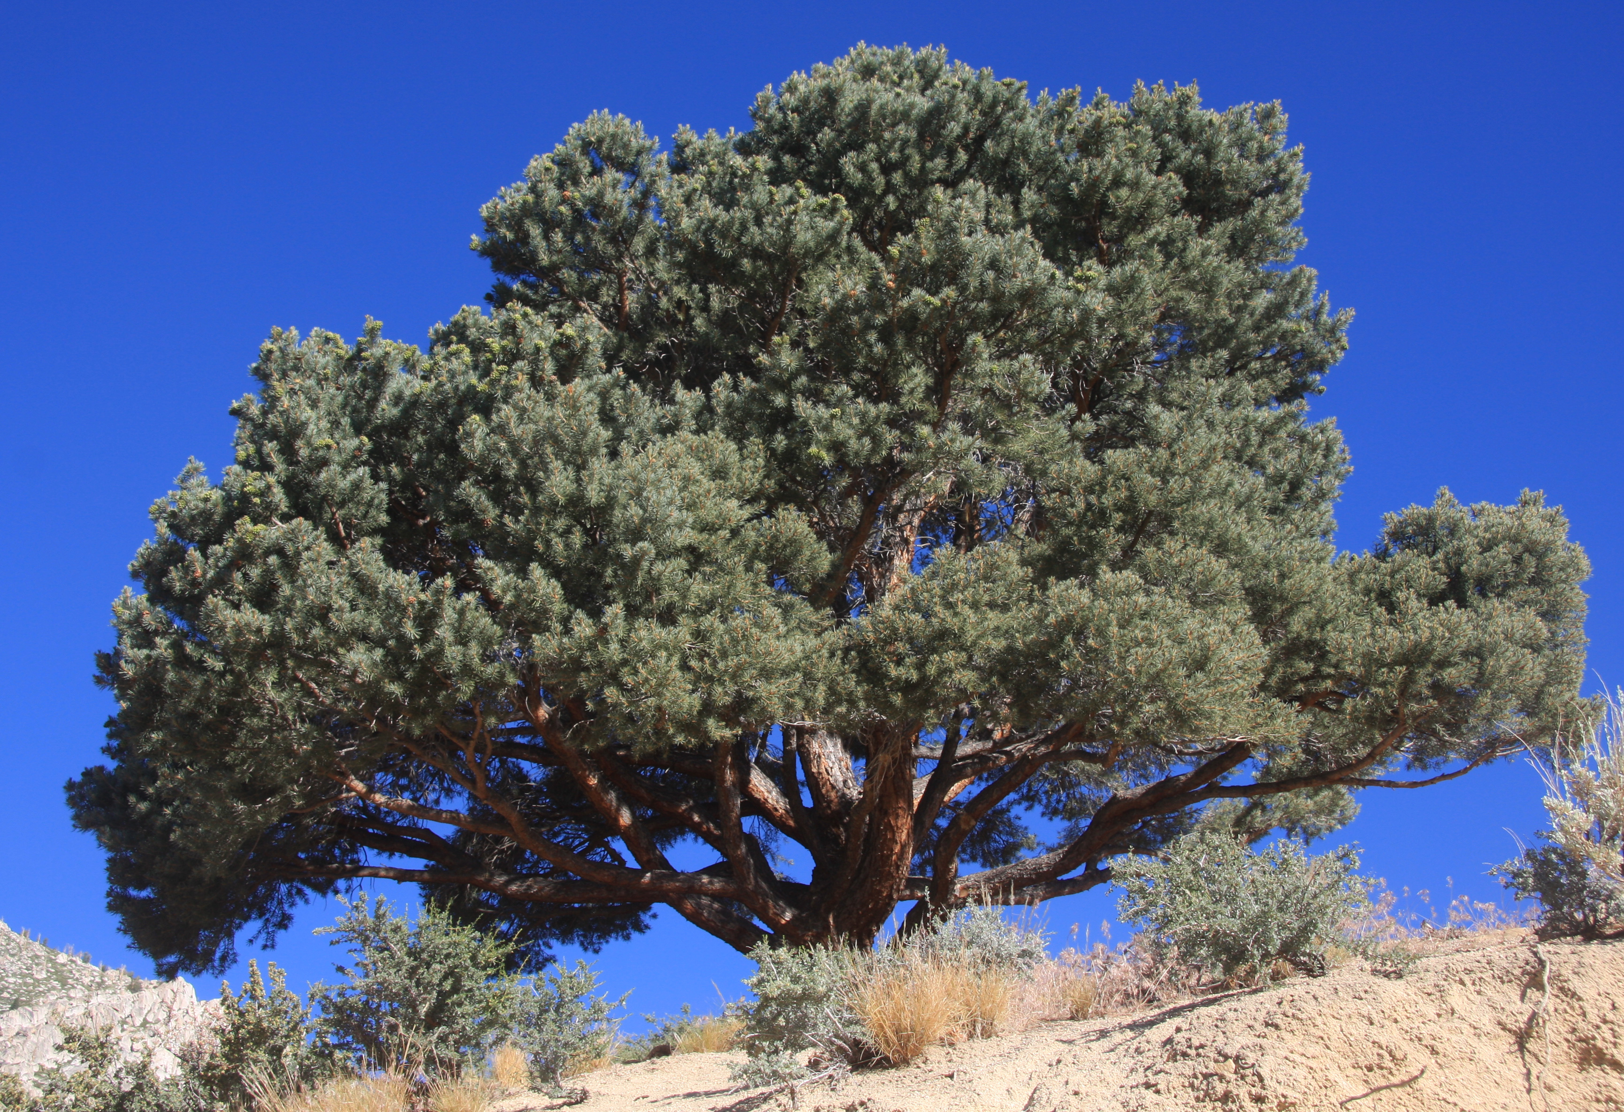
Pinyon pine trees grow very slowly. It can take up to 60 years for a tree to reach six feet tall, and they can grow for over 600 years. It takes 35 years for a pinyon pine to first make cones, and reaches maximum cone production at around 160-200 years. Each cone takes approximately three years to make. The seeds are only spread by animals, mostly birds, who store the seeds up to 13 miles away from the tree in piles to eat later. Sometimes these seed piles get forgotten and sprout. In a good season, a single bird can store up to 17,900 seeds. Pinyon pine trees have a main taproot that goes straight down at least 20 feet and many shallow roots that spread out just below the ground. Young pinyon pine trees that do not yet have deep roots can be easily killed by drought. Because of this, Pinyon pine trees often grow in small areas where there is slightly more water or shade from another tree.
Figure 1. A large pinyon pine tree.

Herbivory – Being Eaten
Very few animals eat pinyon pine needles, but many birds, rodents, small mammals and even humans eat the pine nut seeds. Since pinyon pine trees rely on animals moving the seeds to other locations to reproduce, they are adapted to having seeds that are very tasty. Pine nuts from pinyon trees have been a major food source for Native Americans, such as the Washoe, Paiute and Shoshone, in Nevada for the last 10,000+ years. For both humans and animals, pine nuts gathered in the summer and early fall provide an important food source during the winter months.

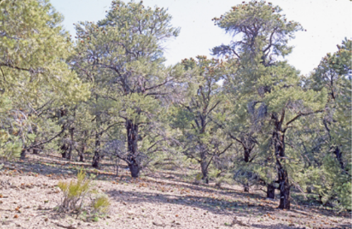
Fire
In Nevada, pinyon pine forests tend to grow in higher elevations where temperatures are cooler and wildfires generally burn during a shorter part of the year than in warmer areas with large amounts of cheatgrass. The size and density of pinyon pine trees makes them much harder to catch on fire than other smaller plants such as cheatgrass. However, if these trees do catch on fire, they can burn at hot temperatures, which usually kills the tree. Since pinyon pine trees take so long to grow, a wildfire that burns trees can have impacts on populations that last for over 100 years. During pine nut harvesting, Native American tribes traditionally clear the area around the tree of dead flammable material and then burn that material away from the tree. These small clearings around trees make it more likely a tree will survive a wildfire. There are many forests in Nevada where Native Americans have been taking care of pinyon pines in this way for several hundred, if not thousands, of years.
Figure 2. A woodland with several pinyon trees.

