Names:

Lesson 3 – Field Day
Quadrat Surveys
Date:
Science Period:

Conducting a Quadrat Survey
- Randomly place a quadrat in the sample area.
- Estimate the percent the quadrat is filled with the four main types of plants
- Repeat 10 times in the same area
- Repeat these steps in one or two other study areas.

Hypothesis
Write a hypothesis for how the percent cover of plants in your survey area will compare to the percent cover of plants in the recently burned areas.
__________________________________________________________________________________________
__________________________________________________________________________________________
__________________________________________________________________________________________

Data Table
Site # 1 | Notes:
Quadrat # | Annuals | Perennials | Shrubs | Trees
1
2
3
4
5
6
7
8
9
10
AVERAGE Site 1

Site # 2 | Notes:
Quadrat # | Annuals | Perennials | Shrubs | Trees
1
2
3
4
5
6
7
8
9
10
AVERAGE Site 2

Site # 3 | Notes:
Quadrat # | Annuals | Perennials | Shrubs | Trees
1
2
3
4
5
6
7
8
9
10
AVERAGE Site 3

Reflection Questions
1. How does the average percent cover in your study area(s) compare to the percent cover in the photos of the recently burned areas?

2. How do your findings compare to your hypothesis?
Common Types of Plants in Nevada
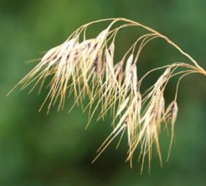  Figure 2.Cheatgrass. | 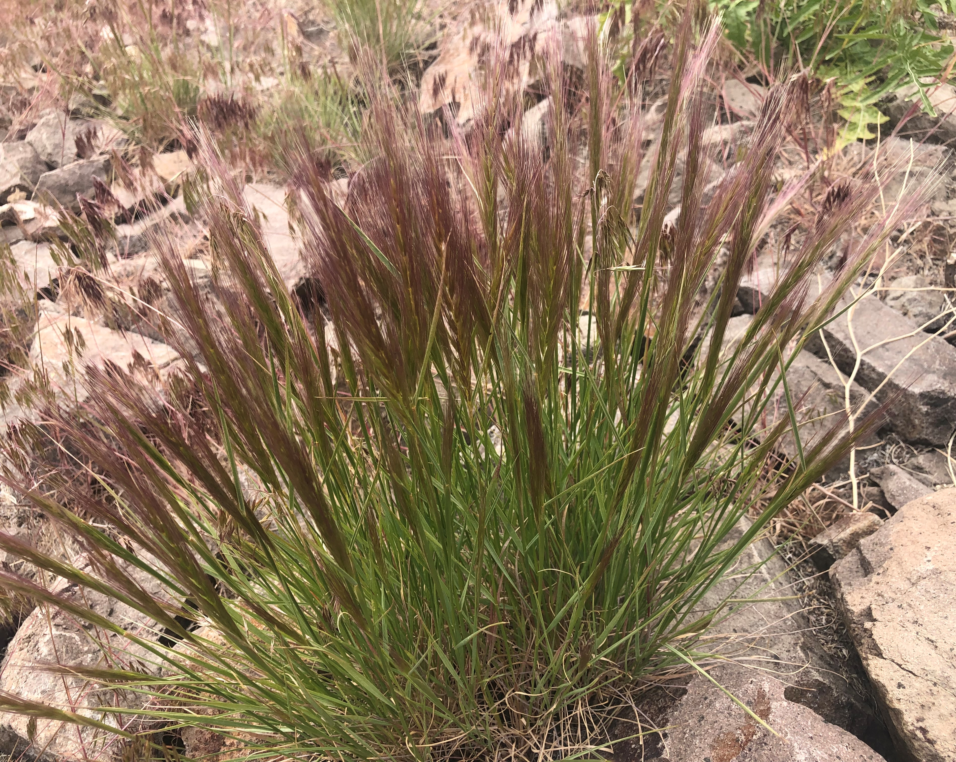  Figure 3. Bottlebrush squirreltail grass.
Annual grass: Much of this is cheatgrass but also includes some other invasive annual grasses. Annual grasses grow entirely from seed each year. They often grow during the early spring before drying out and dying in the beginning of the summer. Once dry, they are not suitable for animals to eat. Cheatgrass can decrease biodiversity by growing back quickly after a disturbance such as wildfire before other plants are able to regrow. | Perennial grass: Most of Nevada’s native grasses are perennial grasses. These tend to grow in bunches and grow from the same roots from one year to the next. Consequently, perennial grasses have much larger root systems than annual grasses. These grasses stay greener longer and provide better food for grazing animals. Bottlebrush squirreltail is a perennial grass. The stalks are purple during the spring and light brown after they dry later in the summer.
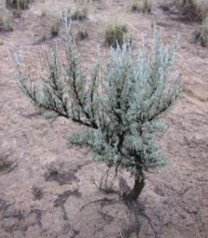  Figure 4. A smaller sagebrush shrub. | 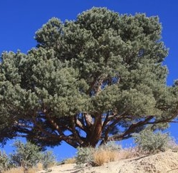  Figure 5. A pinyon pine tree.
Shrubs: This group is mostly composed of different types of sagebrush. Sagebrush is one of the most recognizable and common plants in Nevada, and it grows very slowly. Shrublands mixed with sagebrush and perennial grasses are one of the more biodiverse ecosystems in Nevada. While sagebrush tends to be too bitter for many animals to eat, several other types of native shrubs are commonly eaten. | Trees: Some of the most common trees in Nevada are pinyon pines and junipers. These trees grow even more slowly than sagebrush. Pine nuts from pinyon pines are an important ecological food source for some animals such as squirrels and birds as well a native tribes including the Washoe, Paiute and Shoshone peoples. Pinyon pines have needles that come off the branch in pairs or as a single needle.

