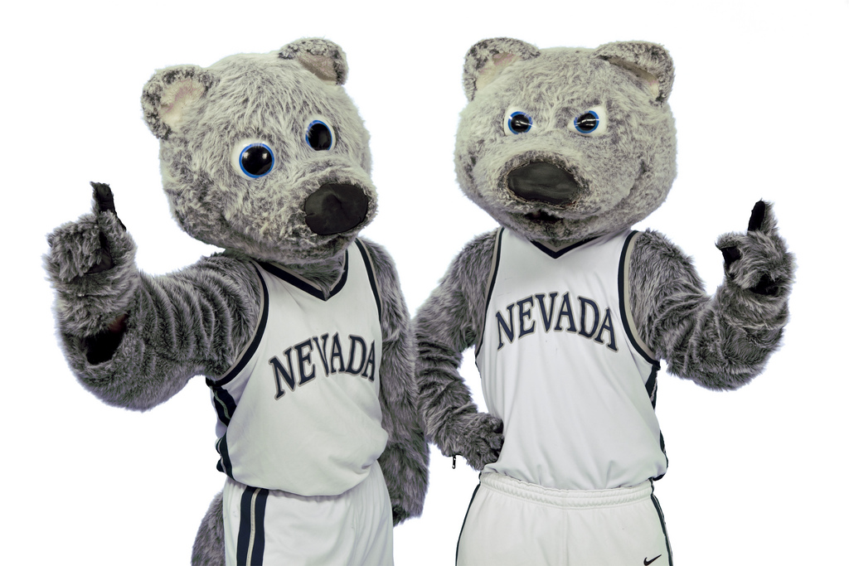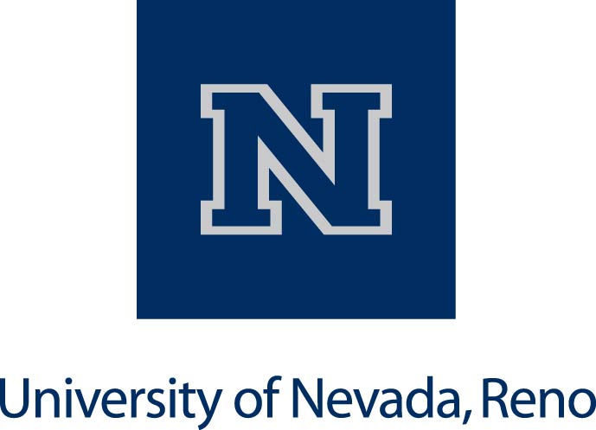

**Wolf Cub of the Year**

**Purpose of the award:**

The Wolf Cub of the Year award recognizes outstanding full-time and part-time classified staff members who exemplify the University’s standards for excellence and innovation during their first two years of employment.

**Award recipient shall receive:**

A Wolf Shop gift card, personalized trophy and The Wolf Cub of the Year award is presented at the Silver and Blue Salute

**Who is eligible?**

* All current full-time or part-time classified staff with two (2) years or less of service.
* Classified staff employed at any of UNR’s physical locations.

**Award criteria:**

* Excellence in innovation and initiative (ability to creatively tackle projects with enthusiasm).
* Positive attitude towards fellow employees, faculty, students and the public.
* Positive attitude towards work ( availability, creativity, initiative, dependability)
* Outstanding quality of work (accuracy, timeliness and dependability).

**NOMINATION DEADLINE: April 5, 2019**

NOMINATION FORM AVAILABLE AT: <http://www.unr.edu/sec/forms-and-resources>

**unr.edu/sec**

**Call for nominations of outstanding classified staff members**