Life Cycle

Perennial Grasses – Bottlebrush Squirreltail
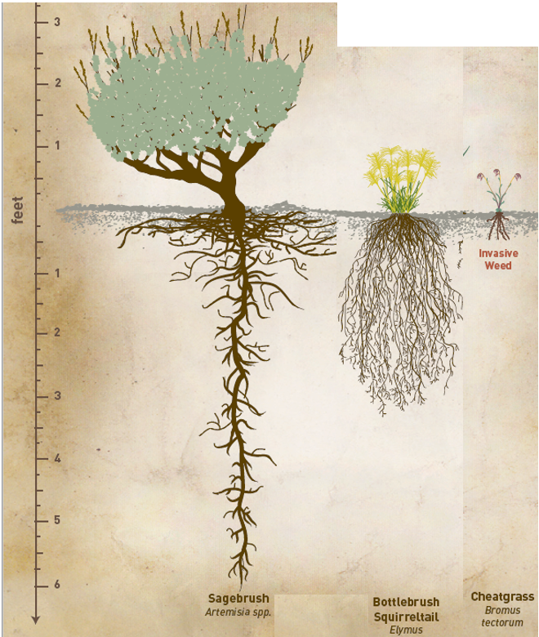
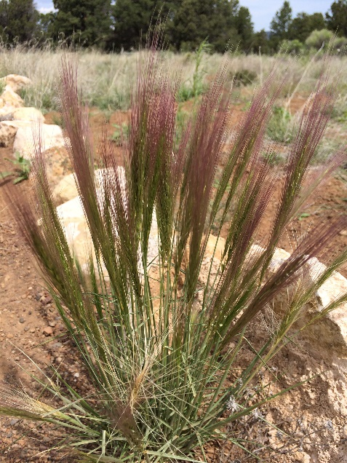
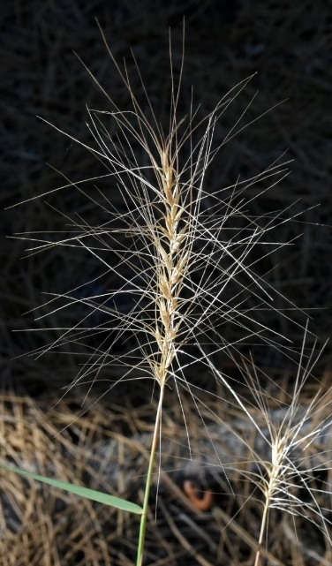
Perennial means that this plant grows for more than one year. The aboveground leaves and stems may die during the winter, but they will regrow from the same root system the next spring. Many perennial grasses in Nevada are called bunchgrasses because they grow with many stalks coming out of a tight cluster. A single bottlebrush squirreltail plant normally only lives for a few years, while other perennial bunch grasses can live for over 10 years. In the fall and/or spring, bottlebrush squirreltail can spread its seeds long distances by letting a dry seedhead (photo on the right) break off from the stem and get blown away. This plant can also spread its seeds by animals eating them. The hard seed will pass through the animal without being digested and be deposited in another location. Since bunchgrasses are larger and stay greener for longer into the summer than annual grasses, they take more resources to grow. Due to this, bunchgrasses tend to grow in bunches with a lot of bare ground in between them. Over time bunchgrasses can outcompete annual grasses such as cheatgrass for resources.
Figure 1. Bottlebrush Squirreltail plant.
Figure 2. A dry seedhead.

Herbivory – Being Eaten
Perennial bunchgrasses, such as bottlebrush squirrletail, stay green longer than annual grasses, and are some of the favorite plants for animals in Nevada to eat. However, since the total number of grazing animals such as deer, antelope and jackrabbits in Nevada was low over the last 10,000 years, many of these bunchgrasses are not adapted to survive being eaten by large numbers of livestock such as cows or sheep for several years in a row.

Fire
The large root systems bunchgrasses have below ground makes them one of the more fire-resistant plants in Nevada. When a fast-moving, low- or medium-severity wildfire burns a bunchgrass, the top of the plant may burn, but the roots below ground can stay alive and provide nutrients that will help the plant grow back next season. However, if a fire burns too hot or for too long, it can kill the roots, and the whole plant will die. New individuals would then need to grow from seed, which can take one to two years.
Figure 3. Root size of Nevada plants.

