Name:

Lesson1: Wildfire Unit
Preparedness Homework
Date:
Science Period:

How Can You Protect Yourself From Wildfire?
Below are several ways you can protect yourself and those that you live with from wildfire. (See attached pages 2-9). Your homework is to complete 1 or more of these actions. Each action has a point value and you will be graded on the points of the tasks you complete.
Grading Rubric
Exceeds Standard | Meets Standard | Partially Meets Standard | Below Standard
4+ points | 3 points | 2 points | 1 point
Complete this self-evaluation after taking actions and turn it is as your homework.
What action(s) did you take?
How many points did you score? | How many members of your household participated in those actions?

Get Prepared

Sign up for Emergency Notifications (1 point)
Local Emergency Notification Systems, commonly known as Reverse Dial, are used by safety officials to send phone calls, emails and texts to a specific area with a prepared message during an emergency. For example, if an area is asked to evacuate, this message will be sent to all of those residents who are in the system. Some residents might not receive these messages if the electricity fails, if they are not home during an emergency, they do not have a land line, or if they have an unlisted phone number. Most systems allow residents to enter multiple forms of contact information, such as an unlisted home number, cell phone, work phone and email address into the database.

Action: Go to bit.ly/NVEmergencyNotifications to sign up for emergency notifications in your area.

Prepare my home and family for evacuation (2 points)
Wildfire evacuations are stressful events, and often individuals don't have much notice before it's time to leave their homes. Successful community evacuation requires preparation.
Figure 1. Planning escape routes.
Action: Help the members of your household prepare for evacuation by completing one of the following:

- Identify escape routes and safe places, and be sure everyone in your family knows them. In a fire or other emergency, you may need to evacuate very quickly. Draw an escape plan with your family, highlighting two routes out of each room.
- Complete an inventory of home contents and photograph/videotape the house and landscape.
- Complete a family communications plan. Your plan should include contact information for family members, work and school.

Make a disaster supplies kit or to-go bag or (3 points)
Prepare for at least three days, but preferably seven days. The best time to assemble a to-go bag and disaster supplies kit is well before you need them. Most of these items are already in your home, and stocking up on emergency supplies now can add to your family’s safety and comfort during and after a disaster.

Action: Make either a disaster supplies kit OR a go-bag using the checklists below.

Essentials for a Disaster Supplies Kit:
If you anticipate an extended evacuation at an emergency shelter or your family is returning to a home without functioning electricity and water, these items will prove helpful:
- One gallon of water per person, per day stored in unbreakable containers and labeled with the storage date. Replace every six months.
- Supply of nonperishable packaged or canned foods with a hand-operated can opener.
- Antibacterial hand wipes or gel.
- First-aid kit, including a first-aid book.
- At least one blanket or sleeping bag per person.
- ABC-type fire extinguisher.
- Special items for infants, elderly or disabled family members.
- Large plastic trash bags, tarps and rain ponchos.
- A large trash can.
- Bar soap, liquid detergent and household bleach.
- Rubber gloves and duct tape.

Essentials for a To-Go Bag
The to-go bag should be easily accessible and filled with items needed to help you quickly and safely evacuate your home. When a wildfire is approaching, you may only have enough time to retrieve this bag. Include:
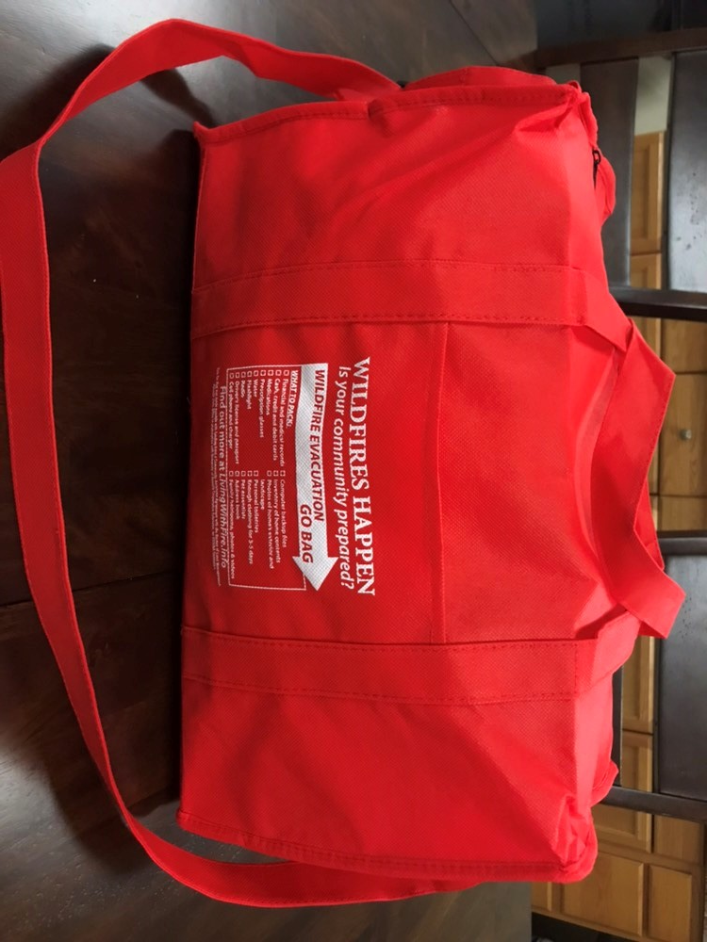
- Important documents (bank, IRS, trust, investment, insurance policy, birth certificates, medical records).
Figure 2. Evacuation go-bag
- ATM, credit and debit cards and cash in small bills.
- Medications, Rx numbers and vaccination records for humans and pets.
- Non-perishable food and water.
- Driver’s license, passport.
- Computer backup files.
- Inventory of home contents (consider making a video inventory now, prior to an emergency).
- Photographs of the exterior of the house and landscape.
- Address book including medical and veterinarian contact information.
- Cell phone charger.
- Personal toiletries.
- Enough clothing for 3-5 days.
- Family heirlooms, photo albums and videos.

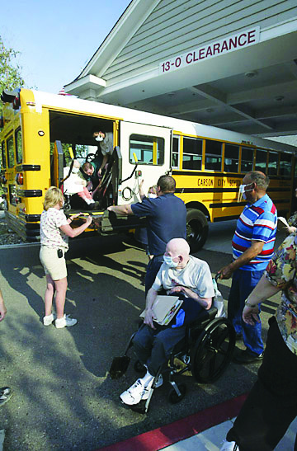
Understand the needs of individuals with disabilities
(1 point)
Figure 3. Evacuating vulnerable populations.
During a disaster, it is essential that individuals with special needs receive proper care, including the elderly, people with medical problems and people with certain disabilities.
Action: Make a plan to evacuate vulnerable populations in your community that takes into account the following:

- If an individual is dependent upon medications, equipment or has special dietary needs, plan to bring those items with you. Documentation about insurance and medical conditions should also accompany the person.
- Transportation available to the general public during an emergency evacuation may not be suitable for family members with special needs. Plan ahead for their transportation.
- Many special-needs populations are easily upset and stressed by sudden and frightening changes. Your plans should ensure that a caregiver or trusted family member is able to stay with them at all times during an evacuation.

Prepare for pets (1 point)
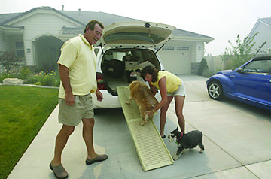
Plan to take your animals with you and never turn them loose. Animals may not be allowed inside human emergency shelters. Contact your county’s animal services department for advice on animal evacuation.
Figure 4. Preparing to evacuate animals.
Action: Make a plan to evacuate your pets using the following checklist:

- Make sure dogs and cats wear properly fitted collars with identification, vaccination, microchip and license tags.
- Your pet evacuation plan should include routes, transportation needs and host sites. Share this plan with trusted neighbors in your absence.
- Exchange veterinary information with neighbors and file a permission slip with the veterinarian authorizing emergency care for your animals if you cannot be located.
- Make sure all vehicles, trailers and pet carriers needed for evacuation are serviced and ready to be used.
- Assemble a pet to-go bag with a supply of food, nonspill food and water bowls, cat litter and box and a restraint (chain, leash or harness). Additional items to include are newspaper and paper towels plastic bags, permanent marker, bleach/disinfectant solution and water buckets.

Review an evacuation checklist (1 point)
Remember, there is nothing you own worth your life! During a wildfire event, please evacuate immediately when asked by fire or law enforcement officials. If you are concerned, don’t wait to be asked to leave.
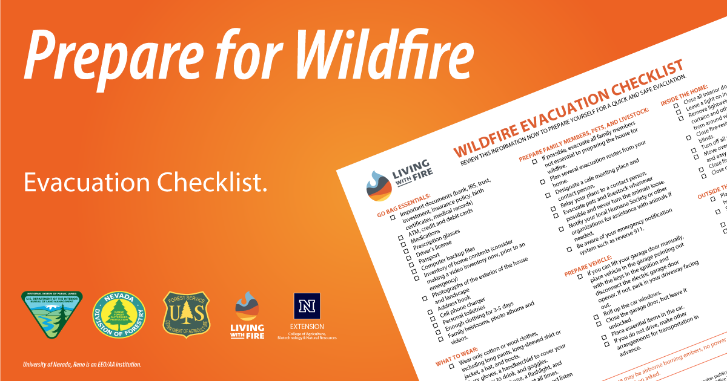
Action;: Print the Wildfire Evacuation Checklist linked below and review it to prepare for a quick and safe evacuation. Put it somewhere easy to find in case of an emergency.
Link to Checklist: bit.ly/WildfireEvacuationChecklist.
Figure 5. Evacuation checklist
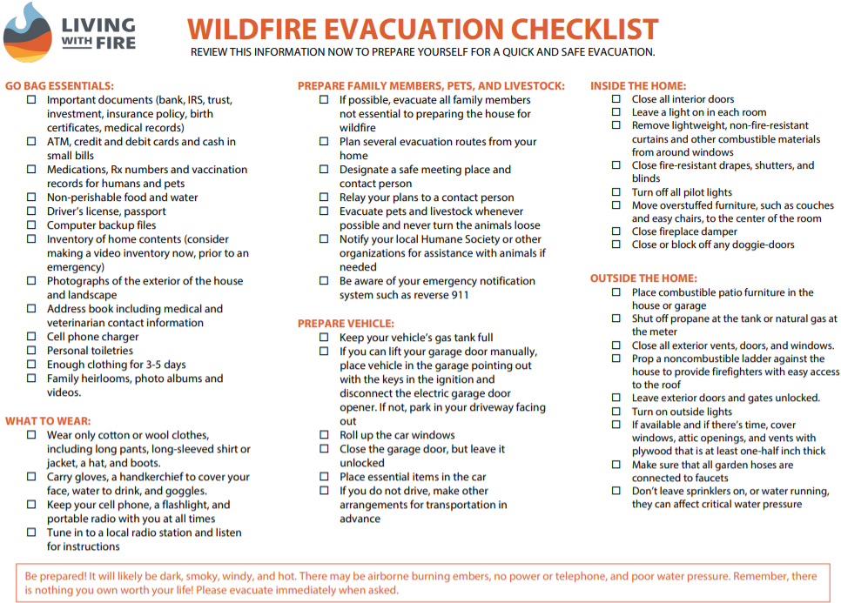

Improve a Home’s Defensible Space

Share resources or make recommendations to a landlord, homeowners association or other community group (2 points)

Even if you aren’t allowed to make changes to where you live, sharing information on protecting where you live with people in charge of it can encourage them to take action.
Action: Share the following resource with a person or group that takes care of homes near where you live, https://www.livingwithfire.com/get-prepared/.

Take action in defensible space zones (3 points)
The term defensible space refers to the area between a house and an oncoming wildfire where the vegetation has been managed to reduce the wildfire threat and allow firefighters to safely defend the house. In the event that firefighters are not available, defensible space also improves the likelihood of a home surviving without assistance. Every home is different, so feel free to adapt the recommendations below.

Action: Complete one of the recommended tasks in a defensible space zone, listed below.
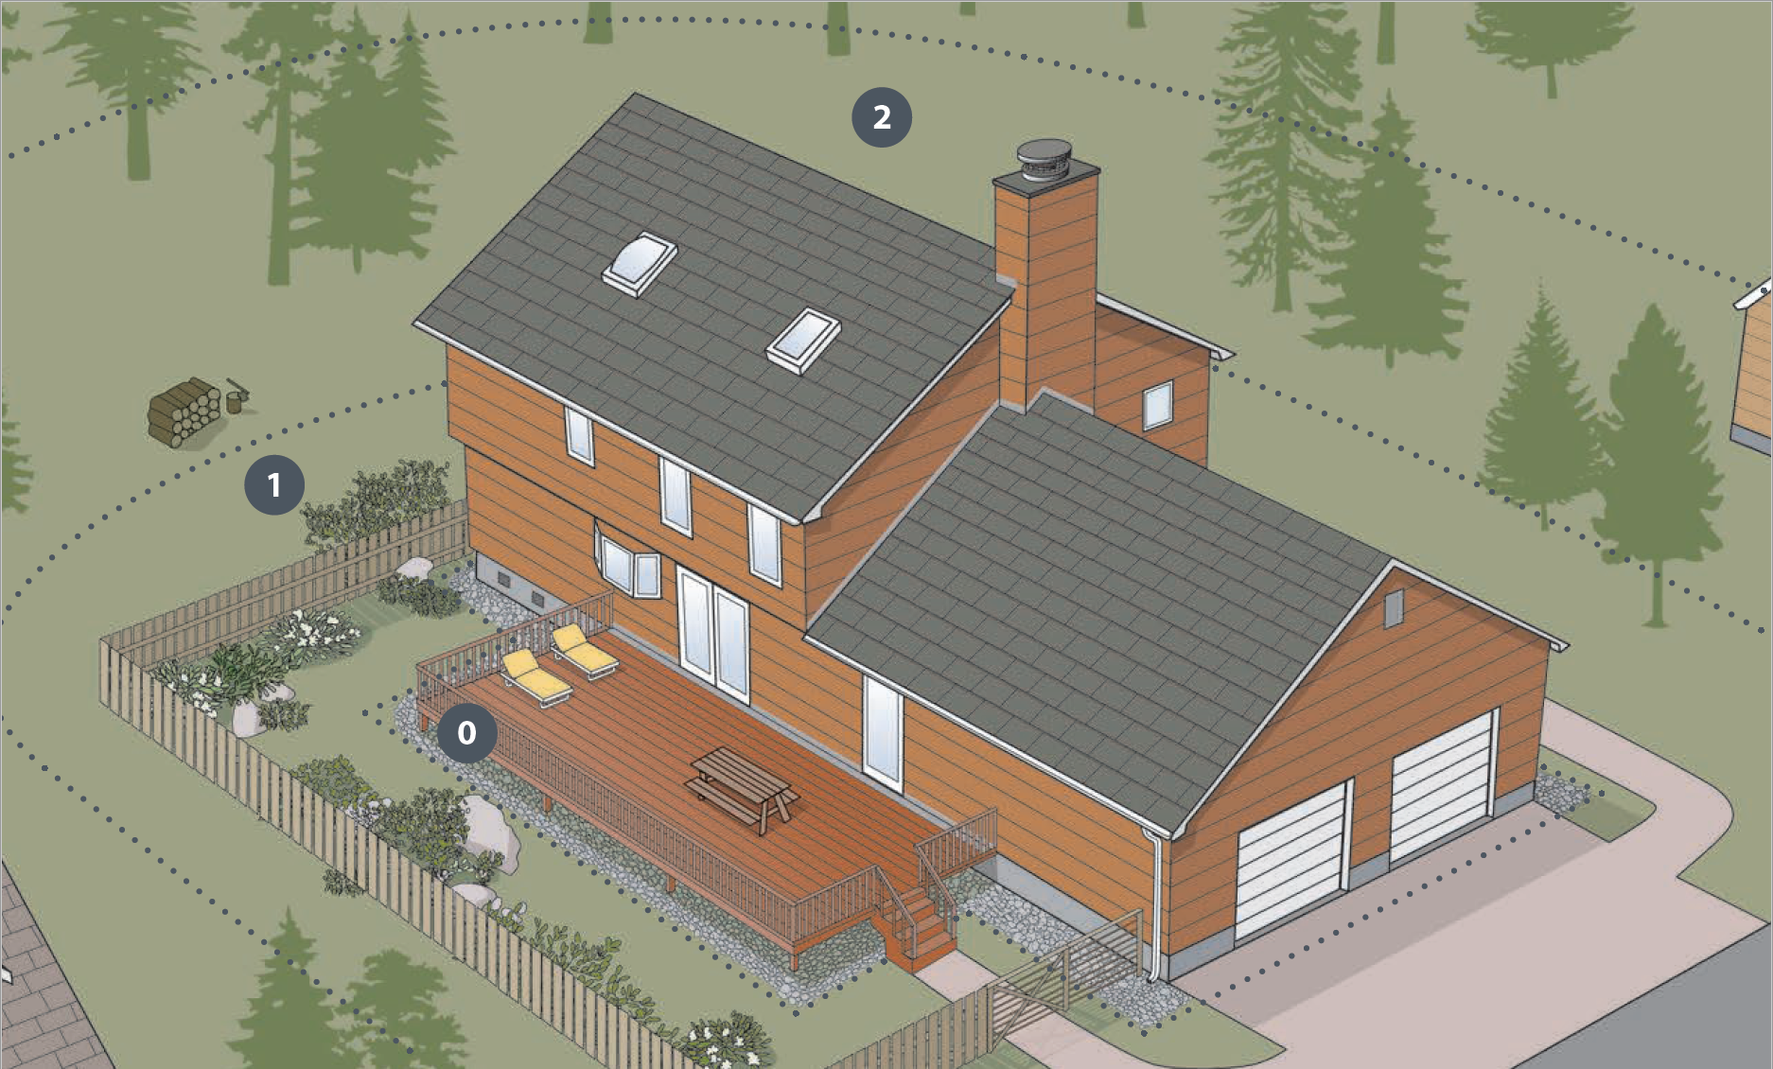
Figure 6. Defensible space zones.
- THE EMBER-RESISTANT ZONE (Zone 0) | 0–5 feet: The zone within 5 feet of your home has many different names (e.g., the noncombustible zone, the immediate zone, the zero zone), but the objective is generally the same — to reduce the vulnerability of the home to embers by creating a zone of nonflammable ember-resistant materials around the home.
  - Recommended task: Remove weeds and flammable material in the Ember Resistant Zone, 0-5 feet from the house (3 points).
- THE LEAN, CLEAN AND GREEN ZONE (Zone 1) | 5–30 feet: The objective of this zone is to reduce the risk of fire spreading from surrounding vegetation to the home. Lean indicates that there is only a small amount of vegetation, if any, present. Vegetation should be grouped in discontinuous islands. Clean indicates that vegetative debris and dead materials are routinely removed. Green indicates that vegetation within this zone is kept green and well irrigated (if appropriate) during the fire season.
  - Recommended task: Removal of firewood or other large flammable materials in the Lean, Clean and Green Zone, 5-30 feet around a building (3 points).

- THE REDUCED FUEL ZONE (Zone 2) | 30–100 feet: The objective of this zone is to reduce fire spread and restrict fire movement into the crowns of trees or shrubs. Remove dead plant material, lower tree branches and other ladder fuels (e.g., shrubs, lower branches, smaller trees). Locate outbuildings (e.g., for storage) at least 30 feet away from the home and create an ember-resistant zone around all outbuildings and propane tanks.
  - Recommended task: Use the defensible space take home lab to identify and reduce flammable materials in the Reduced Fuel Zone, 30-100 feet from your home (3 points).

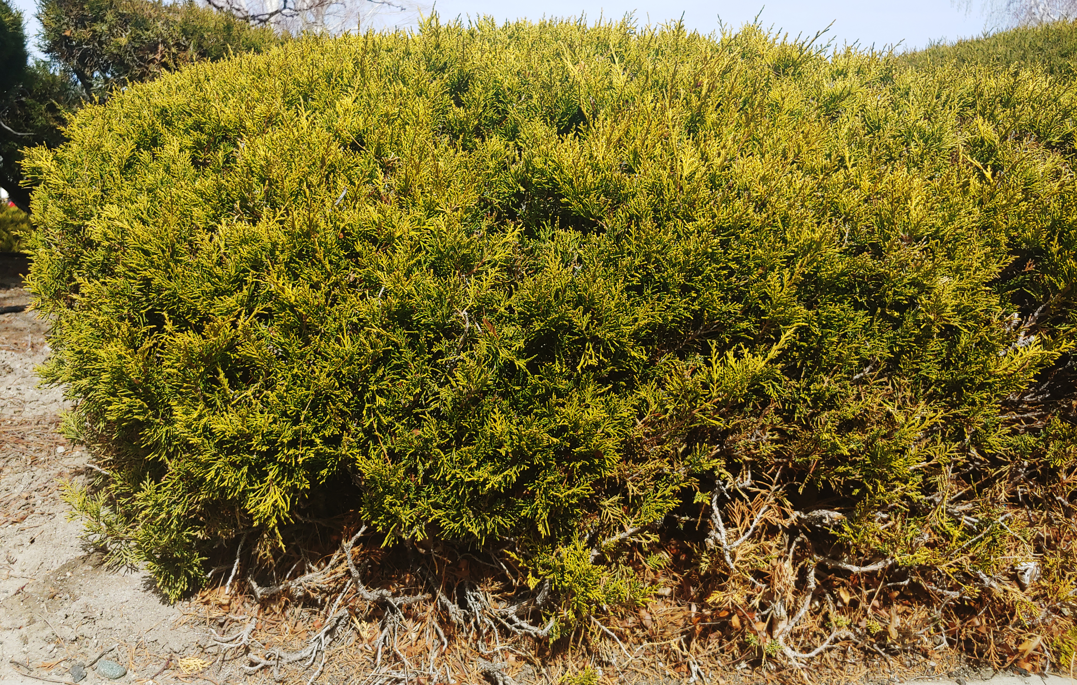
3. Remove Ornamental Junipers (2 points)
Firefighters often refer to ornamental junipers as little green gas cans. During a wildfire involving homes, embers can smolder undetected under ornamental junipers. The junipers can then ignite and burn intensely after firefighters have left the area. Planting ornamental junipers next to your house is never a good idea. Keep these little green gas cans at least 30 feet from the house or replace them with low-growing deciduous shrubs, herbaceous flowers, rock mulches and hard surfaces.
Figure 7. Ornamental juniper.

Action: Remove an ornamental juniper plant within 30 feet from your house.

Protect a Home from Embers: Home Hardening
In wildfire events, 60-90% of home loss is due to embers. Embers can originate from an approaching wildfire or small parts of nearby burning vegetation and construction materials (e.g., a home, storage shed, wood pile). Embers are important because of what they can do directly (e.g., ignite materials in an attic after entering through a vent) and what they can do indirectly (e.g., ignite a wood pile or storage shed located close to the home, resulting in radiant heat or direct flame contact to the side of the home). Reducing the vulnerability of homes to ember ignition will increase the chance of homes and neighborhoods surviving a wildfire.
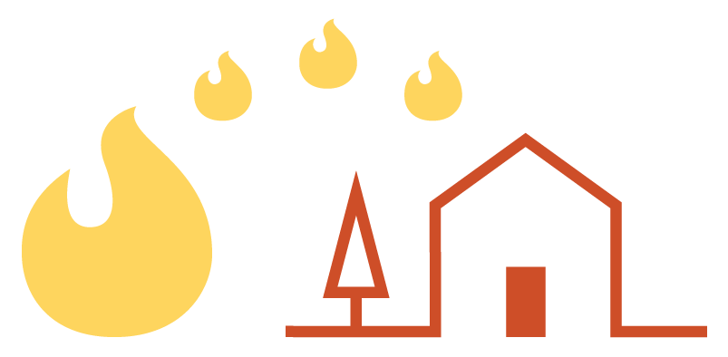
Action: Complete a home hardening task listed below.

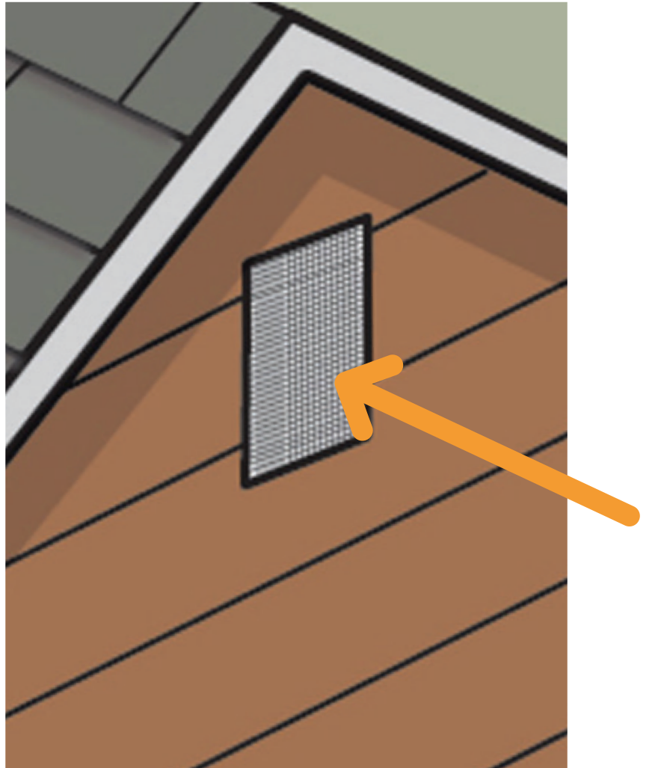

Place ember screens on vents (3 points)
Attic and crawl space vents provide an entry point for embers. Vents should be covered by, at a minimum, 1/8-inch noncombustible corrosion-resistant metal mesh screening. Screening will not prevent the intrusion of all embers but will minimize their size. Finer mesh screening (e.g., 1/16-inch mesh) is more effective at keeping embers out of the home but requires more maintenance because it can become clogged with debris.
Figure 8. Screen vents.
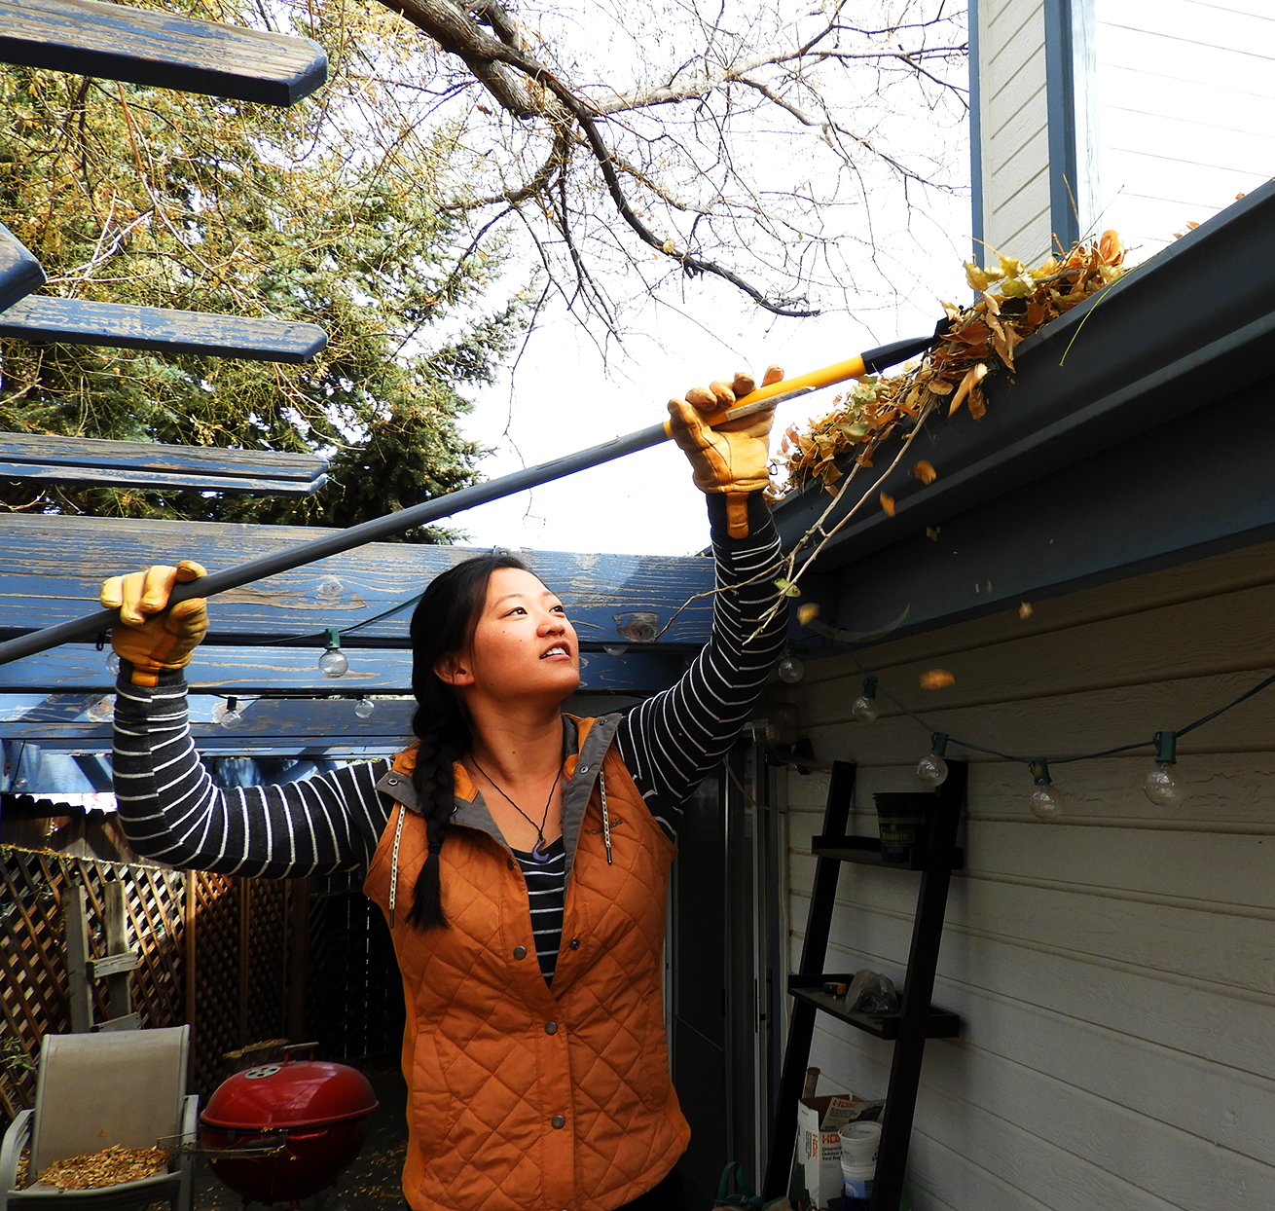

Clean gutters or roof only with help from an adult (3 points)
Roofs can be vulnerable at the roof edge where a gutter is attached. Debris in the gutter can ignite from embers, and flames can ignite other components at the roof edge (e.g., wood-based sheathing and fascia board).

Figure 9. Clean gutters.

Remove plant or flammable debris from on top of and underneath decks (3 points)
If a deck attached to a home ignites, the home can be exposed to flames and/or radiant heat. What is stored underneath and on top of decks can also be an ignition source. Create an ember-resistant zone under the footprint of and around all decks.

