Lesson 1: Nevada Ecosystems
VOCABULARY

Ecosystem
A community of interacting living things and their physical environment. An ecosystem includes all the living biotic things in an area as well as the abiotic factors such as water, sunlight and soil nutrients. Ecology is the study of all of these parts of an ecosystem and how they interact.
Population
The number of individuals of one type, or species, in a specific area. For example, a biologist might study the populations of different pine trees on a mountain.
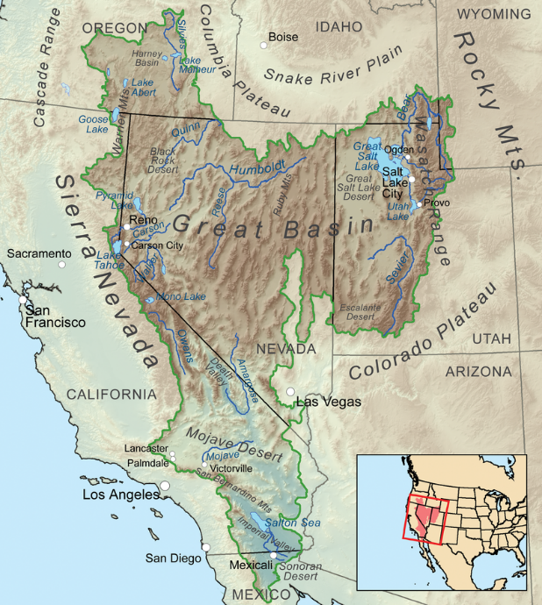
Great Basin
The Great Basin is a large watershed that takes up most of Nevada and is unique in that it does not flow to the ocean. All the precipitation that falls in the Great Basin evaporates, gets absorbed into the ground, or ends up in lakes that do not have an outlet. (See Figure 1.) →
Figure 1. Map of the Great Basin. Source: Wikimedia Commons.
Invasive Species
Any kind of living organism — an amphibian, plant, insect, fish, fungus, bacteria, or even an organism's seeds or eggs — that is not native to an ecosystem and causes harm. They can harm the environment, the economy or even human health. For example, cheatgrass is a common invasive plant in Nevada.
Biodiversity
The variety of living things in the world or in a particular area. Areas that have many different types of living things are more biodiverse. Because Nevada is very dry, areas near water often have the highest biodiversity.
Carrying Capacity
The number of people, other living organisms or crops that a region can support without environmental degradation. For example, the carrying capacity of coyotes is often determined by the amount of food available for them to eat in a specific ecosystem.
Homogenous
The same or similar in nature. Homogenous areas have very little variation and low biodiversity. A grassy lawn with no weeds is an example of a homogenous area.
Heterogenous
Something or some place that is composed of different things that are uneven in their distribution. A heterogenous area has higher biodiversity and some parts of that area look very different from other parts. In Nevada, a heterogenous area might have a patchy mix of sagebrush, different types of grasses and some trees.

Wildfire Severity
The severity of a wildfire is often describe by how many plants in a burned area survive a wildfire. In a low-severity fire, many plants, especially the trees, will survivie a wildfire. In a high-severity wildfire, most, if not all, of the plants, shrubs and trees will be killed.
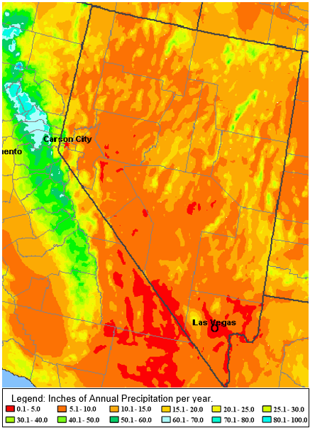
Resilience
The ability to recover from a disturbance. In these lessons we will talk about fire resilience, which means how well an ecosystem can recover and return to how it was before it burned.
Ecological Succession
A process of how plant, animal and living populations change over time. For example, after a severe wildfire most plants may be killed. Grasses tend to be the first plants to regrow, while some trees can take 50-100+ years to reestablish in an area. Since different plants can grow at different rates, the populations of different types of plants, and other living things, will continue to change for many years after a disturbance.
Annual Precipitation
The total amount of water or precipitation an area receives in a year, either as rain or snow. Nevada is the driest state in the United States, receiving an average of 9.5 inches of annual precipitation a year. (See Figure 2.) →

Figure 2. Map of annual precipitation in Nevada.

