Lesson 3 – Field Activity
Take-home Lab: Defensible Space Survey

Introduction
In this lab you will build a map to measure a building’s risk to wildfire. Buildings that are square or rectangular are easier. You will build a map of the building and surrounding area on graph paper and code each graph paper square for fire risk based on what is in that square and in neighboring squares.
What you are doing today is similar to what a defensible space inspector might do to as part of their job to help protect buildings from wildfire. The term defensible space means the space within 100 feet of a building that can be used to create space between a building and a fire. This space is needed to slow or stop the spread of wildfire and protects the building from catching fire — either from embers, direct flame contact or radiant heat. Having defensible space also provides firefighters a safe area to work. Your local fire department will often perform a defensible space inspection for free to help you identify ways to reduce the risk of wildfire to a building.
To build your map, we will need to decide how many feet one square on the graph paper will represent. An easy way to measure distance outside is with paces. For many adults one pace (one large step) is 2.5 feet or 75 centimeters. You can check the length of your paces with a ruler or tape measure. On your map, one square equals one pace. The most important thing is to keep all your paces the same length while completing this lab.

Procedure
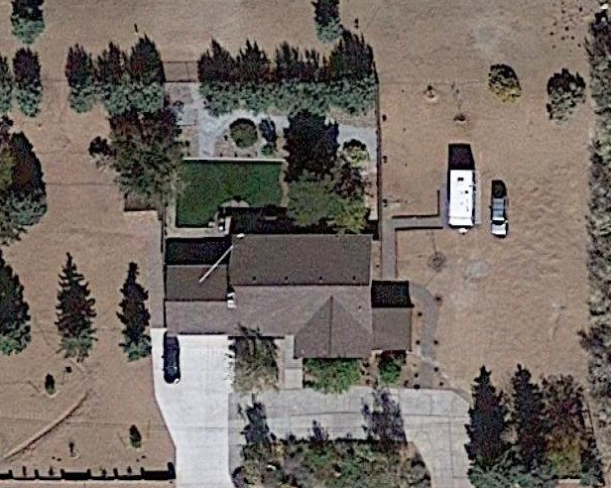
- Start by outlining the outside of the building by counting how many paces long each side of the building is. On your graph paper, each square is equal to one pace. It helps to start with the longest straight side of the building first. We recommend rounding to the nearest whole square for the building perimeter. (Examples 1.a and 1.b)
Example 1.a.
Aerial view of a building.

Example 1.b.
Outline of the perimeter of the building from Example 1.a.

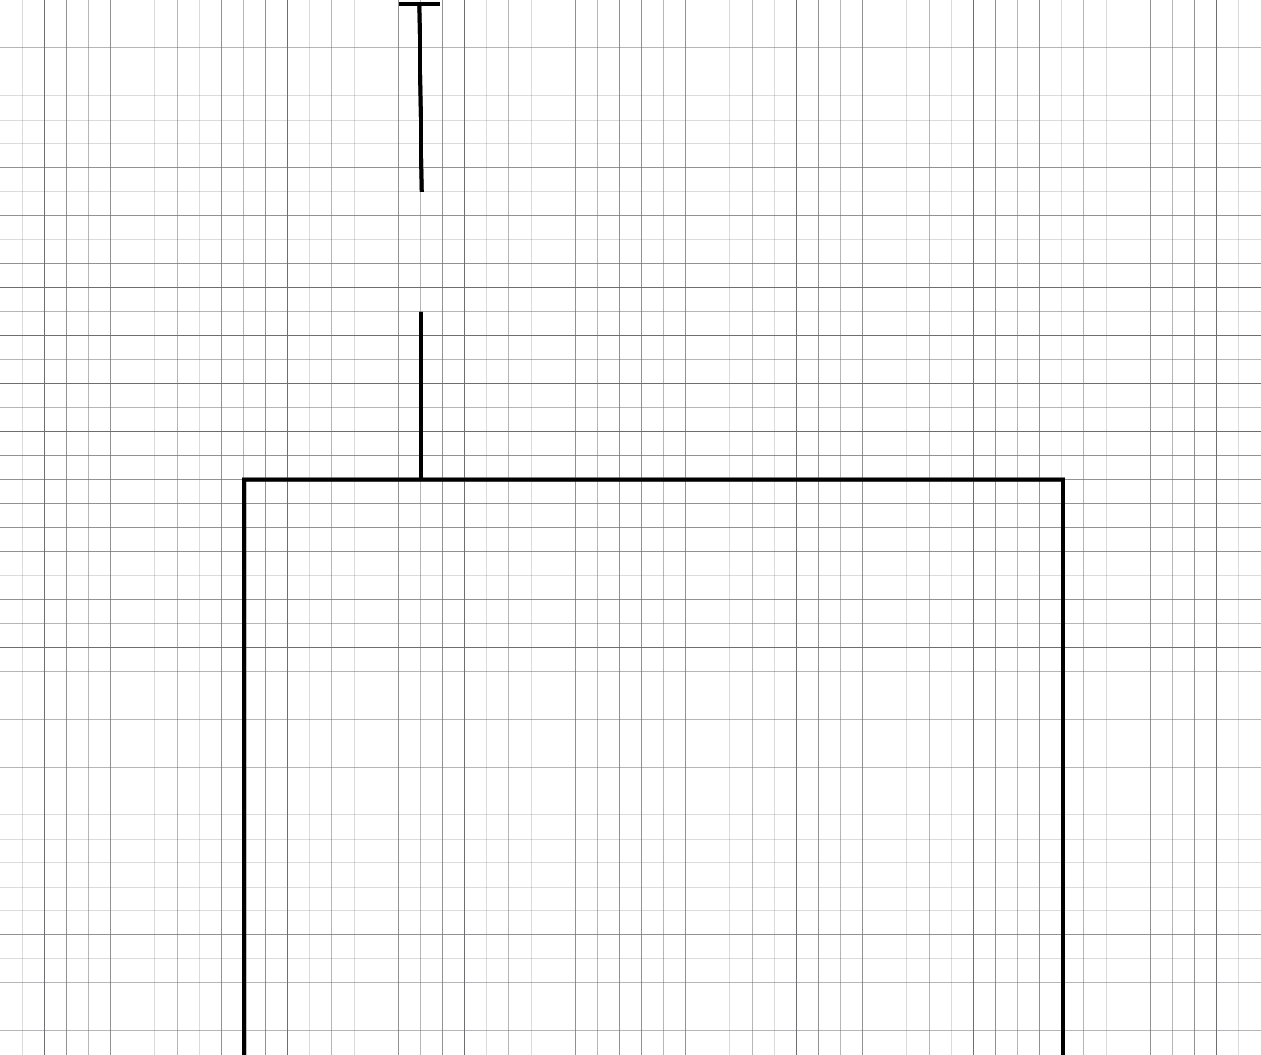
- Large buildings. If your building is larger than 18 x 14 paces, position the building on the paper so that one side of the building is at least 20 squares away from the far edge of the paper. To do this you may need to only put part of your building on the graph paper. (Example 2)
Example 2.
The perimeter of a large building placed on the paper so that one side is at least 20 squares from the far edge of the paper.

20 squares

- Now that you have outlined the perimeter of your building, assess fire risk in the first row of squares touching the edge of the building. In each square write a number based on the wildfire risk. The higher the number the greater the risk. Start at a corner of the building and move a pace along the edge for your first square. Look at what is in that first area. Are there bushes, dead leaves or anything that could burn? Use the table below to calculate what number to put in each square. Go around the entire building square by square recording the fire risk in each square. You will need to look at what is in neighboring squares to calculate the score for a square. (Example 3)

Example 3. Start by outlining the first row around the building. Write a fire risk score in each square.

First Row Square Contents | Score
Rocks, bare dirt, concrete, asphalt or another nonflammable surface | 0
Short grass or green plants less than 12 inches tall | 1
Plants between 1 and 3 feet tall, trees with no branches below 6 feet or dead plants less than 12 inches tall | 2
Plants and shrubs taller than 3 feet and trees with branches below 6 feet | 3
If the outside material of the building is made of wood or another flammable material below 4 feet | Add 1
If any square next to this one has a score of 2 or more, add 1 to this square’s score. Ignore this if this square had a score of 0 before this rule | Add 1 to the score
Wooden or flammable fence, deck, stairs, porch or garden structure that touches the building | Add 2 to the score

- Now fill in the area around the building that is four to 25 paces away from the building. It is helpful to map things like trees, fences, roads and driveways first, and then fill in areas that are likely to have higher number scores. Use the table below to calculate what number to put in each square. If you have large areas such as a lawn or driveway that all have the same risk score, use paces to map the corresponding squares and mark them all down at once. (Example 4)
Second-level Square Contents | Score
Rocks, bare dirt, concrete, asphalt, green grass, green plants less than 12 inches tall, another nonflammable surface | 0
Dead or brown grass, dead leaves, dead plants less than 12 inches tall | 1
Plants between 1 and 3 feet tall or trees with no branches below 6 feet | 2
Plants and shrubs taller than 3 feet and trees with branches below 6 feet  Wooden or flammable fence, deck, stairs, porch, firewood or garden structure | 3
If bushes, trees or shrubs have no other flammable materials closer to them than double their height in distance. | Subtract 1 from the score
If a square has a value of >1 or more AND any adjacent square has a a value of more than 1. Only add 1 point even if there are multiple squares next to it with a score of more than 1. | Add 1 to the score

0

0

Example 4. You can save time by blocking off large areas that are similar, such as a driveway or lawn, and marking their fire risk score once in that block.

- Once you have completed your map and labeled the fire risk in each square, complete the questions on the back of the graph paper.
  - Which areas around the building are most vulnerable to wildfire and why did they score highly?

  - What recommendations could you make to your school leaders to decrease the risk of wildfire around the building?

  - How does having squares with flammable materials next to each other, sometimes called fuel connectivity, affect the risk of fire?

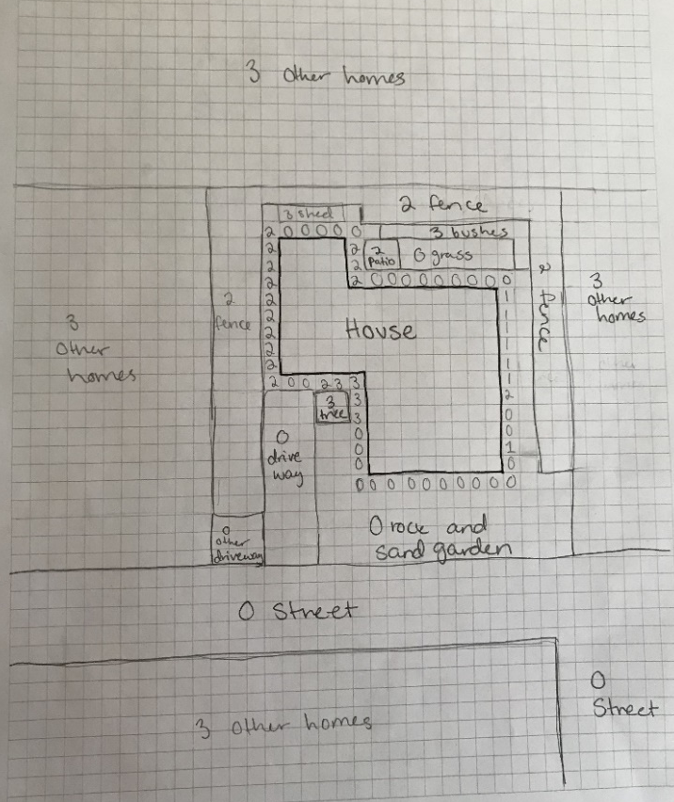
If you are interested in learning more about ways to make a building more resistant to wildfire, you can find more information at www.livingwithfire.com/get-prepared/ or reach out to your local fire department about their free resources or a defensible space inspection.

Example 5. A completed take-home lab.

