Biology Unit

Sample final exam

Vocabulary Matching

HS-LS-2-2
1. A large watershed that takes up most of Nevada and is unique in that it does not flow to the ocean ________ | - Biodiversity  - Ecosystem  - Great Basin  - Population
2. The variety of living things in the world or a particular area ________
3. A community of interacting living things and their physical environment ________

4. The number of individuals of one type, or species in a specific area ________

HS-LS-2-1
5. The number of people, other living organisms, or crops that a region can support without environmental degradation ________ | - Annual precipitation  - Carrying capacity  - Ecological succession  - Invasive species
6. The total amount of water or precipitation an area receives in a year either as rain or snow ________

7. Any kind of living organism that is not native to an ecosystem and causes harm ________
8. A process of how plant, animal, and living populations change over time. For example, after a severe wildfire ________

Timeline of Events After a Wildfire

HS-LS-2-2
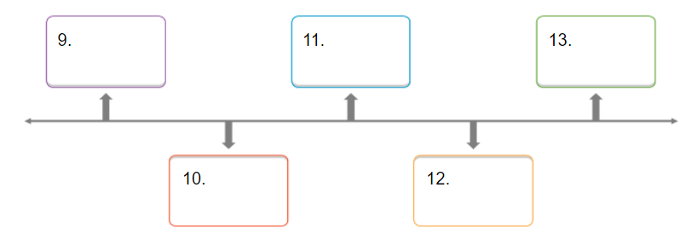
Fill in the blanks on the timeline with correct letter for the major event after a wildfire using the number
- Pinyon pines are fully grown
- Cheatgrass returns to the ecosystem
- Sagebrush begins to regrow
- Bare ground
- Bottlebrush Squirreltail regrows

Analyze Field Site Photos

HS-LS-2-2 and HS-LS-2-7
Use the following field site quadrat photos to answer questions 14 through 17.
14. Observe the following images. Which areas shown have recently had a wildfire? Choose the best option.
- Images 2, 3, 5
- Images 1, 4, 6
- Images 2, 4, 6
- Images 1, 2, 3

15. In image 1, what percent ground cover is there?
- 20%
- 100%
- 50%
- 70%

16. In image 1, what species of plants are not observable?
- Pinyon Pine
- Squirreltail
- Sagebrush
- Cheatgrass

17. Using these photos, how recent was the wildfire?
- More than 60 years
- 10 years
- 3 years
- 1 year

Field Site Photos
1 | 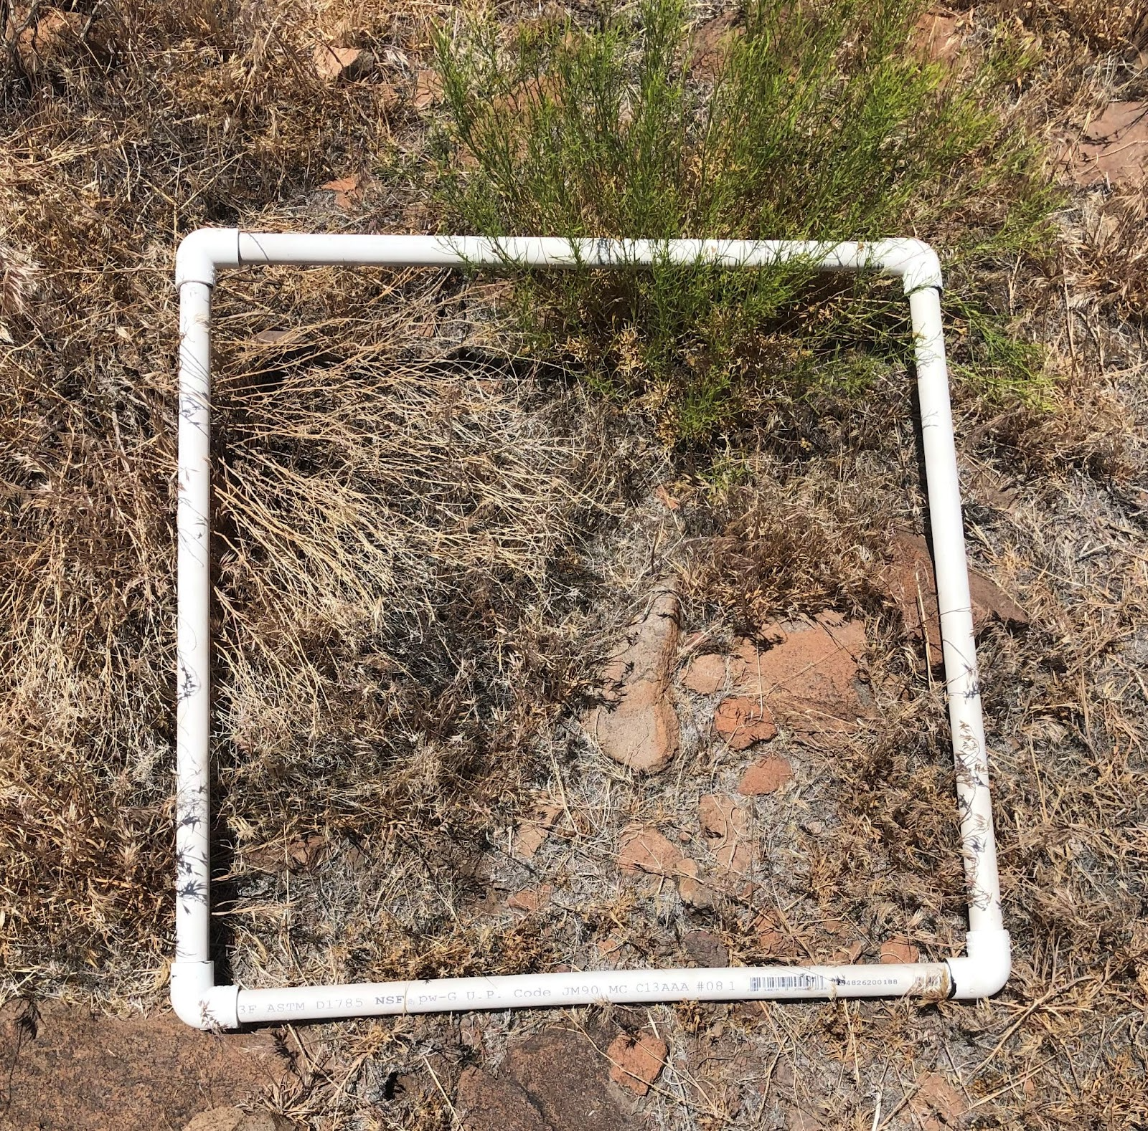 | 2 | 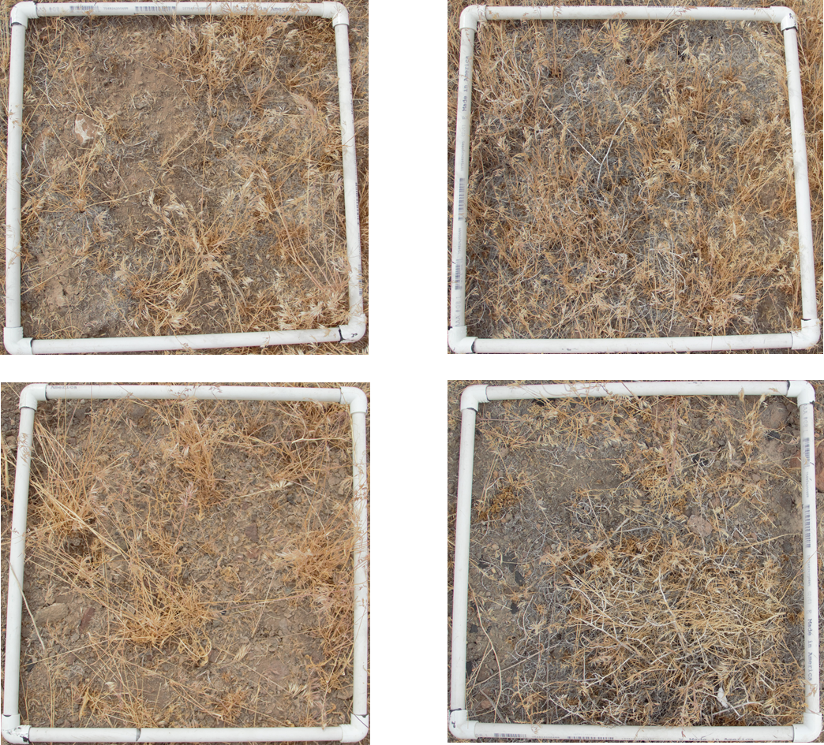
3 |  | 4 | 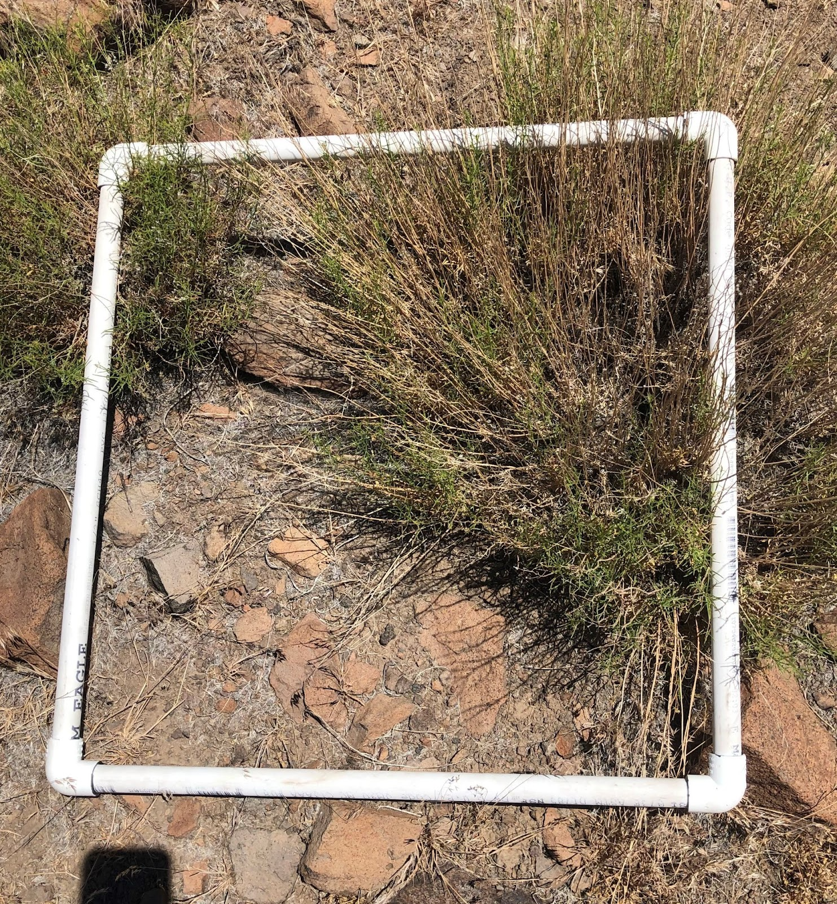
5 |  | 6 | 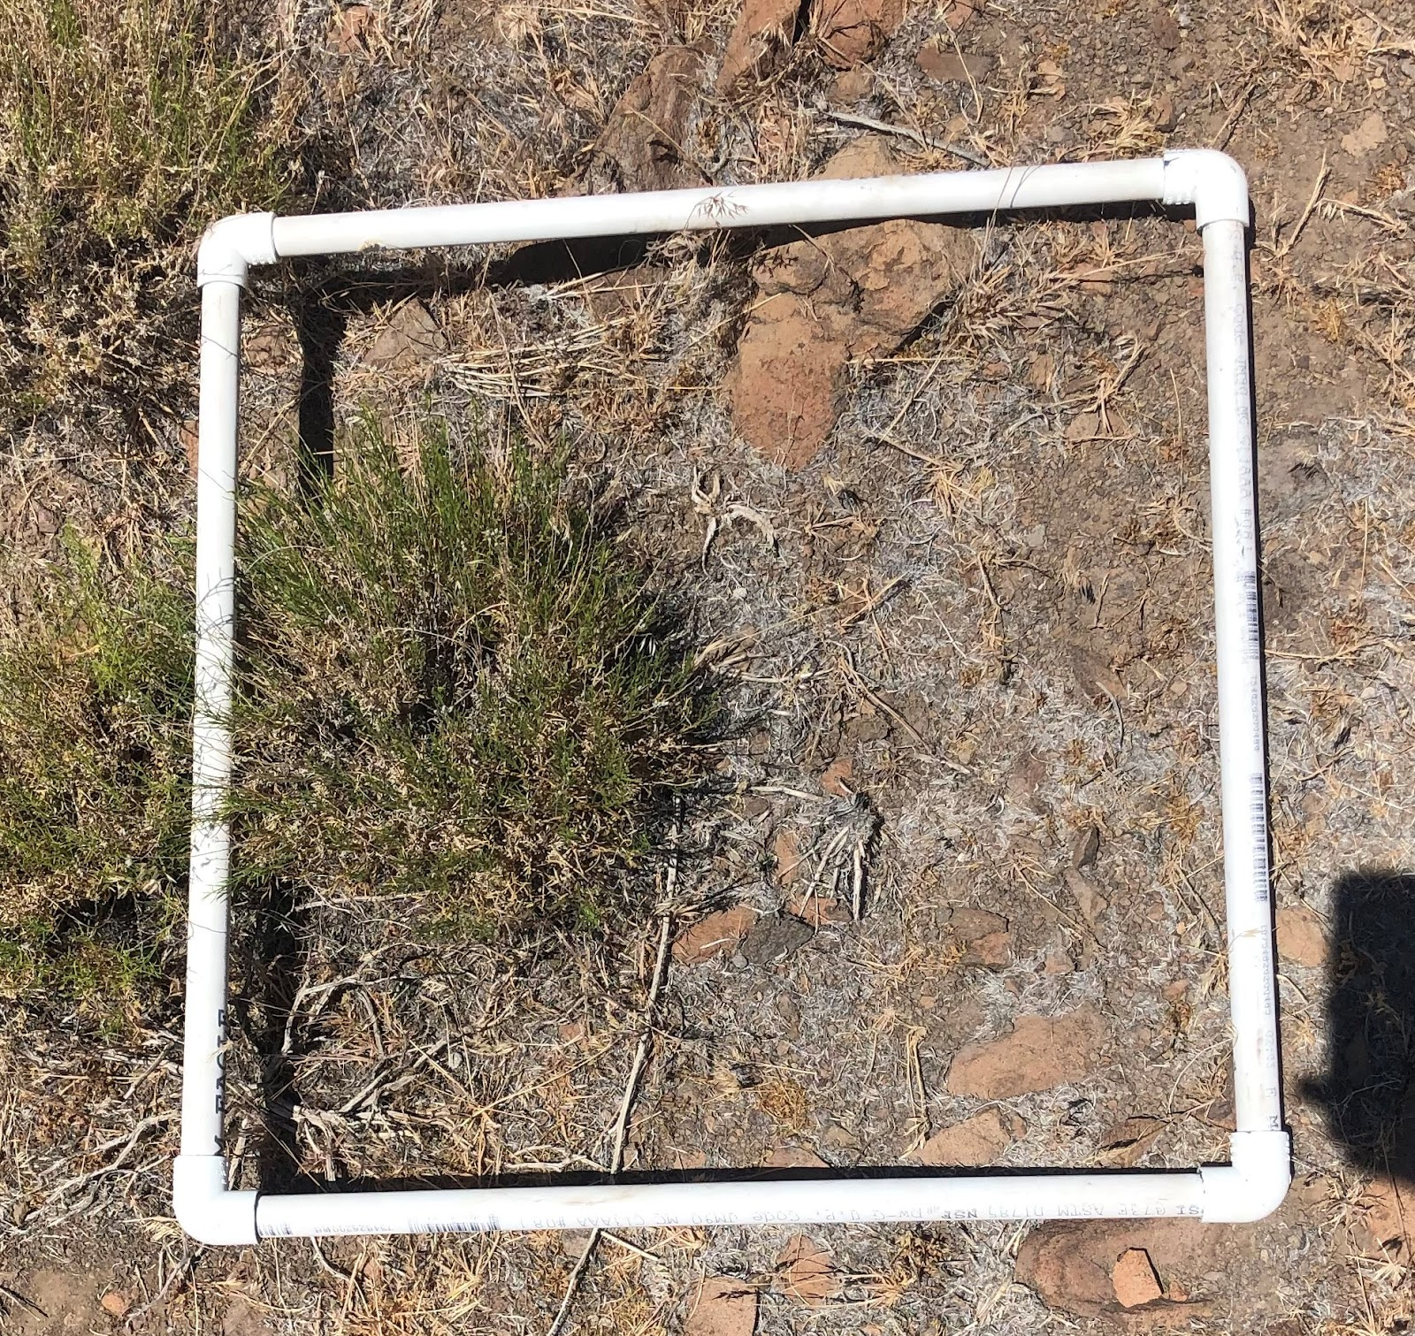

How to Prepare for Wildfire
18. Which of the following is the best action can you do around your house to REDUCE your risk of wildfires?
- Create space between flammable materials and buildings
- Bulldoze all trees in the neighborhood
- Plant cheatgrass
- Planting shrubs close to your house
- Stack firewood against building walls

True or False
Questions 19-23 A-True, B=False

19. Wildfires are most frequently caused by lightning.
20. Humans are responsible for causing 40% wildfires.
21. Sagebrush takes 10 years to regrow after a fire.
22. Removing dead trees from the forest will have no effect on wildfires.
23. Tree health is partially dependent on forest density.

Claim Evidence Reasoning

HS-LS-2-6
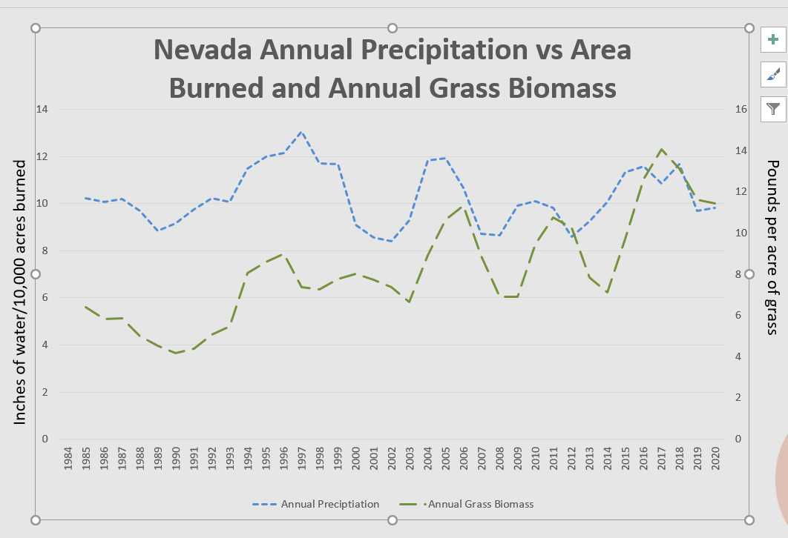
Use the graph below to complete the Claim Evidence Reasoning Statement in questions 24 through 27.
24. (2 points) State Claim: What relationship do you see between annual precipitation (water) and annual grasses? ______________________________________________________________________________________________________________________________________________________________________________________________________________________________________________________________________________

25. (2 points) Cite evidence (quantitative data, numbers) from the above graph to support your claim.
______________________________________________________________________________________________________________________________________________________________________________________________________________________________________________________________________________
26 (2 Points) Predict: Record the two years where large wildfires are most likely to occur:

______________ _______________

27. Reasoning: Explain why you think the above years will have the highest chances on wildfires
________________________________________________________________________________________________________________________________________________________________________________________________________________________________________________________________________________________________________________________________________________________________________

