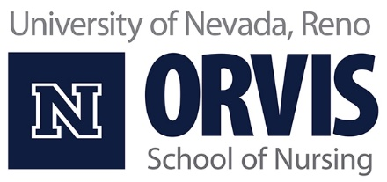

Admission Process for the Accelerated Second Baccalaureate BSN Program 2021 Application Cohort

Students must meet the following requirements to apply to the ASBSN nursing major.

- Must be a graduate of an accredited institution with a baccalaureate degree. Degree must be posted no later than June 30, 2020.
- Must have a minimum cumulative GPA of 2.75.
- Must apply to the University of Nevada, Reno no later than July 1, 2020. All transcripts and transfer credits must be reconciled by admissions & records before a student can apply to the ASBSN program. In progress coursework must be documented on transcripts.
- Applications for the 2021 ASBSN cohort will open July 15, 2020 at 8:00 AM. Candidates must submit a formal application to the ASBSN program no later than 12:00 PM (noon) on Friday, August 21st. No more than two prerequisite courses may be in progress during the application period. Only one of the in-progress courses may be a required science course.
- Submit a completed GPA/Point calculator with the ASBSN application. All prerequisite courses must be taken for a grade (not S/U). Transfer credits taken for S/U credit from an institution that does not offer letter grades are evaluated on an individual basis.
- The following courses must be completed with a grade C or higher from an accredited college with minimum GPA of 3.0 to qualify for application to the ASBSN program. All prerequisites must be completed within 7 years of application.

  - Anatomy & Physiology (with Lab): 12 quarter credits or 8 semester credits. Must include a full sequence of human anatomy and physiology inclusive of all body systems. (UNR equivalent: BIOL 223 A/L and BIOL 224 A/L)
  - Microbiology (with Lab): 4 quarter/semester credits. Basic microbiology with a laboratory component. Must include content on morphology, physiology, and classification of prokaryotic and eukaryotic microorganisms.
(UNR equivalent: BIOL 251)
  - Nutrition: 3 quarter/semester credits. Must address nutrient functions and basis for nutrient requirements at the cellular level. (UNR equivalent: NUTR 223)
  - Human Development: 3 quarter/semester credits. Must include content on human development across the lifespan (conception through death), including physical, cognitive, and socioemotional development.
(UNR equivalent: HDFS 201)
  - Statistics: 3 quarter/semester credits: Course must include both descriptive and inferential components. (UNR equivalent: STAT 152)
  - Math: 3 quarter/semester credits: Course must be at the precalculus level or higher. (UNR equivalent: MATH ≥ 126)
- To accommodate COVID-related testing center closures, students will complete either the Test of Essential Academic Skills (TEAS) – OR – the Health Education Systems Inc (HESI) Admission Assessment (A²) exam no later than August 10, 2020. HESI A² and TEAS exam results will be evaluated based on the percentile rank associated with the cumulative score received on the exam. Exam scores must reflect an exam date within twelve months of application. A minimum benchmark score is not required for either exam to apply to the ASBSN 2021 cohort.

- If you took the TEAS Exam: Applicants will enter their percentile score into the GPA/Point Calculator. Please enter the percentile number in the BLUE bar on your score report into the GPA Calculator. This is the percentile rank that compares your performance to BSN program applicants.

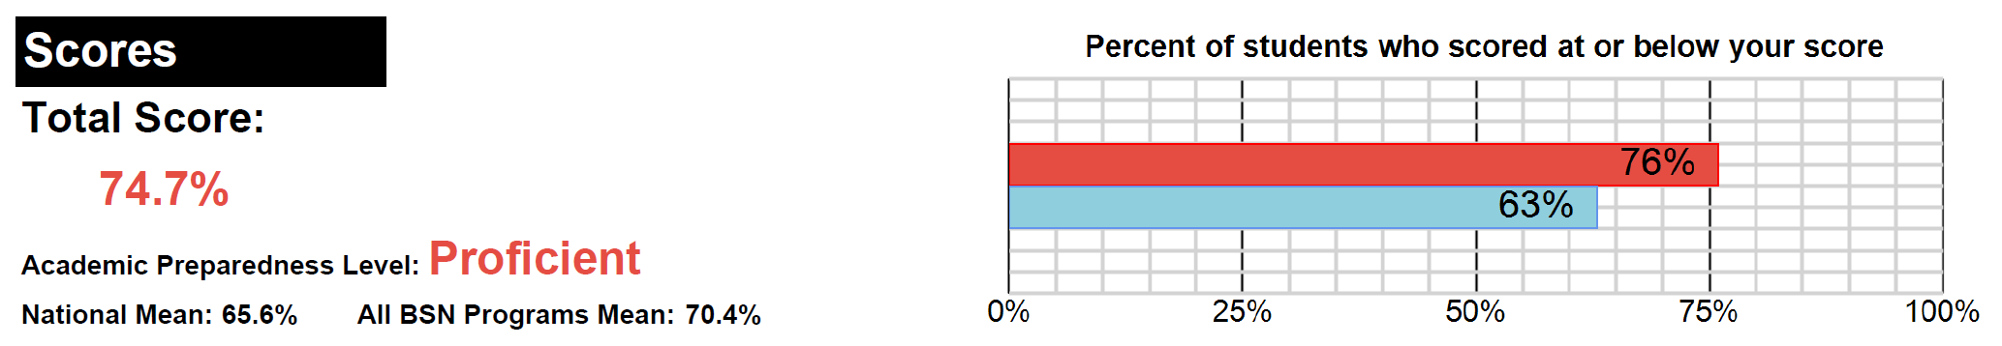
Use THIS Score
NOT This One

- If you took the HESI A2 Exam: The HESI score report does not provide a percentile ranking. The percentile rankings on page three reflect the percentile data provided from HESI (see page 5). Please enter the percentile rank that corresponds with your cumulative HESI score into the GPA Calculator.

- Applicants who have not yet scheduled their admission exam are strongly encouraged to register for the TEAS exam. The TEAS exam can be completed remotely in the comfort and safety of your own home. A similar remote proctoring process is not available for the HESI A² exam.

How to Register for the TEAS Assessment

- The Orvis School of Nursing actively supports the University of Nevada, Reno's policies that ensure equal opportunity/ affirmative action and diversity.

Prelicensure Program Application Process
- Applications are reviewed by the ASBSN Program Officer, the Associate Dean of Undergraduate programs, and the track leader for the ASBSN program.
- Applications that do not meet minimum requirements will not be considered.
- Applications that meet minimum requirements will be evaluated through the ASBSN admission point matrix.
- Applicants will be ranked from highest to lowest based on the application matrix. Applicants with the top 32 matrix scores will be offered provisional admission to the ASBSN program.
- In the event of a tie, the tie-breaking candidate will be selected using the following criteria in order of preference:
  - Nevada Residency
  - Health Care Experience (licensed or certified healthcare worker)
  - Admission exam percentile score

Orvis School of Nursing Accelerated Second Baccalaureate BSN Admission Criteria Point Matrix

Points | 0 | 0.5 | 1 | 1.5 | 2 | 2.5 | 3 | 3.5 | 4
Pre-Nursing GPA* | < 3.40 | 3.40 – 3.499 | 3.50 – 3.599 | 3.60 – 3.699 | 3.70 – 3.799 | 3.80 – 3.899 | 3.90 – 4.00
Cumulative GPA** | ≤ 3.499 |  | ≥ 3.50
HESI Cumulative Percentile Score  -- OR -- | < 50th | 50th – 60th | 61st – 69th | 70th – 74th | 75th – 79th | 80th – 84th | 85th – 89th | 90th – 94th | 95th – 99th
TEAS Cumulative  Percentile Score | < 50th | 50th – 60th | 61st – 69th | 70th – 74th | 75th – 79th | 80th – 84th | 85th – 89th | 90th – 94th | 95th – 99th
Nevada Resident*** | No |  |  |  | Yes
Military Veteran or  Active Duty Military | No |  | Yes

*Pre-Nursing GPA Includes: | All prerequisites courses required for entry into accelerated second baccalaureate program
**Cumulative GPA includes: | All college credit
***Nevada Resident: | Classified as a Nevada Resident at the University of Nevada, Reno at the time of nursing program application

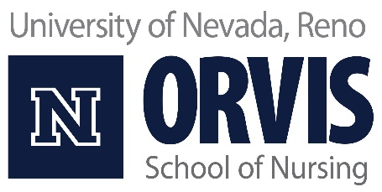
Nevada Residency Preference for Accelerated 12-month Second Baccalaureate of Science in Nursing program
The Orvis School of Nursing supports the University of Nevada, Reno land grant mission to develop a health care workforce for Nevada. To this end, Nevada residents receive application preference in all prelicensure nursing programs offered by the Orvis School of Nursing.
A student must be classified as an “In State” student in MyNevada to claim Nevada residency when applying to the Accelerated 12-month Second Baccalaureate of Science in Nursing program.
Note that Nevada residency for reduced tuition purposes does not demographically classify a student as a Nevada resident.
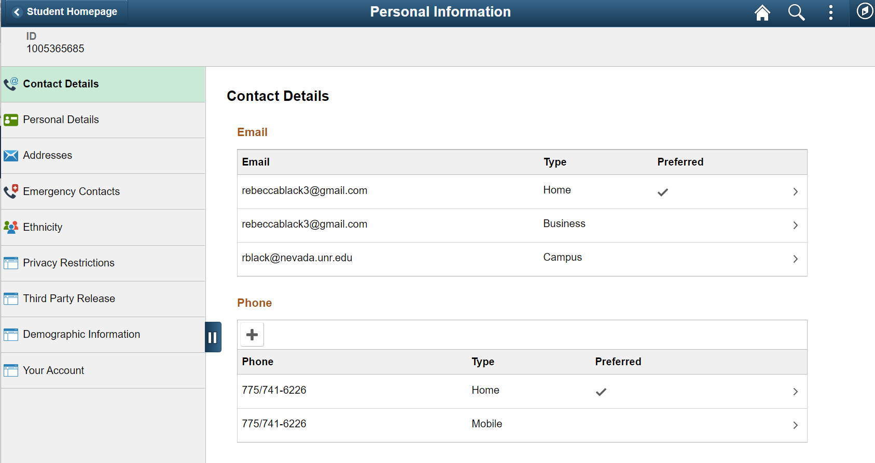
Click Here

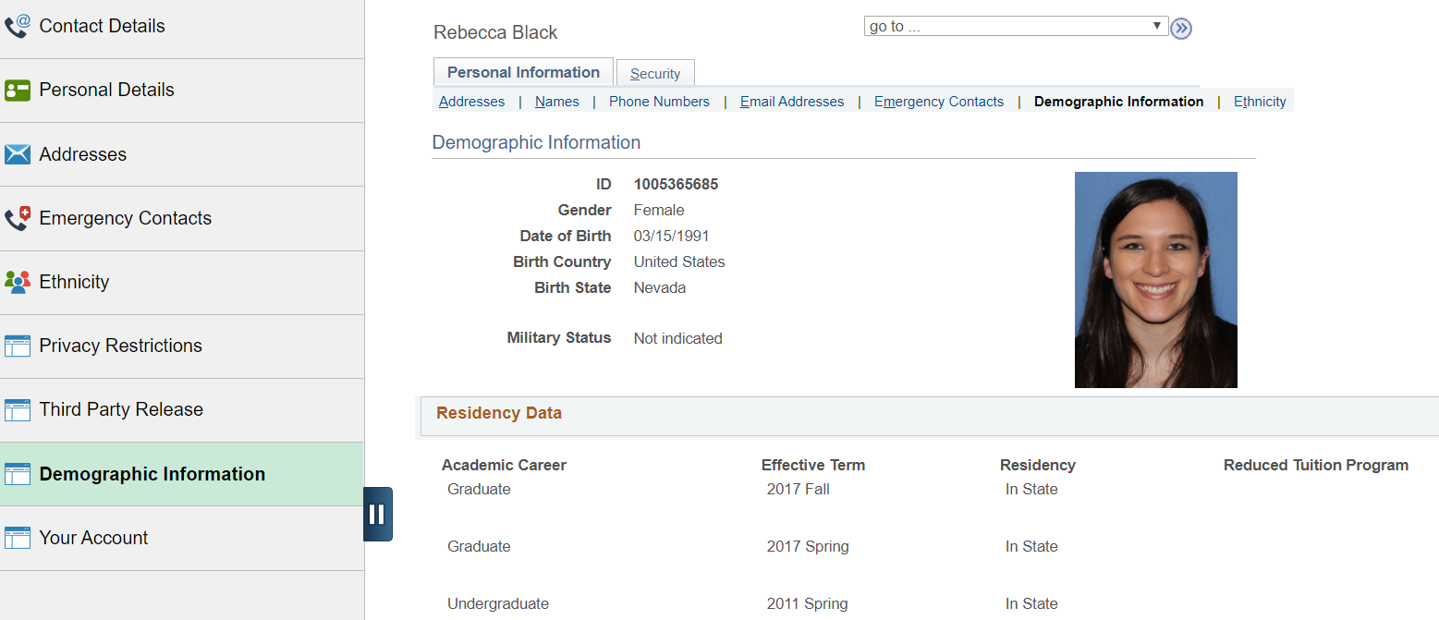
Most recent term listed must show “In State” to receive Nevada Resident points in the Accelerated Second-Bachelor’s Bachelor of Science in Nursing Application Process.

HESI Admissions Assessment RN Percentiles
(2018-2019)
HESI RN Admissions Assessment
HESI Admissions Assessment (A2) scores are calculated using a simple percentage correct calculation. This document contains the percentile rank data for a cumulative score across the following four subject areas: Anatomy and Physiology, Grammar, Math, and Reading Comprehension.

Score | Percentile |  | Score | Percentile
50 | 0.81 |  | 75 | 37.10
51 | 1.04 |  | 76 | 40.66
52 | 1.32 |  | 77 | 44.44
53 | 1.68 |  | 78 | 48.11
54 | 2.08 |  | 79 | 51.78
55 | 2.62 |  | 80 | 55.61
56 | 3.11 |  | 81 | 59.64
57 | 3.70 |  | 82 | 63.67
58 | 4.46 |  | 83 | 67.64
59 | 5.39 |  | 84 | 71.55
60 | 6.33 |  | 85 | 75.56
61 | 7.43 |  | 86 | 79.30
62 | 8.53 |  | 87 | 82.91
63 | 9.79 |  | 88 | 86.43
64 | 11.02 |  | 89 | 89.56
65 | 12.62 |  | 90 | 92.20
66 | 14.33 |  | 91 | 94.60
67 | 16.34 |  | 92 | 96.53
68 | 18.32 |  | 93 | 97.78
69 | 20.43 |  | 94 | 98.79
70 | 22.73 |  | 95 | 99.47
71 | 25.28 |  | 96 | 99.78
72 | 27.92 |  | 97 | 99.92
73 | 30.88 |  | 98 | 99.98
74 | 33.86 |  | 99 | 99.99

