Life Cycle

Annual Grass – Cheatgrass
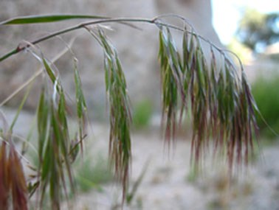
Cheatgrass is an annual grass, which means that it grows from a seed and then dies within one year. Cheatgrass plants are adapted to living in the desert by only living for the part of the year when there is the most moisture in Nevada (October to May). Cheatgrass seeds usually sprout in the fall but only grow a little bit until the snow melts in the late winter or early spring. Then this plant grows very quickly, producing a single stem, short roots and many seeds. Each plant can make between 25 and 500+ seeds. Once the cheatgrass seeds are ripe, the plant will dry up and droop, creating its distinctive look. The dry seeds have many sharp barbs that allow them to easily stick to clothing, shoes or fur and travel long distances. By only growing during the wettest part of the year, and dying before the driest part, cheatgrass can grow in many places. Since shrubs, trees and perennial grasses need enough water to stay alive during the hot and dry summer, their populations are often less dense than cheatgrass due to their competition for limited water resources. Because cheatgrass does not need water during the summer, it can grow in large patches, filling in the spaces between these native plants. Unlike the other three plants in this lesson, cheatgrass is an invasive species that originally came from Europe/Asia and was first introduced to Nevada approximately 130 years ago.
Figure 1. Cheatgrass seeds drooping.

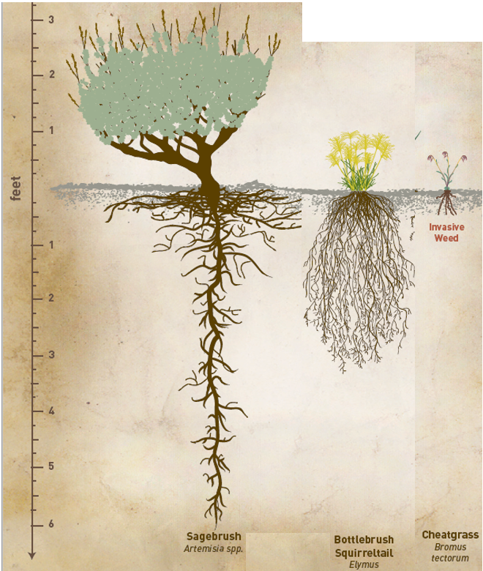
Herbivory – Being Eaten
When cheatgrass is green, it can be eaten by animals. However, it dries up, turning brown early spring. Once cheatgrass has dried out, very few animals will eat it.

Fire
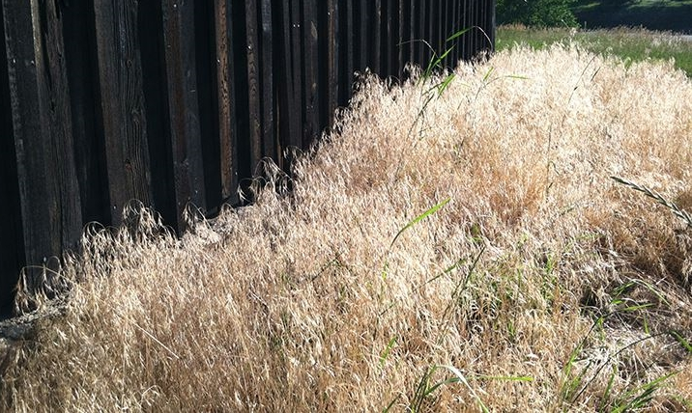
Cheatgrass catches on fire very easily because it is dry for most of the year and has a thin, paper-like texture. Since cheatgrass can grow in the open spaces between other plants such as bunchgrass and sagebrush, it makes it easier for fire to spread from one plant to another. Cheatgrass fires spread quickly, but since each plant is so small and paper-like, they don’t burn for very long.
Figure 2. A thick patch of dry cheatgrass. Very flammable!
Figure 3. Root size of Nevada plants.
Figure 3. Root Size of Nevada Plants.

