Name:

Lesson 4: Carrying Capacity
What Amount of Trees are Healthy?
Date:
Science Period:

Warm-up
How could having dead trees near Emberville impact the threat of wildfire?

Tree Density
Write or draw what you think will happen to these two areas of trees after a few years with less precipitation.
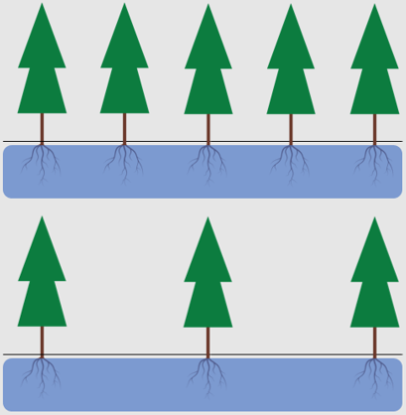

What would happen to each of these two areas if a wildfire happened there?

Top row.

Bottom row.

Matchstick Model Forest
Make a hypothesis for what will happen when the matches are burned. This could include how many of the matches will catch on fire or how fast the fire will spread.
How did your hypothesis compare to your observations?

Career Spotlight – Wildland Firefighter

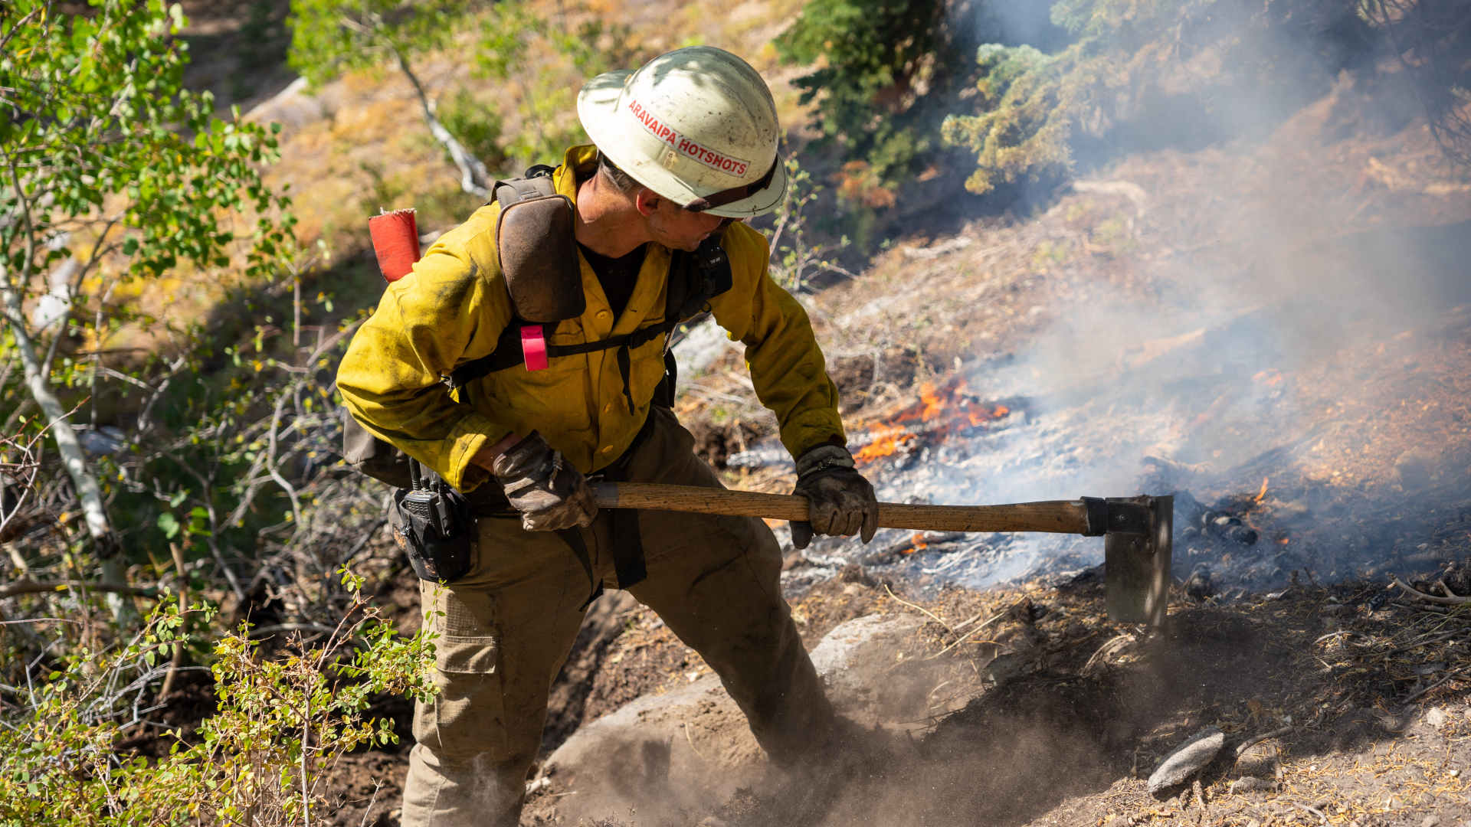
Overview
Wildland firefighters are the main group of people who put out and try to control wildfires. There are both seasonal and year-round wildland firefighters. Most wildland firefighters start out on a wildland firefighting crew but then have many opportunities to specialize in different areas such as forecasting weather around wildfires, flying planes or helicopters that fight fires, serving as incident commanders who coordinate efforts on large fires, or being fuels specialists who plan ways to reduce the fuels in problem areas well before there is a wildfire.

Job duties
While wildland firefighters do many different types of things, one of the main ways they directly fight fires is to build fire breaks, which are areas with very little flammable material ahead of active fires that will slow or stop the wildfire. To do this they use tools such as chainsaws, shovels, and even bulldozers to remove plants and trees from an area. Fire breaks are often created around homes to protect them during a wildfire and around ridges, rivers and roads creating a long barrier that can contain a wildfire. When conditions allow, firefighters will do a backburn, where they intentionally burn areas in front of a fire to remove burnable material in front of the fire gets there.

Getting started and career opportunities
The average pay for a wildland firefighter ranges from $30,000 to $104,000 depending on whether you’re a crew member or fire chief. To become a wildland firefighter, you only need to be 18 years or older, have a high school diploma or GED, and pass a physical fitness test. Many federal and state fire organizations will offer trainings for new wildland firefighters joining their crews. The introductory wildfire training “Type 2 wildland firefighter” is also offered at several community colleges around Nevada. To be promoted to higher ranks and pay levels wildland firefighters often take professional trainings through their fire crew or college-level courses related to wildfire or natural resource management during the winter off-season. Some firefighters pursue bachelor’s or graduate degrees in wildfire science.

How Does Wildfire Frequency Impact Tree Populations?
Draw a line on each graph to show how wildfire might impact tree populations. Each graph represents a long period of time, 400+ years.
Draw how tree populations would change with less frequent wildfire.
Draw how tree populations would change with frequent wildfire.

What Does a Healthy Emberville Look Like?
Draw or describe what the “healthy” side of this diagram could look like.
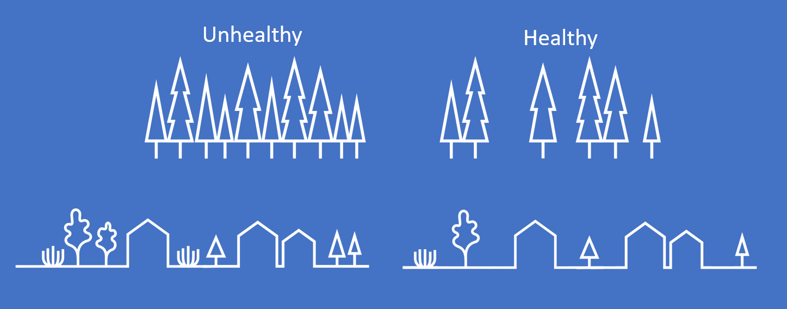

What Impacts Carrying Capacity?
Carrying capacity – The population size of one or more types of living things that can healthily live in an area.
Complete a Claim Evidence Reasoning statement about factors that impact the carrying capacity of tree populations around Emberville.

Claim:

Evidence:

Reasoning:

‘

